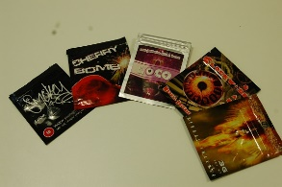**Psychoactive substances (Formally known as Legal Highs)**

What are they?

The Psychoactive Substances Act is new legislation which makes distributing psychoactive substances (used to be known as Legal Highs) for human consumption a criminal offence. It came into effect in 2016.

New psychoactive substances (NPS) might sound like an awkward term, but it’s more accurate than legal highs. You’ll still hear people talking about legal highs, and since it’s a widely understood term, you might still find it used on this site. But they’re all illegal when the new law comes into effect.

There’s not enough known about many of these drugs to know about their potency, their effects on people, or what happens when they’re used with other substances or alcohol' The packaging might describe a list of ingredients but you can’t be sure that this is what’s inside.  So you can’t really be sure what you’ve bought or been given, or what effect it’s likely to have on you or your friends. Many NPS are sold under brand names like ‘Clockwork Orange’, ‘Bliss’, ‘Mary Jane’ and some have been linked to poisoning, emergency hospital admissions and, in some cases deaths.

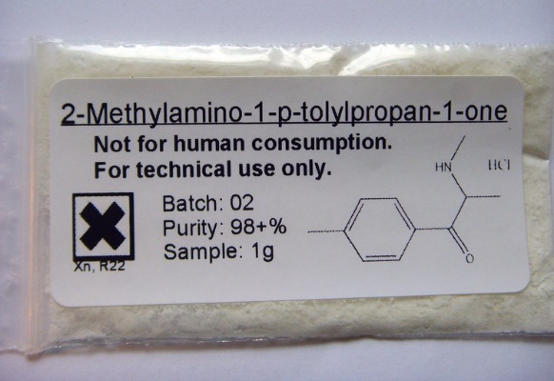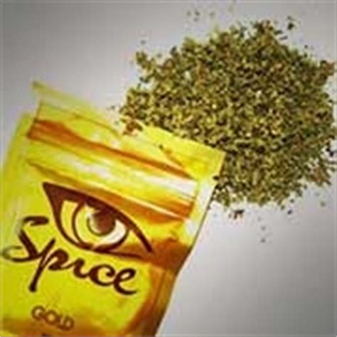

Real Life Example

“I live a fairly regular life now. I don't have a job but have hobbies, a house, car and a baby. I used to be addicted to ketamine in uni but overcame it. I heard from a close friend that MXE was available on the internet. After my pregnancy when I had finished breast feeding I decided to give it a go as my partner and his brother and his partner, who we are close friends with were all using. At first I found it boring and I still do now but 7 months later I cannot stop using it. I take line after line and have used everyday for pretty much 7 months. I don't want to do it and it makes me hugely depressed and anxious but it seems to have some kind of grip on me. My close friends are even worse and I sart to feel their child is suffering. They are fantastic loving parents but have started staying indoors all the time. They spend all their money on MX. I really don't want to ruin my life or my little mans. The addictive quality to this drug is very high I have used MDMA, Speed, Cannibis, Codeine, Mephedrone, Coke and Ketamine. Close to K are the only things I have found so addictive.”

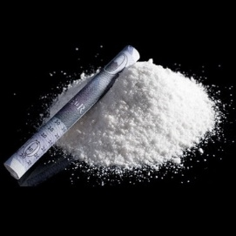

**What are the effects of new psychoactive substances?**  
The main effects of almost all psychoactive drugs, including so-called legal highs, can be described using the four main categories below. While drugs in each of these categories will be similar in the effects they produce, they will have widely different strengths and effects on different people.

* **Stimulants** (like mephedrone, naphyrone) act like amphetamines, cocaine, or ecstasy, in that they can make you feel energised, physically active, fast-thinking, very chatty and euphoric.
* **Downers or sedatives** (like GBH/GBL, methoxetamine)  act similarly to benzodiazepines (drugs like diazepam or Valium), or GHB/GBL, in that they can make you feel euphoric, relaxed or sleepy.
* **Hallucinogens or psychedelics**(like NBOMe drugs)act like LSD, magic mushrooms, ketamine and methoxetamine. They create altered perceptions and can make you hallucinate (seeing and/or hearing things that aren’t there). They can induce feelings of euphoria, warmth, ‘enlightenment’ and being detached from the world around.
* **Synthetic cannabinoids** (like Spice or Black Mamba): act similarly to cannabis. The effects of these are similar cannabis intoxication:  relaxation, altered consciousness, disinhibition, a state of being energised and euphoria.

An Example

**What is mephedrone?** (White Magic, Miaow, Meph, Meow Meow, MC, m-smack, M-Cat, Drone, Charge, Bubble, Bounce)  
Mephedrone is a powerful stimulant and is part of a group of drugs that are closely related to the amphetamines, like speed and ecstasy. There isn't much evidence about mephedrone and it's long term effects as it's quite a new drug but because it is similar to speed and ecstasy the long term effects may well be similar.

There have reports of people hospitalised due to the short-term effects.

**How do people take mephedrone?**  
Mephedrone is usually snorted like cocaine or is wrapped in paper and swallowed (‘bombed’ is a slang name used for this). It can also be found as capsules and pills and can be smoked. Much less often, mephedrone is injected.