**Just war theory**

What would be your list of conditions for going to war? What would be your rules during and after the conflict?

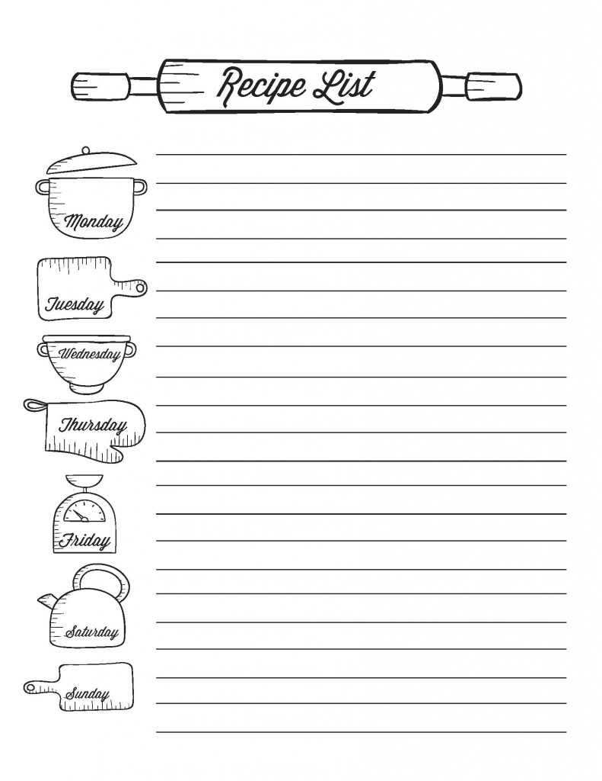

Jus Ad Bellum

|  |
| --- |
|  |

Jus In Bello

|  |
| --- |
|  |

Jus Post Bellum

|  |
| --- |
|  |