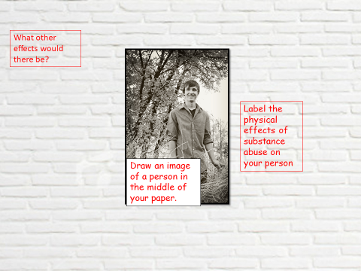

|  |  |
| --- | --- |
| Group 1 | You are in a group of friends.  You are hanging out in a local park.  One of your friends has brought some alcohol for you to drink. You decide to drink it. |
| Group 2 | You have been out with a group of friends. You are walking home and it starts raining really hard. You have a long walk home.  A car stops and it is an older teenager you kind of recognise. They offer you a lift home. You decide to get in. |
| Group 3 | You have been out with your friends and you are all walking back. You are talking to another group of friends on your phones. You have to cross some busy main roads. |
| Group 4 | You and your best friends have started hanging out with an older group of friends. They are part of a gang and have asked you to drop of some drugs to another person. They said it will just be a one-off and you will get paid. Your friend isn’t keen but you decide to do it. |
| Group 5 | You are the expert panel.  You need to think about the dangers of going out without an adult and develop ways to stay safe and advice on what to do if something does go wrong.  You will have to offer each group advice based on their role play. |

**Watch the A-Z Of Drugs**