The Spanish Armada

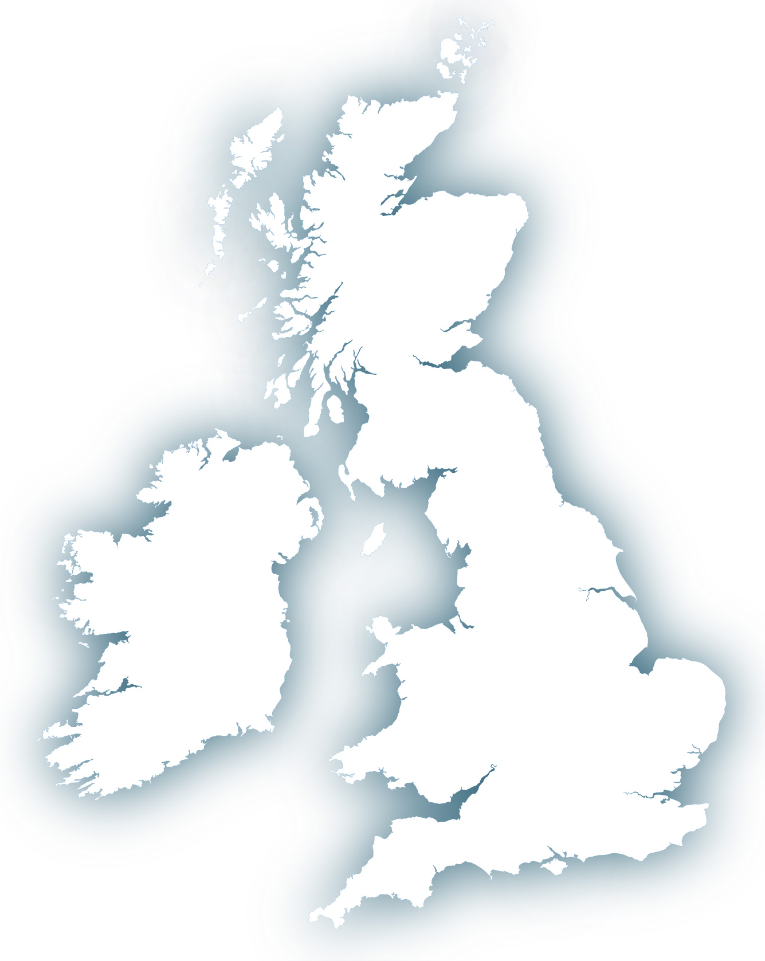Using Source A on p.80-81, draw the route the Spanish Armada took around England. Then mark on the events of the Spanish Armada battle onto this map, using the cartoon. (Use source A to see where each event should go).