**What is death?**

|  |
| --- |
| Official Definition |
|  |

Other points or ideas…

Evidence For The Existence Of A Soul

|  |
| --- |
| REINCARNATION |

|  |
| --- |
| What is it? |

|  |
| --- |
| Hindu Beliefs |

|  |
| --- |
| Thoughts from the video |

|  |  |
| --- | --- |
| HEAVEN | HELL |
|  |  |
| CHRISTIAN BELIEFS AND IDEAS | |
| HEAVEN | HELL |
|  |  |

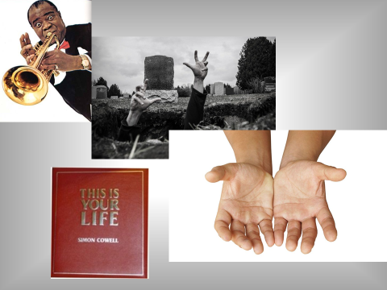

|  |
| --- |
|  |
|  |
|  |
|  |
|  |
|  |
|  |
|  |
|  |
|  |
|  |
|  |
|  |
|  |
|  |
|  |
|  |
|  |
|  |
|  |
|  |
|  |
|  |
|  |
|  |
|  |
|  |

**Ghosts**

Non-Religious Views And Ideas

|  |
| --- |
|  |
|  |
|  |
|  |
|  |
|  |
|  |
|  |
|  |
|  |
|  |
|  |
|  |
|  |
|  |
|  |
|  |
|  |
|  |
|  |
|  |
|  |
|  |
|  |
|  |
|  |
|  |
|  |
|  |
|  |
|  |
|  |
|  |
|  |
|  |
|  |
|  |
|  |
|  |