**Year 11 Spanish TERM 3: Lessons Outline**



* Pupils have 2 lessons of Spanish a week (one single and one double).
* Pupils have been given their own copy of the **GCSE Viva**  textbook they also have access to online resources to accompany the textbook <https://pearsonactivelearn.com/>
* If absent, pupils should read through the relevant vocabulary for module 8 **(found on pages 180-181 and also in the pupil work area)** and then work through all of the exercises (with the exception of the listening tasks). Pupils should copy the relevant vocabulary in to their folders and learn it. For extension they could also look at lessons on BBC Bitesize or Oak Academy where there are a range of topic areas to extend their learning. Pupils can also use the Linguascope website (Username is Kingshill, password is mfl123*) or Quizlet.
* **SPEAKING WORK-** Pupils should also work on their GCSE speaking questions which are on the next page. They should aim to complete them this term.
* **Homework** will be set on Show my Homework.

|  |  |  |
| --- | --- | --- |
| **Week** | **Work Set**  **(Viva GCSE- Starting to revise previous modules)** | Link to pages in On- line textbook where possible  Or alternative activity |
| **Week 1** | **Punto de partida 1 and 2**  Describing types of houses  Talking about the environment Talking about healthy eating Discussing diet-related problems | **Pages 160-163** |
| **Week 2** | **Piensa globalmente**  Global issues Big numbers | **Pages 164-165** |
| **Week 3** | **Actúa localmente**  Talking about local actions | **Pages 166-167** |
| **Week 4** | **Vivir a tope**  Discussing healthy lifestyles Giving extended reasons | **Pages 168-169** |
| **Week 5** | **El deporte nos une**  Talking about international sporting events Explaining your point of view | **Pages 170-171** |
| **Week 6** | **Apúnate**  Talking about natural disasters Translation skills | **Pages 172-173** |
| **Week 7** | **Leer y escuchar**  Reading and listening skills | **Pages 174-175** |

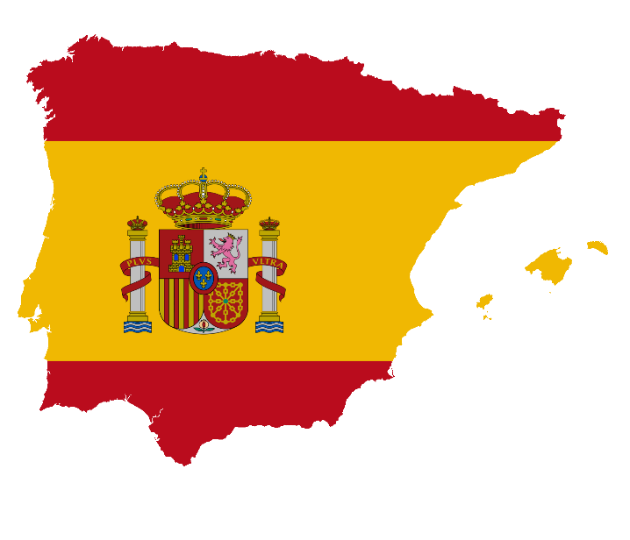

**GCSE Spanish Speaking Booklet**

**Theme 1**

**Module 3 – Me, my family and friends; Technology in everyday life**

¿Describe a un buen amigo tuyo/una buena amiga tuya.

……………………………………………………………………………………………………………………………………………………………………………………………………………………………………………………………………………………………………………………………………………………………………………………………………………………………………………………………………………………………………………………

¿Qué aplicaciones usas para estar en contacto con tus amigos y con tu familia?

……………………………………………………………………………………………………………………………………………………………………………………………………………………………………………………………………………………………………………………………………………………………………………………………………………………………………………………………………………………………………………………

¿Qué piensas de las redes sociales?

……………………………………………………………………………………………………………………………………………………………………………………………………………………………………………………………………………………………………………………………………………………………………………………………………………………………………………………………………………………………………………………

¿Te llevas bien con tu familia? ¿Por qué (no)?

……………………………………………………………………………………………………………………………………………………………………………………………………………………………………………………………………………………………………………………………………………………………………………………………………………………………………………………………………………………………………………………

¿Qué planes tienes con tus amigos o con tu familia este fin de semana?

……………………………………………………………………………………………………………………………………………………………………………………………………………………………………………………………………………………………………………………………………………………………………………………………………………………………………………………………………………………………………………………

**Module 4 – Free-time activities (music, cinema and TV, sport)**

¿Qué sueles hacer en tus ratos libres?

……………………………………………………………………………………………………………………………………………………………………………………………………………………………………………………………………………………………………………………………………………………………………………………………………………………………………………………………………………………………………………………

¿Prefieres ver películas en casa o en el cine? ¿Por qué?

……………………………………………………………………………………………………………………………………………………………………………………………………………………………………………………………………………………………………………………………………………………………………………………………………………………………………………………………………………………………………………………

¿Te gusta la música? ¿Por qué (no)?

……………………………………………………………………………………………………………………………………………………………………………………………………………………………………………………………………………………………………………………………………………………………………………………………………………………………………………………………………………………………………………………

Háblame de la última vez que participaste en un deporte.

……………………………………………………………………………………………………………………………………………………………………………………………………………………………………………………………………………………………………………………………………………………………………………………………………………………………………………………………………………………………………………………

¿Quién es tu modelo a seguir?

……………………………………………………………………………………………………………………………………………………………………………………………………………………………………………………………………………………………………………………………………………………………………………………………………………………………………………………………………………………………………………………

**Module 6 – Customs and festivals in Spanish-speaking countries; Free-time activities (food and eating out)**

¿Qué te gusta comer? ¿Por qué?

……………………………………………………………………………………………………………………………………………………………………………………………………………………………………………………………………………………………………………………………………………………………………………………………………………………………………………………………………………………………………………………

¿Prefieres cenar en casa o en un restaurante? ¿Por qué?

……………………………………………………………………………………………………………………………………………………………………………………………………………………………………………………………………………………………………………………………………………………………………………………………………………………………………………………………………………………………………………………

¿Has asistido a un festival de música? ¿Puedes describirlo?

……………………………………………………………………………………………………………………………………………………………………………………………………………………………………………………………………………………………………………………………………………………………………………………………………………………………………………………………………………………………………………………

¿Crees que las fiestas tradicionales son importantes? ¿Por qué (no)?

……………………………………………………………………………………………………………………………………………………………………………………………………………………………………………………………………………………………………………………………………………………………………………………………………………………………………………………………………………………………………………………

Háblame de una fiesta a la que te gustaría asistir.

……………………………………………………………………………………………………………………………………………………………………………………………………………………………………………………………………………………………………………………………………………………………………………………………………………………………………………………………………………………………………………………

**Theme 2**

**Module 1 – Travel and tourism**

¿Por qué son importantes las vacaciones?

……………………………………………………………………………………………………………………………………………………………………………………………………………………………………………………………………………………………………………………………………………………………………………………………………………………………………………………………………………………………………………………

¿Adónde fuiste de vacaciones el año pasado?

……………………………………………………………………………………………………………………………………………………………………………………………………………………………………………………………………………………………………………………………………………………………………………………………………………………………………………………………………………………………………………………

¿Dónde te alojaste?

……………………………………………………………………………………………………………………………………………………………………………………………………………………………………………………………………………………………………………………………………………………………………………………………………………………………………………………………………………………………………………………

¿Qué fue lo mejor de tus vacaciones?

……………………………………………………………………………………………………………………………………………………………………………………………………………………………………………………………………………………………………………………………………………………………………………………………………………………………………………………………………………………………………………………

¿Qué planes tienes para el próximo verano?

……………………………………………………………………………………………………………………………………………………………………………………………………………………………………………………………………………………………………………………………………………………………………………………………………………………………………………………………………………………………………………………

**Module 5 – Home, town, neighbourhood and region**

¿Cómo es la ciudad o el pueblo donde vives?

……………………………………………………………………………………………………………………………………………………………………………………………………………………………………………………………………………………………………………………………………………………………………………………………………………………………………………………………………………………………………………………

¿Cuál es tu ciudad favorita? ¿Por qué?

……………………………………………………………………………………………………………………………………………………………………………………………………………………………………………………………………………………………………………………………………………………………………………………………………………………………………………………………………………………………………………………

¿Qué es mejor, vivir en la ciudad o en el campo?

……………………………………………………………………………………………………………………………………………………………………………………………………………………………………………………………………………………………………………………………………………………………………………………………………………………………………………………………………………………………………………………

¿Qué hay para turistas en tu zona? ¿Qué se puede hacer?

……………………………………………………………………………………………………………………………………………………………………………………………………………………………………………………………………………………………………………………………………………………………………………………………………………………………………………………………………………………………………………………

¿Cómo cambiarías tu zona?

……………………………………………………………………………………………………………………………………………………………………………………………………………………………………………………………………………………………………………………………………………………………………………………………………………………………………………………………………………………………………………………

**Module 8 – Home; social issues; global issues**

¿Cómo te puedes mantener en forma?

……………………………………………………………………………………………………………………………………………………………………………………………………………………………………………………………………………………………………………………………………………………………………………………………………………………………………………………………………………………………………………………

¿Qué opinas de fumar?

……………………………………………………………………………………………………………………………………………………………………………………………………………………………………………………………………………………………………………………………………………………………………………………………………………………………………………………………………………………………………………………

¿Qué haces en casa para proteger el medio ambiente?

……………………………………………………………………………………………………………………………………………………………………………………………………………………………………………………………………………………………………………………………………………………………………………………………………………………………………………………………………………………………………………………

¿Cuál es son los problemas globales más serios hoy en dia?

……………………………………………………………………………………………………………………………………………………………………………………………………………………………………………………………………………………………………………………………………………………………………………………………………………………………………………………………………………………………………………………

¿Para qué sirven los eventos deportivos internacionales?

……………………………………………………………………………………………………………………………………………………………………………………………………………………………………………………………………………………………………………………………………………………………………………………………………………………………………………………………………………………………………………………

**Theme 3**

**Module 2 – My studies; Life at school/college**

¿Cómo es tu instituto? ¿Qué instalaciones tiene/no tiene?

……………………………………………………………………………………………………………………………………………………………………………………………………………………………………………………………………………………………………………………………………………………………………………………………………………………………………………………………………………………………………………………

¿Qué asignaturas te gustan y no te gustan? ¿Por qué?

……………………………………………………………………………………………………………………………………………………………………………………………………………………………………………………………………………………………………………………………………………………………………………………………………………………………………………………………………………………………………………………

¿Qué opinas del uniforme escolar?

……………………………………………………………………………………………………………………………………………………………………………………………………………………………………………………………………………………………………………………………………………………………………………………………………………………………………………………………………………………………………………………

¿Qué piensas de las normas de tu insti?

……………………………………………………………………………………………………………………………………………………………………………………………………………………………………………………………………………………………………………………………………………………………………………………………………………………………………………………………………………………………………………………

¿Qué actividades extraescolares haces?

……………………………………………………………………………………………………………………………………………………………………………………………………………………………………………………………………………………………………………………………………………………………………………………………………………………………………………………………………………………………………………………

¿Qué es lo bueno/lo malo de tu insti?

……………………………………………………………………………………………………………………………………………………………………………………………………………………………………………………………………………………………………………………………………………………………………………………………………………………………………………………………………………………………………………………

Compara tu escuela primaria con tu instituto.

……………………………………………………………………………………………………………………………………………………………………………………………………………………………………………………………………………………………………………………………………………………………………………………………………………………………………………………………………………………………………………………

¿Puedes describir un intercambio o un viaje escolar que hiciste en el pasado?

……………………………………………………………………………………………………………………………………………………………………………………………………………………………………………………………………………………………………………………………………………………………………………………………………………………………………………………………………………………………………………………

**Module 7 – Education post-16; jobs, career choices and ambitions**

¿Tienes un trabajo a tiempo parcial? Que haces?

……………………………………………………………………………………………………………………………………………………………………………………………………………………………………………………………………………………………………………………………………………………………………………………………………………………………………………………………………………………………………………………

¿Qué planes para seguir estudiando en el futuro?

……………………………………………………………………………………………………………………………………………………………………………………………………………………………………………………………………………………………………………………………………………………………………………………………………………………………………………………………………………………………………………………

¿Dónde hiciste tus prácticas laborales?

……………………………………………………………………………………………………………………………………………………………………………………………………………………………………………………………………………………………………………………………………………………………………………………………………………………………………………………………………………………………………………………

¿En que te gustaría trabajar? ¿Por qué?

……………………………………………………………………………………………………………………………………………………………………………………………………………………………………………………………………………………………………………………………………………………………………………………………………………………………………………………………………………………………………………………

¿Crees que es importante aprender otras lenguas? ¿Por qué (no)?

……………………………………………………………………………………………………………………………………………………………………………………………………………………………………………………………………………………………………………………………………………………………………………………………………………………………………………………………………………………………………………………

¿Qué otras ambiciones tienes?

……………………………………………………………………………………………………………………………………………………………………………………………………………………………………………………………………………………………………………………………………………………………………………………………………………………………………………………………………………………………………………………

¿Qué cosas te importan más en la vida? ¿Por qué?

……………………………………………………………………………………………………………………………………………………………………………………………………………………………………………………………………………………………………………………………………………………………………………………………………………………………………………………………………………………………………………………