**Supporting Information – Tudor Voyagers**

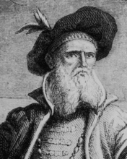

John Cabot – Early Explorer from Henry VII’s reign. He explored West, sailing to Canada. He believed there was a ‘northern passage’ to the Pacific, sailing through Canada. He was wrong and returned to England.

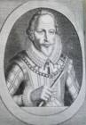

John Davis – Sailed between 1585 and 1587 to Canada (Baffin Island). He was unable to travel the icy waters, and never returned.

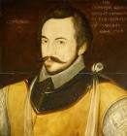

Humphrey Gilbert – Tried to find the Northern passage also, was unable to pass the icy waters and didn’t return. 1583.

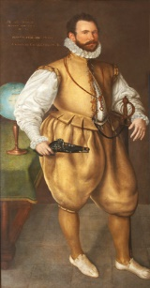

Martin Frobisher – In 1576, he led a group into Canada to find the Northern Passage. He was unable to succeed.

Sir Walter Raleigh – Led many expeditions in the Elizabethan period. Known as the ‘father of the English colonies’, attempting a settlement on in modern North Carolina known as Roanoke. Upon returning the Roanoke, he learnt that the colony had been deserted, likely due to starvation, fleeing, or war with Natives. Also sailed to Guiana and South America looking for ‘El Dorado’ – the City of Gold.

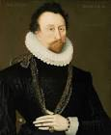

Sir John Hawkins – Led the first English expedition in the slave trade. He travelled to West Africa, captured 300 Africans and transported them to the Spanish colonies in America, selling them. This would begin England’s involvement in the trans-Atlantic slave trade in 1562.

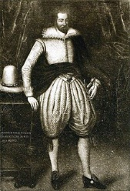

Willoughby and Chancellor – Tried to establish trade with the East, by establishing a northern trade route to Moscow (Russia). They were part of the Muscovy Company, which was to trade with Moscow. This was in 1553 (Mary I)

New ideas and new inventions

Exploration was also spurred on by new ideas. This was the age of the RENAISSANCE, which encouraged learning and also a spirit of adventure. There was a growing belief in intellectual circles that the world was in fact round, not flat. It was therefore suggested that perhaps ships could sail north around Russia, or south around Africa, or west across the Atlantic in order to reach the Far East.

New inventions also prompted the growth in exploration. The PRINTING PRESS now meant that maps and other geographical literature were more readily available than before. The ASTROLABE meant that a ship's position could be plotted accurately (they could now tell how far north/south they were) and the magnetic compass was developed. There had also been developments in ship design. Smaller ships called caravels and carracks were used for exploration and the invention of the rudder gave the crew more control when steering the ship. The triangular lateen sail (copied from Arab ships) made ships faster and easier to steer - ships could now sail whichever way they wished, whatever the wind direction. Improved defences and weapons made sailing through hostile waters much safer.

How did the voyages of exploration benefit England?

Wealth

By raiding Spanish ships and ports, English sailors like Sir Francis Drake brought riches back to England. Sailors like John Hawkins made his fortune and added to the country's wealth by trading in African slaves. However, other countries like Spain and Portugal also made huge amounts of money at this time by trading in spices and taking gold from South America. Despite this, England did build the foundations of the great trading empire it later became, with many of the trading companies established under Elizabeth becoming very important in the following century.

Power

English naval power was a growing force under Elizabeth. It was clear that England could hold its own in any sea battle and was able to exert its influence over many weaker countries.

Territory

England failed in its first attempt to build a colony in America - and other countries beat England in the race to colonise South America. However, English explorers and settlers persevered and over the next few centuries England began to build up more and more territory overseas.

Conflict with the Ottomans and Trade with the East

At the start of the fifteenth century, much of the world as we know it had yet to be discovered by Europeans. It was believed that the world was flat and that the Mediterranean lay at its centre. However, there were trade links beyond Europe as there was great demand for luxury goods from the East including spices, incense, silks, cottons and perfumes. Such items were highly prized because transporting them took so long and was so expensive. They were brought from the Far East over land on the backs of camels. It could take two or three years for the goods to reach the Italian trading centres of Genoa and Venice.

These difficulties in trading with the East were made worse by Ottoman expansion. The OTTOMAN EMPIRE was Muslim and hostile to Christian Europe. The Ottoman Turks had conquered much of Eastern Europe and now held power in the Mediterranean. The Ottomans placed high taxes on all goods passing through their territory. This annoyed the Europeans, who were also aware that the Turks had the ability to block off trade between Europe and the East altogether. The Europeans therefore wanted to find an alternative route, which would remove the need to pass through Ottoman lands. Ships also had the advantage of being able to carry far more than camels, so it was hoped that new sea routes would mean that more goods from the East could be imported for less money.