# EXPLORATION

Independent Study Booklet

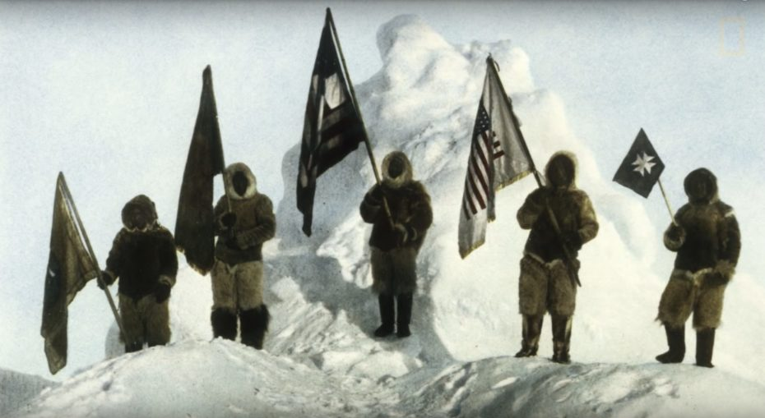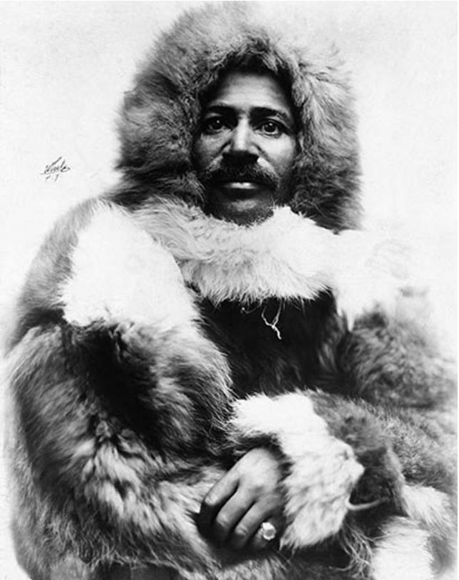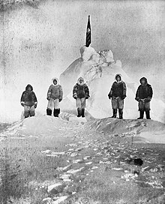

MATTHEW HENSON

NAME: _________________________________________

# **H/W TASK ONE**

Research the explorer Matthew Henson and answer the questions.

Useful websites:

<https://thekidshouldseethis.com/post/matthew-henson-north-pole>

<https://untoldstories.net/1886/08/matthew-henson-explorer-scientist/>

<https://www.nationalgeographic.com/adventure/article/the-legacy-of-arctic-explorer-matthew-henson>

What was he famous for?

When did he live?

What skills did he bring to the expedition?

What did you learn about his background and upbringing?

What did you find the most interesting about his story and why?

# **H/W TASK TWO**

Read this extract from his autobiography and highlight where he is describing moments that are challenging and difficult as he reaches the North Pole.

# **A BLACK EXPLORER AT THE NORTH POLE**

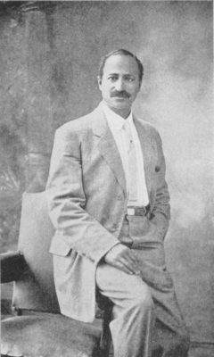

**MATTHEW A. HENSON**

**CHAPTER XV**

THE POLE!

Captain Bartlett and his two boys had commenced their return journey, and the main column, depleted to its final strength, started northward. We were six: Peary, the commander, the Esquimos: Ootah, Egingwah, Seegloo and Ooqueah, and myself.

Day and night were the same. My thoughts were on the going and getting forward, and on nothing else. The wind was from the southeast, and seemed to push us on, and the sun was at our backs, a ball of livid fire, rolling his way above the horizon in never-ending day.

The Captain had gone, Commander Peary and I were alone (save for the four Esquimos), the same as we had been so often in the past years, and as we looked at each other we realized our position and we knew without speaking that the time had come for us to demonstrate that we were the men who, it had been ordained, should unlock the door which held the mystery of the Arctic. Without an instant's hesitation, the order to push on was given, and we started off in the trail made by the Captain to cover the Farthest North he had made and to push on over one hundred and thirty miles to our final destination.

The Captain had had rough going, but, owing to the fact that his trail was our track for a short time, and that we came to good going shortly after leaving his turning point, we made excellent distance without any trouble, and only stopped when we came to a lead barely frozen over, a full twenty-five miles beyond. We camped and waited for the strong southeast wind to force the sides of the lead together. The Esquimos had eaten a meal of stewed dog, cooked over a fire of wood from a discarded sledge, and, owing to their wonderful powers of recuperation, were in good condition; Commander Peary and myself, rested and invigorated by our thirty hours in the last camp, waiting for the return and departure of Captain Bartlett, were also in fine fettle, and accordingly the accomplishment of twenty-five miles of northward progress was not exceptional. With my proven ability in gauging distances, Commander Peary was ready to take the reckoning as I made it and he did not resort to solar observations until we were within a hand's grasp of the Pole.

The memory of those last five marches, from the Farthest North of Captain Bartlett to the arrival of our party at the Pole, is a memory of toil, fatigue, and exhaustion, but we were urged on and encouraged by our relentless commander, who was himself being scourged by the final lashings of the dominating influence that had controlled his life. From the land to 87° 48' north, Commander Peary had had the best of the going, for he had brought up the rear and had utilized the trail made by the preceding parties, and thus he had kept himself in the best of condition for the time when he made the spurt that brought him to the end of the race. From 87° 48' north, he kept in the lead and did his work in such a way as to convince me that he was still as good a man as he had ever been. We marched and marched, falling down in our tracks repeatedly, until it was impossible to go on. We were forced to camp, in spite of the impatience of the Commander, who found himself unable to rest, and who only waited long enough for us to relax into sound sleep, when he would wake us up and start us off again. I do not believe that he slept for one hour from April 2 until after he had loaded us up and ordered us to go back over our old trail, and I often think that from the instant when the order to return was given until the land was again sighted, he was in a continual daze.

Onward we forced our weary way. Commander Peary took his sights from the time our chronometer-watches gave, and I, knowing that we had kept on going in practically a straight line, was sure that we had more than covered the necessary distance to insure our arrival at the top of the earth.

It was during the march of the 3d of April that I endured an instant of hideous horror. We were crossing a lane of moving ice. Commander Peary was in the lead setting the pace, and a half hour later the four boys and myself followed in single file. They had all gone before, and I was standing and pushing at the upstanders of my sledge, when the block of ice I was using as a support slipped from underneath my feet, and before I knew it the sledge was out of my grasp, and I was floundering in the water of the lead. I did the best I could. I tore my hood from off my head and struggled frantically. My hands were gloved and I could not take hold of the ice, but before I could give the "Grand Hailing Sigh of Distress," faithful old Ootah had grabbed me by the nape of the neck, the same as he would have grabbed a dog, and with one hand he pulled me out of the water, and with the other hurried the team across.

He had saved my life, but I did not tell him so, for such occurrences are taken as part of the day's work, and the sledge he safeguarded was of much more importance, for it held, as part of its load, the Commander's sextant, the mercury, and the coils of piano-wire that were the essential portion of the scientific part of the expedition. My kamiks (boots of sealskin) were stripped off, and the congealed water was beaten out of my bearskin trousers, and with a dry pair of kamiks, we hurried on to overtake the column. When we caught up, we found the boys gathered around the Commander, doing their best to relieve him of his discomfort, for he had fallen into the water also, and while he was not complaining, I was sure that his bath had not been any more voluntary than mine had been.

When we halted on April 6, 1909, and started to build the igloos, the dogs and sledges having been secured, I noticed Commander Peary at work unloading his sledge and unpacking several bundles of equipment. He pulled out from under his *kooletah* (thick, fur outer-garment) a small folded package and unfolded it. I recognized his old silk flag, and realized that this was to be a camp of importance. Our different camps had been known as Camp Number One, Number Two, etc., but after the turning back of Captain Bartlett, the camps had been given names such as Camp Nansen, Camp Cagni, etc., and I asked what the name of this camp was to be—"Camp Peary"? "This, my boy, is to be Camp Morris K. Jesup, the last and most northerly camp on the earth." He fastened the flag to a staff and planted it firmly on the top of his[133] igloo. For a few minutes it hung limp and lifeless in the dead calm of the haze, and then a slight breeze, increasing in strength, caused the folds to straighten out, and soon it was rippling out in sparkling colour. The stars and stripes were "nailed to the Pole."

A thrill of patriotism ran through me and I raised my voice to cheer the starry emblem of my native land. The Esquimos gathered around and, taking the time from Commander Peary, three hearty cheers rang out on the still, frosty air, our dumb dogs looking on in puzzled surprise. As prospects for getting a sight of the sun were not good, we turned in and slept, leaving the flag proudly floating above us.

This was a thin silk flag that Commander Peary had carried on all of his Arctic journeys, and he had always flown it at his last camps. It was as glorious and as inspiring a banner as any battle-scarred, blood-stained standard of the world—and this badge of honour and courage was also blood-stained and battle-scarred, for at several places there were blank squares marking the spots where pieces had been cut out at each of the "Farthests" of its brave bearer, and left with the records in the cairns, as mute but eloquent witnesses of his achievements. At the North Pole a diagonal strip running from the upper left to the lower right corner was cut and this precious strip, together with a brief record, was placed in an empty tin, sealed up and buried in the ice, as a record for all time.

Commander Peary also had another American flag, sewn on a white ground, and it was the emblem of the "Daughters of the Revolution Peace Society"; he also had and flew the emblem of the Navy League, and the emblems of a couple of college fraternities of which he was a member.

It was about ten or ten-thirty a. m., on the 7th of April, 1909, that the Commander gave the order to build a snow-shield to protect him from the flying drift of the surface-snow. I knew that he was about to take an observation, and while we worked I was nervously apprehensive, for I felt that the end of our journey had come. When we handed him the pan of mercury the hour was within a very few minutes of noon. Laying flat on his stomach, he took the elevation and made the notes on a piece of tissue-paper at his head. With sun-blinded eyes, he snapped shut the *vernier* (a graduated scale that subdivides the smallest divisions on the sector of the circular scale of the sextant) and with the resolute squaring of his jaws, I was sure that he was satisfied, and I was confident that the journey had ended. Feeling that the time had come, I ungloved my right hand and went forward to congratulate him on the success of our eighteen years of effort, but a gust of wind blew something into his eye, or else the burning pain caused by his prolonged look at the reflection of the limb of the sun forced him to turn aside; and with both hands covering his eyes, he gave us orders to not let him sleep for more than four hours, for six hours later he purposed to take another sight about four miles beyond, and that he wanted at least two hours to make the trip and get everything in readiness.

I unloaded a sledge, and reloaded it with a couple of skins, the instruments, and a cooker with enough alcohol and food for one meal for three, and then I turned in to the igloo where my boys were already sound asleep. The thermometer registered 29° below zero. I fell into a dreamless sleep and slept for about a minute, so I thought, when I was awakened by the clatter and noise made by the return of Peary and his boys.

The Commander gave the word, "We will plant the stars and stripes—*at the North Pole!*" and it was done; on the peak of a huge paleocrystic floeberg the glorious banner was unfurled to the breeze, and as it snapped and crackled with the wind, I felt a savage joy and exultation. Another world's accomplishment was done and finished, and as in the past, from the beginning of history, wherever the world's work was done by a white man, he had been accompanied by a coloured man. From the building of the pyramids and the journey to the Cross, to the discovery of the new world and the discovery of the North Pole, the Negro had been the faithful and constant companion of the Caucasian, and I felt all that it was possible for me to feel, that it was I, a lowly member of my race, who had been chosen by fate to represent it, at this, almost the last of the world's great *work*.

# **H/W TASK THREE**

Choose six words from Matthew Henson’s autobiography that you don’t understand. Look up the word and write a definition and example for it. Then transform each word into a small image to help you remember it. One has been done for you.

|  |  |  |
| --- | --- | --- |
| **Word** | **Definition** | **Image of word** |
| **depleted** | To use up the supply or resources of something.  *The lake is dry because it has been depleted by drought* | Power Depletion NEW Svg Png Icon Free Download (#278304) -  OnlineWebFonts.COM |
|  |  |  |
|  |  |  |
|  |  |  |
|  |  |  |
|  |  |  |

# **H/W TASK FOUR**

Go back to the highlighting you did in task two for homework. Select three phrases that you feel Henson uses to present his expedition as challenging and difficult? Choose evidence that you think shows Henson making specific choices as a writer. For example using emotive language.

|  |  |
| --- | --- |
| **Evidence** | **How does this make the expedition sound challenging and difficult? What methods is he using?** |
| **1** |  |
| **2** |  |
| **3** |  |

# **H/W TASK FIVE**

This week’s homework is to revise the key vocab from the first three lessons. Revise the definitions and spellings for a test in class.

|  |  |
| --- | --- |
| **SPELLING** | **DEFINITION** |
| **scarcest** |  |
| **vainly** |  |
| **fretfully** |  |
| **elixir** |  |
| **commissioned** |  |
| **prophetic** |  |
| **ingenuity** |  |
| **bloated** |  |
| **lurched** |  |
| **deception** |  |
| **distended** |  |
| **perilously** |  |
| **slender** |  |
| **tranquil** |  |
| **stately** |  |
| **abiding** |  |
| **neglect** |  |
| **effusive** |  |
| **affluent** |  |
| **tranquil** |  |
| **stately** |  |

# **H/W TASK SIX**

CREATIVE WRITING

Imagine you are a polar explorer reaching the North Pole for the first time. Write a **descriptive account** of your experience. You should write it in the first person and **think particularly about your vocabulary choices**. You should also use elements of SOSMAPS.

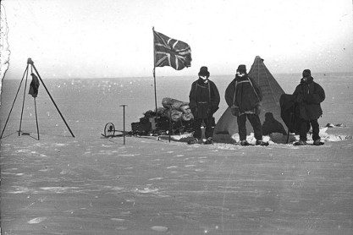

_______________________________________________________

_______________________________________________________

_______________________________________________________

_______________________________________________________

­­­­_______________________________________________________

__________________________________________________________________________________________

__________________________________________________________________________________________

__________________________________________________________________________________________

__________________________________________________________________________________________

__________________________________________________________________________________________

__________________________________________________________________________________________

__________________________________________________________________________________________

__________________________________________________________________________________________

__________________________________________________________________________________________

__________________________________________________________________________________________

__________________________________________________________________________________________

__________________________________________________________________________________________

__________________________________________________________________________________________

__________________________________________________________________________________________

__________________________________________________________________________________________

__________________________________________________________________________________________

__________________________________________________________________________________________

__________________________________________________________________________________________

__________________________________________________________________________________________

__________________________________________________________________________________________

__________________________________________________________________________________________

__________________________________________________________________________________________

# **H/W TASK SEVEN**

Look again at your H/W for task six – the creative writing account of reaching the North Pole.

Pick three words that you have specifically chosen in your writing to create an effect and provide three reasons why you have used the word. The first is done as an example for you.

|  |  |
| --- | --- |
| **Word:** grasped  **Reason 1:** I chose this word because it shows how difficult it was to grab the flag with icy fingers.  **Reason 2:** It also suggests how desperate I was to not let go and cling on  **Reason 3:** It also conveys the idea of how relieved I was to plant the flag. | **Word:**  **Reason 1:**  **Reason 2:**  **Reason 3:** |
| **Word:**  **Reason 1:**  **Reason 2:**  **Reason 3:** | **Word:**  **Reason 1:**  **Reason 2:**  **Reason 3:** |

# **H/W TASK EIGHT**

Research your own Explorer and prepare to talk to a class mate about this person. Try to pick someone who is not very well known so avoid people like Captain Scott, Marco Polo, Captain Cook, Edmund Hillary or Christopher Columbus.

Knowledge dump – write down all your notes about this person

5 Interesting Facts to Share with a Class Mate



What would be a good title for this person’s autobiography? Be creative and make the title link to their life and achievements.