

Resource Booklet

Name: __________________________________

**Jamila Gavin Interview**

**What made you write Coram Boy?**

A passing reference to a “Coram Man” trading in children in the eighteenth century, triggered a story which, the more I researched the history, the more I felt compelled to write. There also seemed to be so many resonances with the present day, so that I didn’t feel I was simply writing about the past.

**How much is true and how much is fictional?**

Captain Thomas Coram was a real man, whose foundation for the protection of abandoned or needy children exists to the present day. The plight of unwanted children and their exploitation was true. The composer, Handel, was indeed a patron, and “Messiah” was performed as a benefit for the Coram Foundation – as it still is today. The fiction lay in my creation of a family, and a set of characters playing out a fictional story set against this truth.

**How has your experience of different cultures in India and England influenced your writing?**

When I was trying to make sense of eighteenth century England, I realised that the India I grew up in was my way into understanding it. England was very class delineated, with very powerful social attitudes towards people who fell by the wayside, and where children were not seen as being the responsibility of society – except in the most minimal way. Likewise, India has much child labour and exploitation, and where women, in particular, are very vulnerable. Poorer Indian children have to pull their weight from the moment they can walk, and huge numbers of women and children who become destitute, are thrown out onto whatever resources they can muster, with little help from anybody.

**Why did you choose to write for children?**

I have always written for children, and it was the plight of children which attracted me to the Coram story. So although Coram Boy is a grim account involving the adult world, it was how children fared in that world which I wanted to write about, and with whom I felt the young reader would identify.

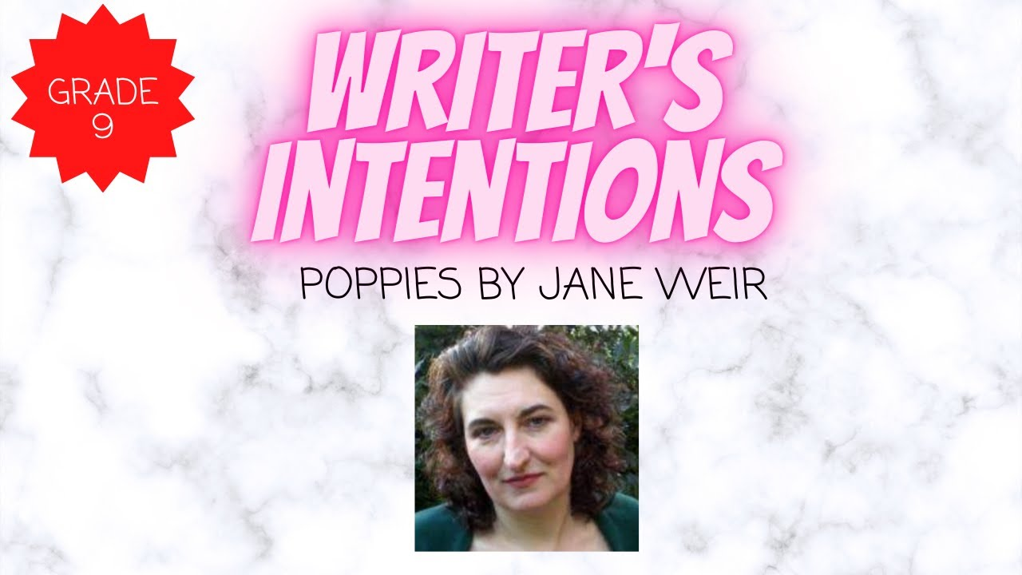**What do you think this phrase means?**

**Jamila Gavin Interview Tasks**

1. Each box around the text is connected to a highlighted word. Find the definition for each of those words. In the box note down a definition in your own words and then add a little image to help you remember what the word means.
2. **CORE:** Write a sentence using three of the words

**CHALLENGE:** Write at least one sentence using five of the words

**SUPER CHALLENGE:** Write a short paragraph using all of the words

1. Answer the following questions:
2. Does the writer view ‘Coram Boy’ as simply a story from the past?
3. Is any of ‘Coram Boy’ true? If so, what parts of it?
4. What is Jamila Gavin’s connection with India?
5. What has she seen taking place in India?
6. Why has Jamila Gavin chosen to write this as a children’s story?
7. Write a paragraph summarising what you think Jamila Gavin’s **intentions** were when writing this story.
8. Bullet point three predictions you have for the play



**Thomas Coram and the Foundling Hospital**

**___________________________________**

Thomas Coram had a vision for abandoned, ‘foundling’ children: that they should be cared for and educated so that, ultimately, they could support themselves.

Babies of unmarried mothers or very poor parents who could not care for them were frequently abandoned or left to die.

Some people were opposed to the idea of providing any care for these children as the view was that this would encourage acceptance ‘immorality’. A man named Thomas Coram had a very different view, and had compassion for the mothers and the children. From the outset, his aim was to provide the opportunity for the mothers to resume a ‘useful life’ in the world, as well as to provide care and a future life for the children.

As an experienced campaigner, Coram knew the importance of making his radical idea for a foundling hospital acceptable to supporters. His campaign not only outlined the plight of foundling children, but also the benefits to society of removing them from the streets and creating ‘useful’ citizens.

Thomas Coram dedicated 17 years to campaigning for the Foundling Hospital to be built. His campaign picked up pace when he engaged ‘21 ladies of distinction‘ – after powerful men in society had initially refused to support his plan – and the king signed the Foundling Hospital Charter in October 1739. Things began to move quickly after this – a large board of wealthy and influential Governors and Guardians was drawn up.

**___________________________________**

While the Governors set to work on their plans for the new hospital, the first children were admitted on 25 March 1741 to a temporary house with a capacity for 30 children.

The governors felt that 60 children would be the maximum limit they could admit, which led to restrictions on admissions, which initially included babies being required to be under two months old and free from disease.

Mothers were encouraged to leave a distinguishing token – such as a marked coin, trinket, or scrap of fabric – as an identifier should they ever be in a position to come back and reclaim their child.

The children were baptised and given a new name. It was thought that a completely new start would give them the best chance of a good life. It was also important for the mothers to assure them of confidentiality so that they could rebuild their lives.

Once received, children were sent to be wet-nursed with foster families in the countryside, a system introduced where they stayed until they were about five years old. At the age of 16, girls were generally apprenticed for domestic service; at 14, boys were apprenticed into a variety of occupations, typically for seven years, and many were trained for military service.

In September 1742, the building of a new hospital began in Bloomsbury. It was designed in plain brick with two wings – one each for boys and girls – and a chapel.

Meanwhile, applications by mothers for their babies to be admitted to the Foundling Hospital soon far outstripped the places available. Demand was so great that a lottery system was introduced. Mothers were asked to draw coloured balls from a bag. If they picked a white ball, their infant was provisionally admitted; if they picked a red one, they could wait and see if one of the infants already accepted turned out to be ineligible because of an infectious illness. A black ball meant outright rejection.

**___________________________________**

In 1756, the Government offered a grant so that more children could be received into the Foundling Hospital without the need for a lottery system. This funding was conditional on the Hospital accepting all children referred and was one of the most challenging periods of the organisation’s history as the governors struggled to cope with the growing number of admissions.

Several new branches of the hospital were temporarily opened to cope with the large number of children during this period, which was called ‘General Admission’, as any child could be admitted.

During the four years of general reception, mortality rates in the Hospital increased to 81% compared to 45% before admission was opened up and the mortality rate of children wet nursed in the countryside doubled.

The funding from the Government proved inadequate to enable Governors to provide a reasonable level of care for so many, and in February 1760 the grant was ended. The Hospital was unable to take many new children for some years.

**___________________________________**

In 1801, the Governors changed the objective of caring for exposed and deserted children to that of caring for illegitimate children. They were admitted only if their mothers made a sufficiently strong case for their ability to make a new start in life. The children still went to foster mothers during their early years, returning to London for schooling at the hospital and moving on to apprenticeships.

Much of Hospital life continued comparatively unchanged, despite attempts to reform aspects of the governance of the institution. In December 1807 it is documented that 13 pupils asked if the rules could be changed so that mothers and children could ‘preserve a mutual knowledge of each other’. However the Governors decided that this was ‘incompatible’ with the founding principles of the organisation.

A principle was appointed to the girls’ school in 1852, and in her report to the General Committee she raised concerns about the unsatisfactory education of the girls, poorly trained staff and poor accommodation. The governors accepted the report, and made changes to the timetable, brought in training for infant school teachers and improved bathing and toilet facilities.

A library was created in 1836 for older boys and by the 1850s English grammar, geography, reading, writing and arithmetic were all part of the curriculum. From the 1850s the children’s clothes were no longer made within the Hospital as part of training for boys, as tailoring was deemed to be harmful to the health of the young trainees.

Few mothers were reunited with their children, despite records showing a large number of enquiries from mothers about their child’s welfare. Similarly, the Annual Report of 1898 states ‘many applications are received from persons anxious to adopt children, but these are not entertained’. It was not until well into the next century that significant advances were made to reform the organisation, alongside changes in society’s views of unmarried mothers and an emerging understanding of child development.

**Thomas Coram and the Foundling Hospital: Comprehension Test**

|  |  |  |
| --- | --- | --- |
|  | **Question:** | **Answer:** |
| **1** | What year was the Foundling Hospital created? |  |
| **2** | How many years did it take Thomas Coram? |  |
| **3** | What does the word ‘campaigning’ mean? |  |
| **4** | Who did Thomas Coram get to finally back his idea? |  |
| **5** | What type of person would be likely to put their baby into the hospital? |  |
| **6** | What was the rules for putting your baby into the hospital to start with? |  |
| **7** | Why did mothers leave ‘distinguishable tokens’? |  |
| **8** | What could an example of these tokens be? |  |
| **9** | How were babies chosen to get one of the limited spaces? |  |
| **10** | What does ‘apprenticed’ mean? |  |
| **11** | What age were boys apprenticed? |  |
| **12** | What age were girls apprenticed? |  |
| **13** | What was made available for just the older boys? |  |
| **14** | Why did the hospital have two wings? |  |
| **15** | What were the conditions for the government providing funding? |  |
| **16** | Why did this stop? |  |
| **17** | What improvements were made in the 1800s? |  |
| **18** | How successful was reuniting mothers with the children in the foundling hospital? |  |
| **19** | Were many of the children adopted? |  |
| **20** | Did creating this hospital change opinions of unmarried women having children? |  |

**End of lesson Quiz**: Each lesson create a quiz about what has happened in that section of the play.

|  |  |
| --- | --- |
| **Date: Pages: Scenes:** | **Date: Pages: Scenes:** |
|  |  |
| **Date: Pages: Scenes:** | **Date: Pages: Scenes:** |
|  |  |
| **Date: Pages: Scenes:** | **Date: Pages: Scenes:** |
|  |  |
| **Date: Pages: Scenes:** | **Date: Pages: Scenes:** |
|  |  |

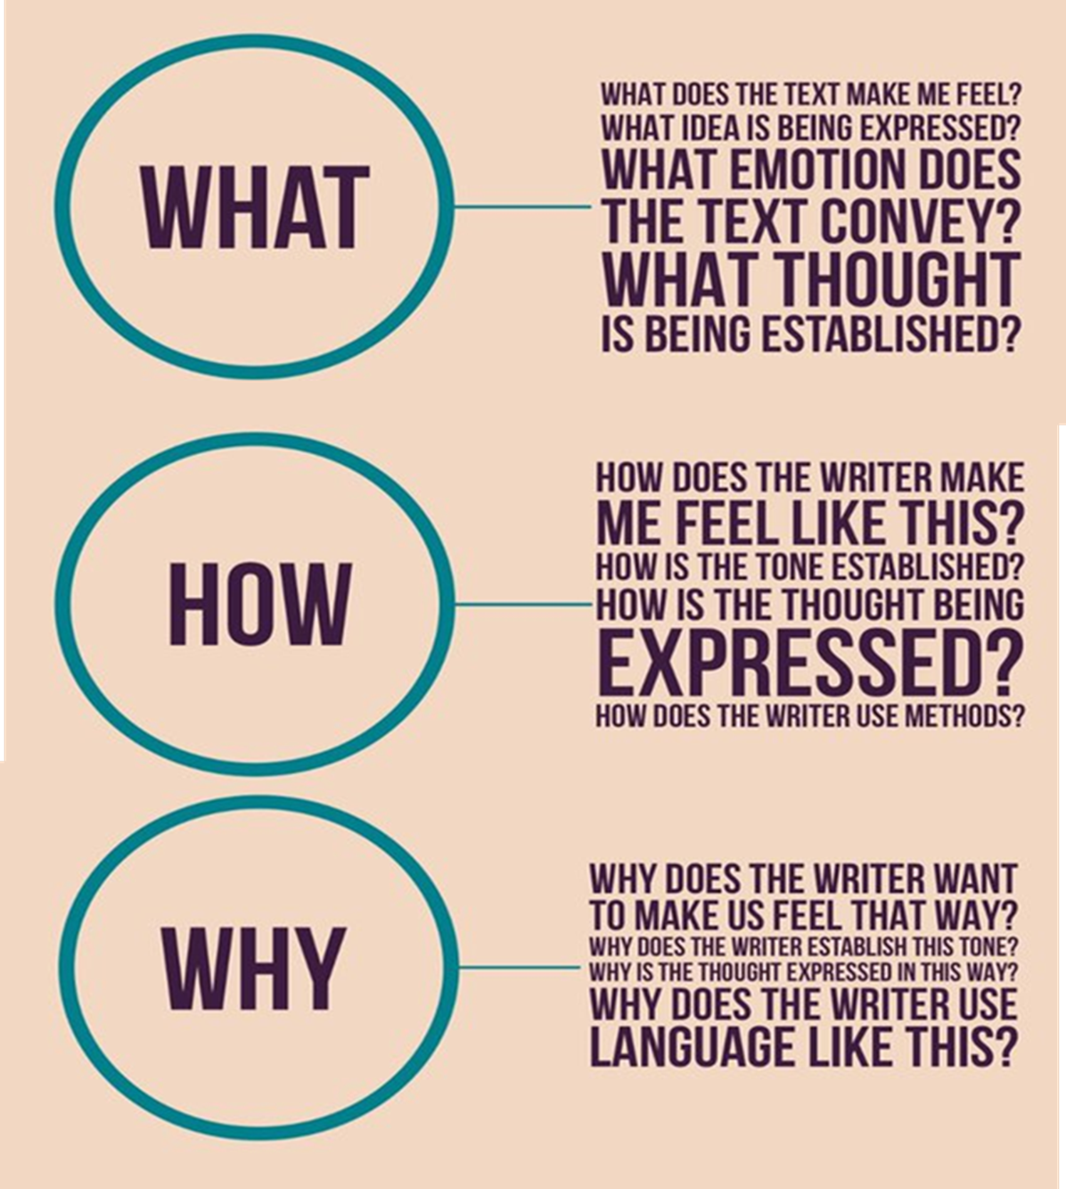

**Character Focus: Melissa Milcote**





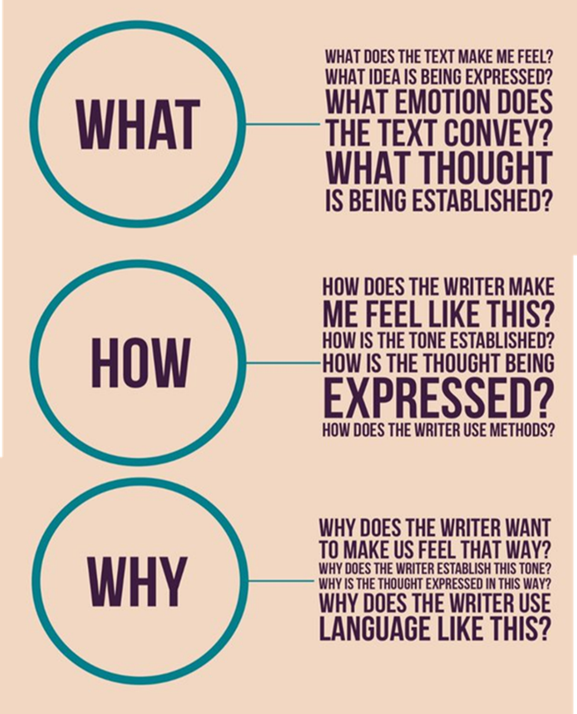**What do you think about Melissa at this point in the play?**

___________________________________________________________________

___________________________________________________________________

**How has the writer created this impression?**

___________________________________________________________________

___________________________________________________________________

**Why do you think she wants us to know this information?**

___________________________________________________________________

___________________________________________________________________

___________________________________________________________________

**End of Act One:** Storyboard the events of Act One, add a quote or brief note/ caption to help understand what you have drawn.(You’ll have to work out how to split into eight key parts)

|  |  |  |  |
| --- | --- | --- | --- |
|  |  |  |  |
|  |  |  |  |
|  |  |  |  |
|  |  |  |  |

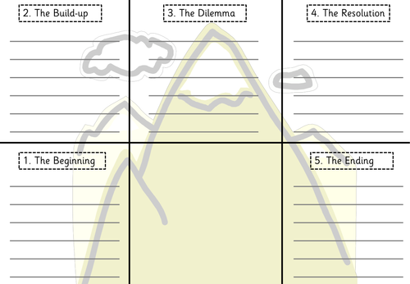Core Task: Dramatic Writing

**What is the scene and what happens in it?**

Finsihed your story? Use the guide below to edit and improve.

**Purple Pen for Polishing:**

1. **Vocab:** Read through and circle any words which are a bit basic, repeated, or just need changing. *E.g. ‘running quickly’ to ‘running frantically’*
2. **Sentence Types:** Read through and break up long sentences so you have a good mix of minor (one word) and simple (short, one piece of info and not connective.) *E.g. The ground was welcoming and soft’ to ‘Soft. Welcoming. He didn’t want to get off the ground’*
3. **Sentence Structure:** Read through and mix up your clauses, so you use adverbs at the start, *e.g. ‘desperately, he clambered back up, hoping he could go on’*
4. **Punctuation:** Count how many different punctuation marks you have used. Then add in more so you have at least four (!?”,;:.-’) *E.g. ‘He was in pain and didn’t know if he could go on’ to ‘The pain! Could he even go on?’*
5. **Adverbs and Adjectives:** Go through and count up how many adjectives and adverbs you have used. Then you need to see where you could add adjectives (so every time a person, place or thing has been mentioned) and adverbs (every time a movement of a person or thing has been mentioned.) E.g. *‘She cautiously stepped up to the peeling, ancient wooden door’*
6. **Paragraphs:** You may not think there’s much you can do about paragraphs but you can add interest to a piece by creating single word or single sentence paragraphs to emphasise a piece of information. It can also create a pause. E.g. ‘He looked over the edge. // Nothing.//’
7. **SOSMAPS:** Read through and underline/ tick every time you have used one of the SOSMAPS techniques listed below. Find one example from each in your writing and copy out below. Which is your favourite and why?

|  |  |  |  |
| --- | --- | --- | --- |
|  |  | **How many times have you used this method?** | **Example?** |
| S | Simile |  |  |
| O | Onomatopoeia |  |  |
| S | Sense |  |  |
| M | Metaphor |  |  |
| A | Alliteration |  |  |
| P | Personification |  |  |
| S | Sentence types |  |  |

1. Finally, swap books with another student and read through each other’s work. Put a WWW and HTI into their booklet and ask them to do the same for you below.

WWW: ______________________________________________________________________________

_____________________________________________________________________________________

HTI: _________________________________________________________________________________

_____________________________________________________________________________________

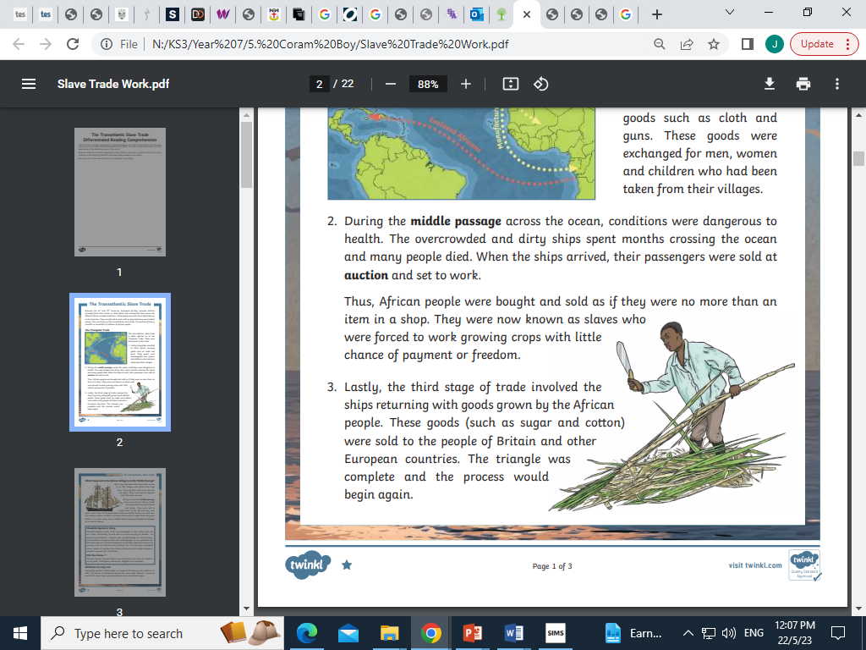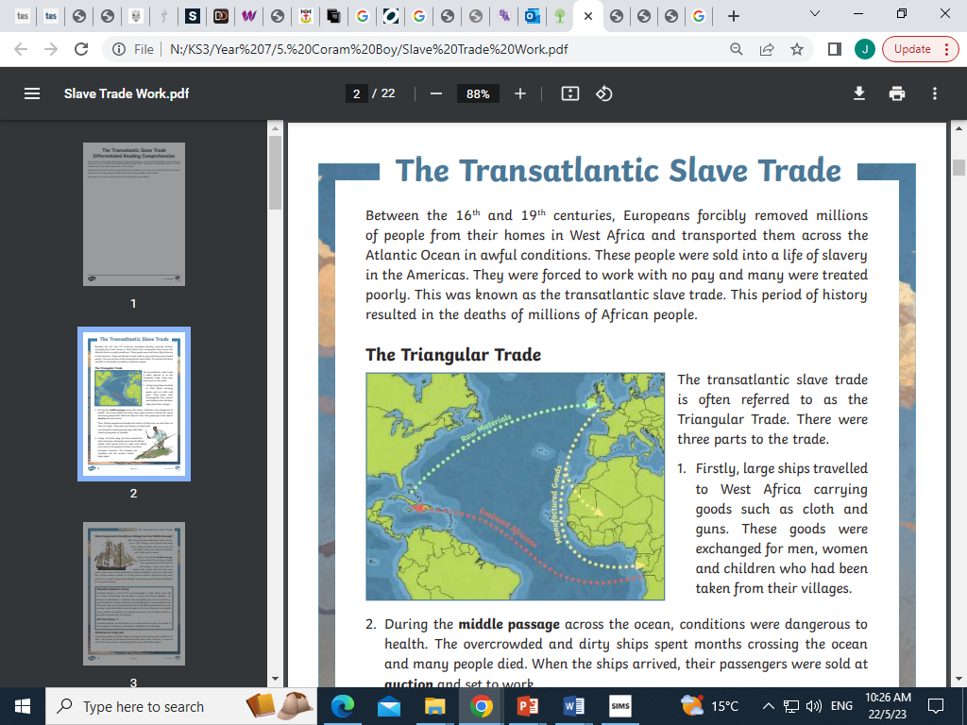

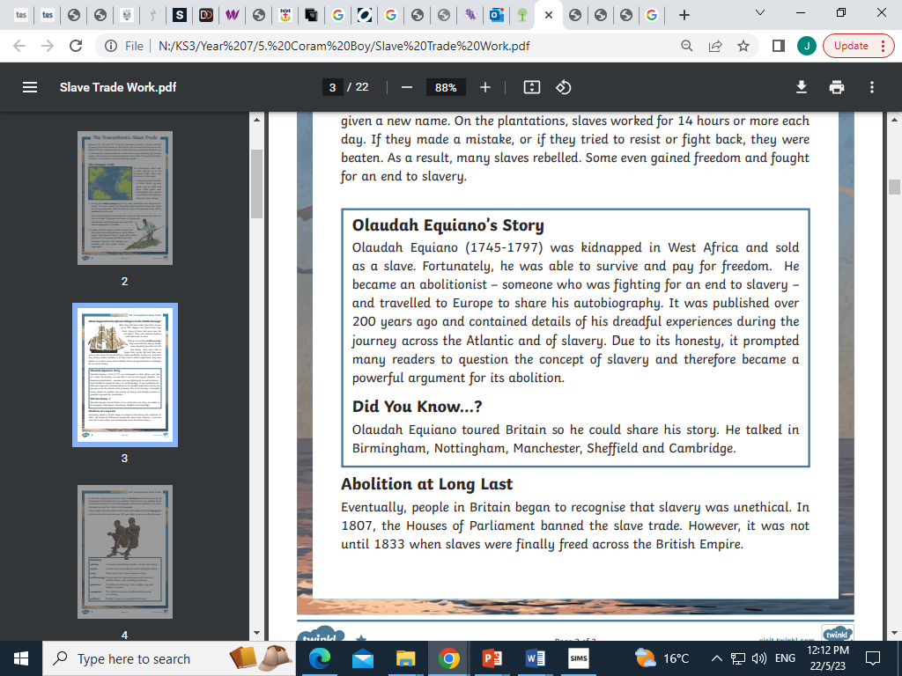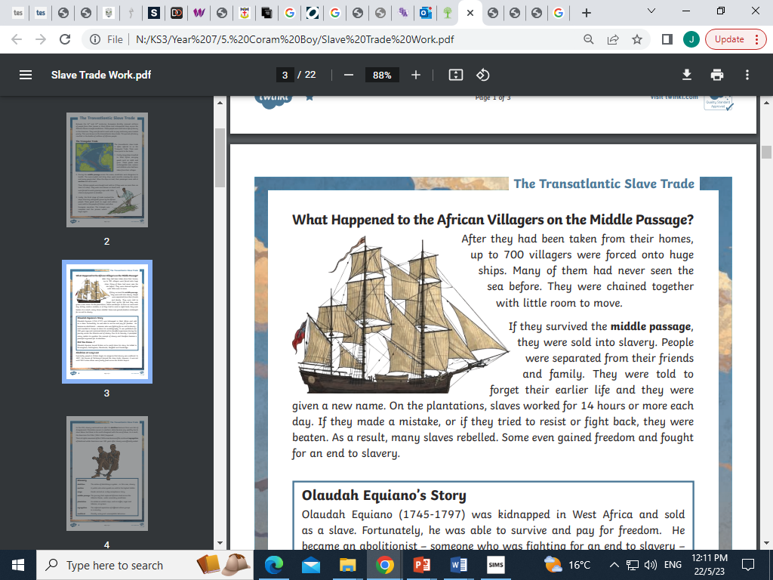

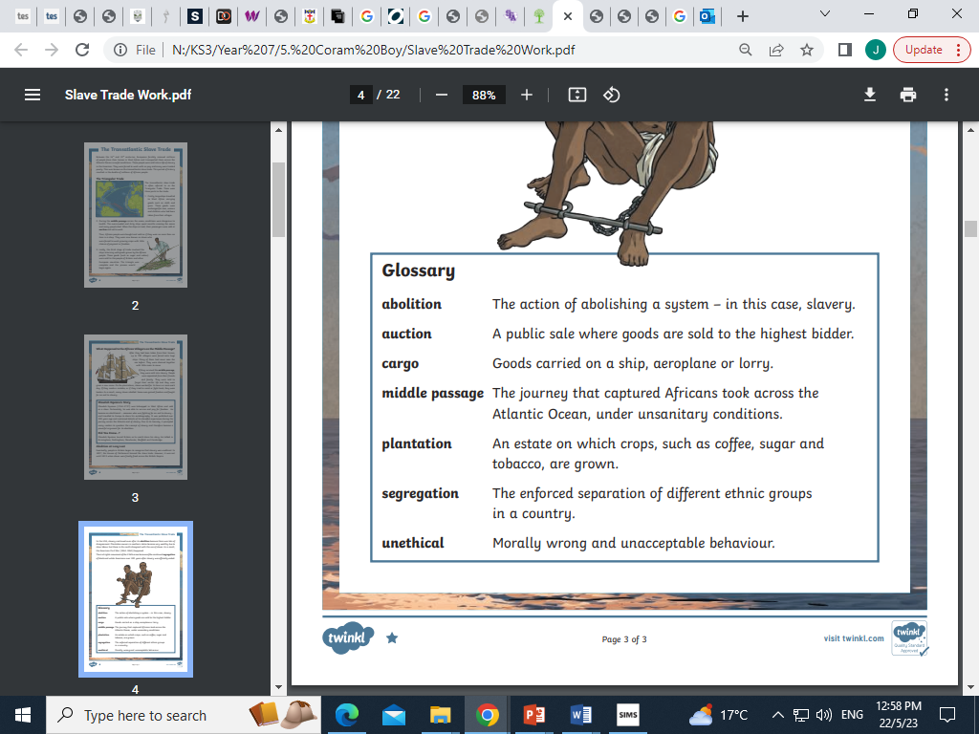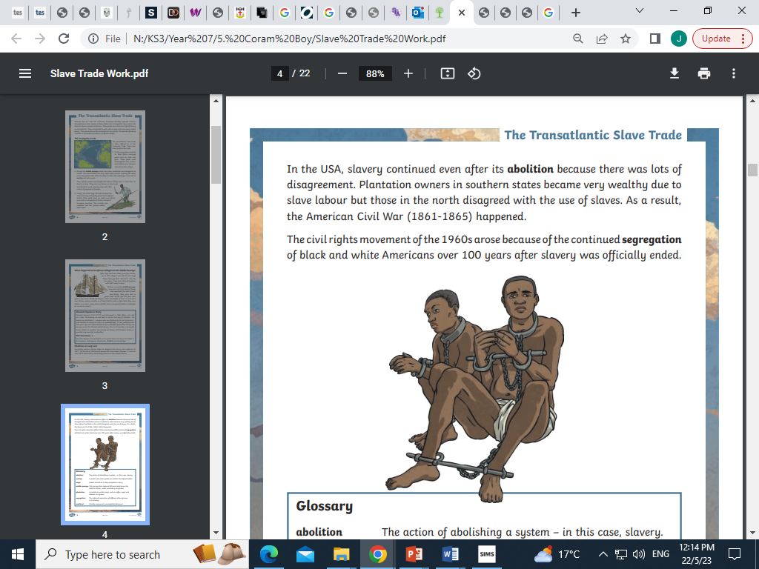

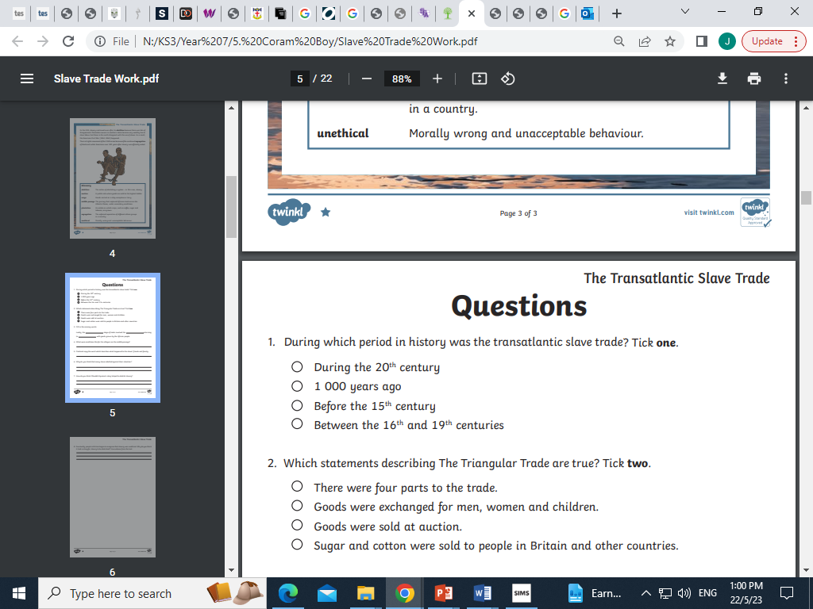

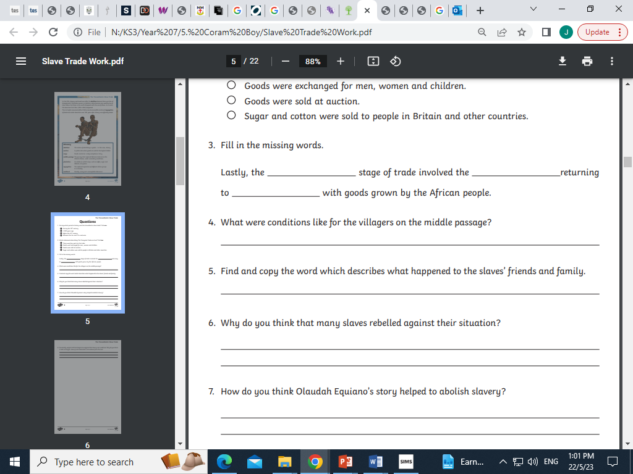

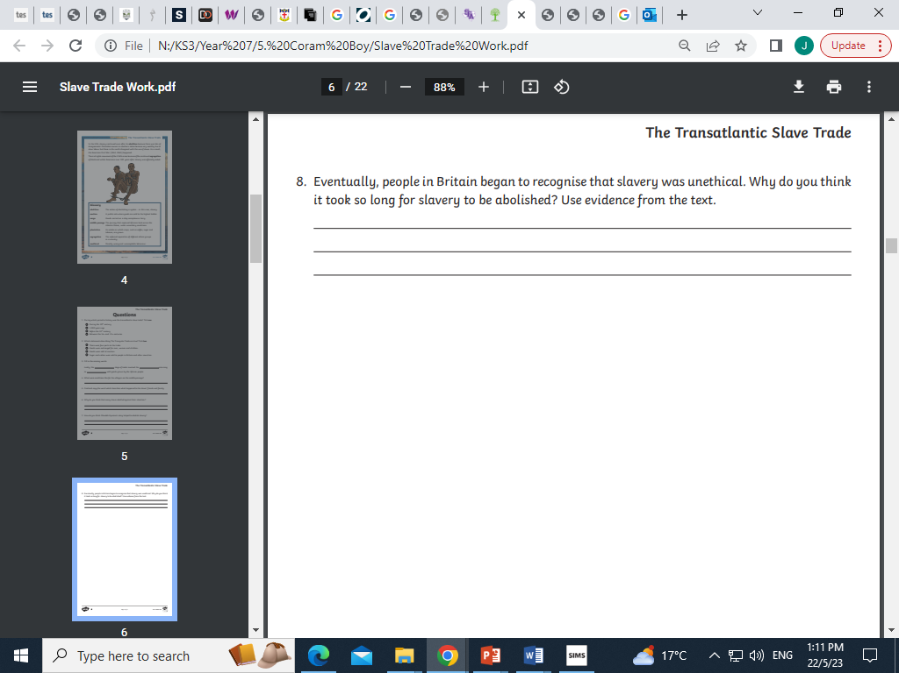

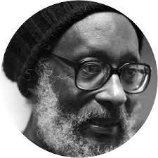

**‘Limbo’**

**by Edward Kamu Brathwaite**

And limbo stick is the silence in front of me

limbo

limbo

limbo like me

limbo

limbo like me

long dark night is the silence in front of me

limbo

limbo like me

stick hit sound

and the ship like it ready

stick hit sound

and the dark still steady

limbo

limbo like me

long dark deck and the water surrounding me

long dark deck and the silence is over me

limbo

limbo like me

stick is the whip

and the dark deck is slavery

stick is the whip

and the dark deck is slavery

limbo

limbo like me

drum stick knock

and the darkness is over me

knees spread wide

and the water is hiding

limbo

limbo like me

knees spread wide

and the dark ground is under me

down

down

down

and the drummer is calling me

limbo

limbo like me

sun coming up

and the drummers are praising me

out of the dark

and the dumb gods are raising me

up

up

up

and the music is saving me

hot

slow

step

on the burning ground.

This poem uses the dialect of the Caribbean. Limbo is not only the title of this poem, but also a lively dance in which the dancers pass under a horizontal.

In this poem the limbo stick is a metaphor for slavery; for the ship in which the future slaves travelled, for the whip that punishes them.

The title ‘Limbo’ is a pun. As well as a dance, limbo it is another word for purgatory, the state of existing on the edge of hell, suffering penance before being admitted to heaven

**Structure**  
The poem is divided into uneven, short-lined stanzas. The is no rhyme scheme.

**Language and Imagery**  
The voice is the first person singular ‘I’, but it represents the terrible experience of all native Africans captured and transported to America and the West indies as slaves.

The rhythms and abbreviated grammar of the dialect are captured, so that the reader identifies closely with the speaker.

The imagery of the limbo stick is powerful, representing slavery and also hope.

Match then sentence halves together and copy them into your exercise book.

Sentence endings

* 1. a drum.
  2. as a way of punishing the slaves.
  3. two reasons.
  4. a long sentence.
  5. the stick.
  6. repetition
  7. to use in the limbo dance.
  8. strong rhythm.
  9. from Africa.
  10. the slave trade.
  11. work on a farm in America

Sentence Starters

1. The poem is about….
2. The slaves have come ……
3. They are going to …….
4. The stick is used for …….
5. The first is ……….
6. The second is ……..
7. Each verse of the poem starts with …….
8. This symbolizes the …….
9. There is lots of ……
10. This gives the poem a …….
11. This sounds like ……

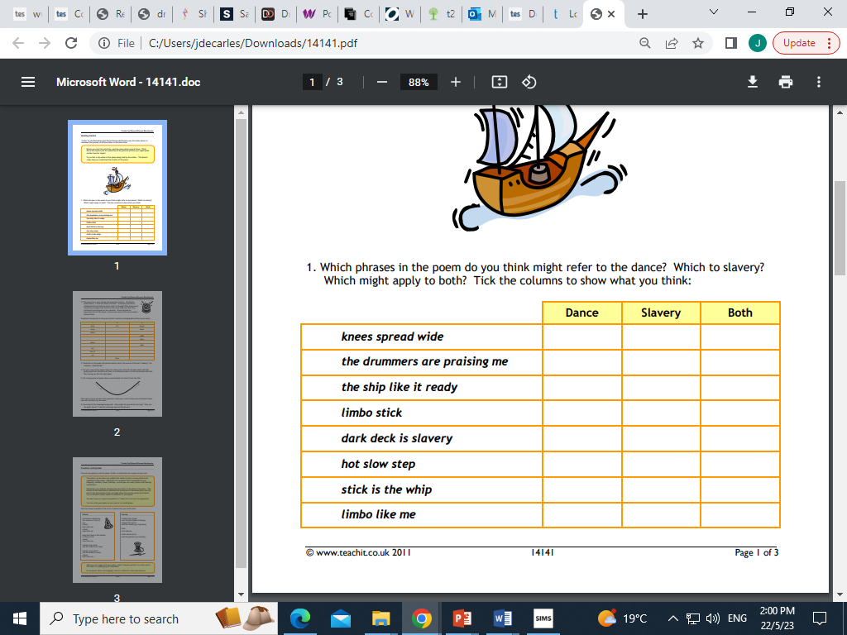

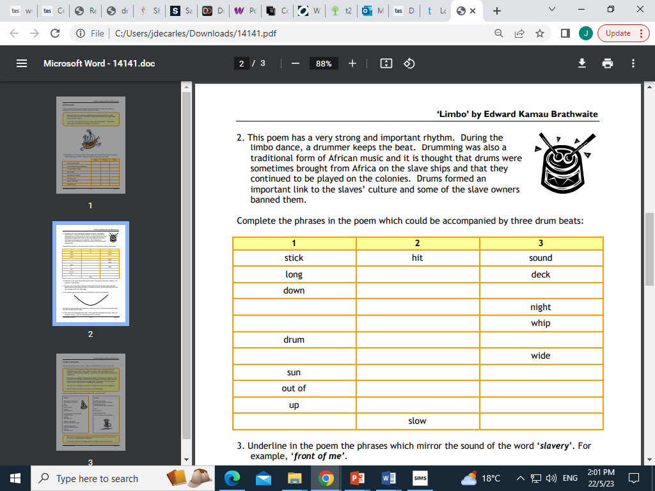

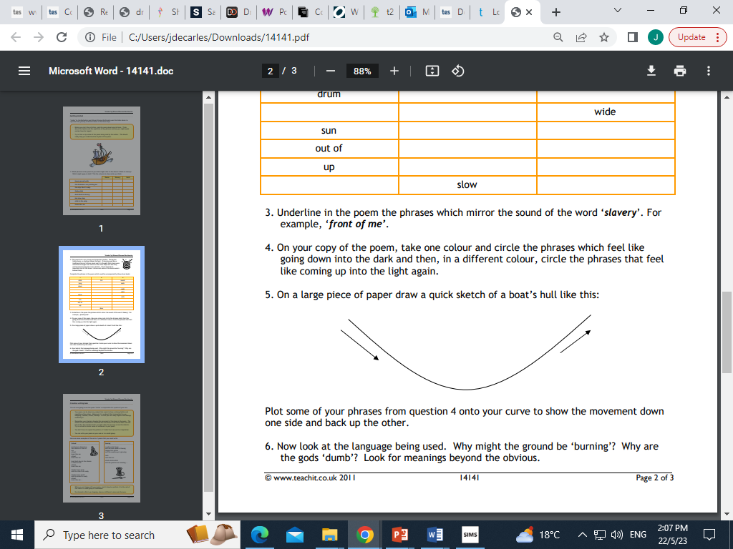

Deeper thinking:

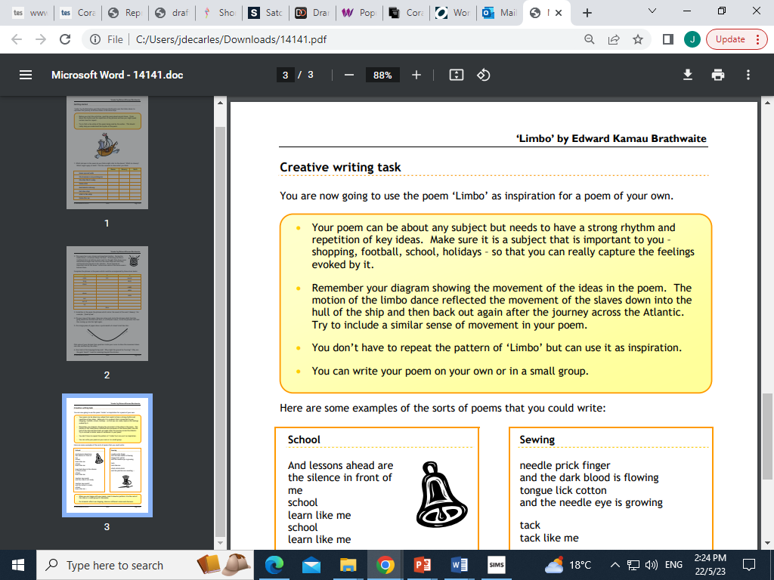

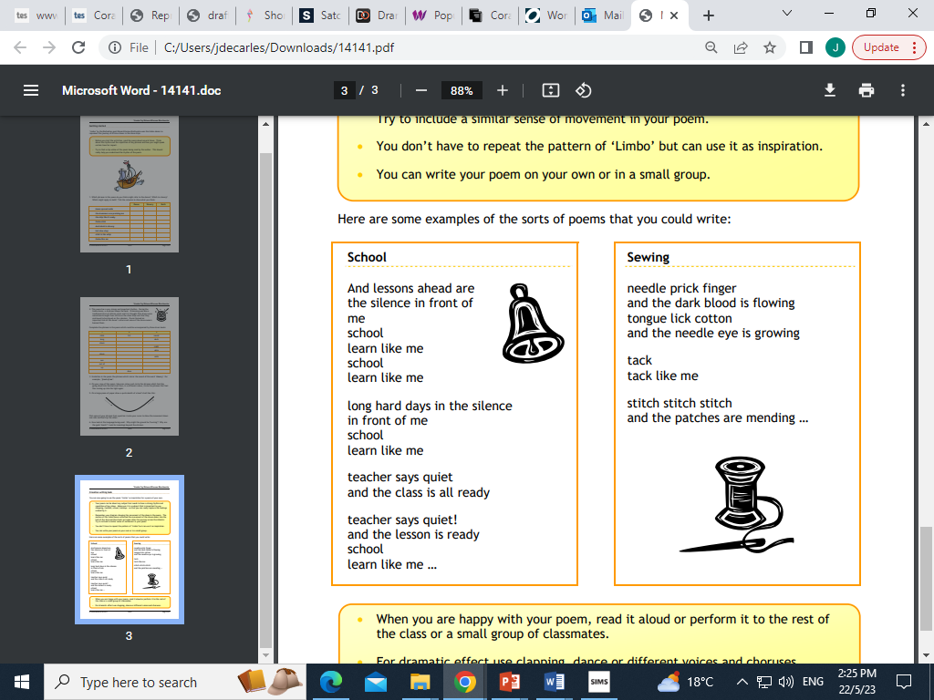

**Final Task: Performance and Hotseat**

For your final task of this unit you will be working in small groups to present an extract from the play, taking on one particular character which we will then ‘hot seat.



What is character hot seating?

Hot-seating is a role-play style strategy in which a character or characters, played by the pupil, are interviewed by the rest of the group. The pupil answers in character, thinking about what that person would say and think.

**Assessment plan**

My group:

Scenes we will perform:

Notes for performance:

Notes on my character: