**Year 10 Spanish TERM 6: Lessons Outline**



* Pupils have 2 lessons of Spanish a week (one single and one double).
* Pupils have been given their own copy of the **GCSE Viva**  textbook they also have access to online resources to accompany the textbook https://pearsonactivelearn.com/
* For extension, they could also look at lessons on BBC Bitesize or Oak Academy where there are a range of topic areas to extend their learning. Pupils can also use the Linguascope (Username is kingshill, password is mfl123* ) or Quizlet websites
* **Extension task –** Pupils can also work on their GCSE speaking questions which are on the next page.
* **Homework** will be set on Satchel One/ Show my Homework.

|  |  |  |
| --- | --- | --- |
| **Week Beginning** | **Work Set**  **(Viva GCSE- Chapter 5 Ciudades continued)** | Link to pages in textbook  Or alternative activity |
| 6th June | **Los pros y los contras de la ciudad**  Talking about problems in a town  Using synonyms and antonyms | **P104-105**  Contact Mrs Leiva if you don’t have your textbook at home |
| 13th June | **Destino Arequipa**  Describing a visit in the past  Recognising and using idioms  Positional phrases for a photocard (page 111) | **P106-107**  Contact Mrs Leiva if you don’t have your textbook at home |
| 20th June | **Reading and listening focus week**  Go over skills for reading and listening exams and do the foundation specimen paper for each. | **Contact Mrs Leiva for specimen papers** |
| 27th June | **WORK EXPERIENCE WEEK** |  |
| 4th July | **Speaking focus week**  Ensure all answers are completed in the speaking books which have been looked at so far. Improve answers where necessary. Make revision resources. | All of the speaking questions are on the next page of this document. |
| 11th July | **Speaking focus week**  Go over some practice roleplays and photocards. | There are some roleplays and photocards at the end of this document. |
| 18th July | **Revision of vocabulary studied so far this year** | Read through the vocab pages for chapters 1-5 in your textbook. The vocabulary pages are also in the pupil work area. |

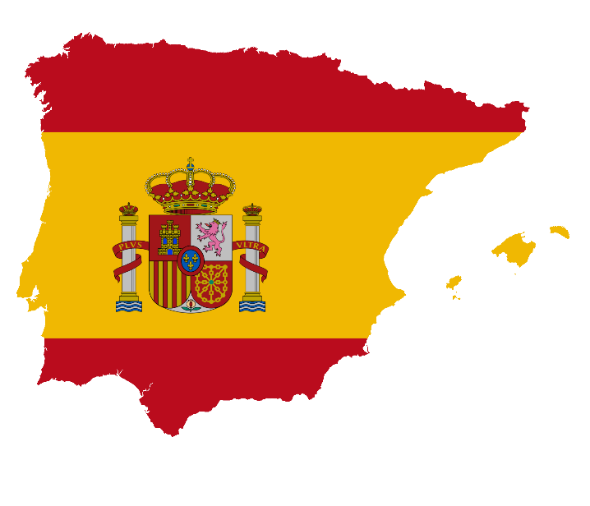

**GCSE Spanish Speaking Booklet**

**Theme 1 Module 3 – Me, my family and friends; Technology in everyday life**

1. ¿Cómo es tu mejor amigo/a descríbelo/a:

……………………………………………………………………………………………………………………………………………………………………………………………………………………………………………………………………………………………………………………………………………………………………………………………………………………………………………………………………………………………………………………

1. ¿Qué planes tienes para el futuro en tu vida personal?

……………………………………………………………………………………………………………………………………………………………………………………………………………………………………………………………………………………………………………………………………………………………………………………………………………………………………………………………………………………………………………………

1. ¿Cómo usaste las redes sociales el fin de semana pasado?

……………………………………………………………………………………………………………………………………………………………………………………………………………………………………………………………………………………………………………………………………………………………………………………………………………………………………………………………………………………………………………………

1. ¿Te llevas bien con tu familia? ¿Por qué (no)?

……………………………………………………………………………………………………………………………………………………………………………………………………………………………………………………………………………………………………………………………………………………………………………………………………………………………………………………………………………………………………………………

……………………………………………………………………………………………………………………………………………………………………………………………………………………………………………………………………………………………………………………………………………………………………………………………………………………………………………………………………………………………………………………

**Module 4 – Free-time activities (music, cinema and TV, sport)**

1. ¿Qué sueles hacer en tus ratos libres?

……………………………………………………………………………………………………………………………………………………………………………………………………………………………………………………………………………………………………………………………………………………………………………………………………………………………………………………………………………………………………………………

1. ¿Qué película viste la semana pasada? Descríbela

……………………………………………………………………………………………………………………………………………………………………………………………………………………………………………………………………………………………………………………………………………………………………………………………………………………………………………………………………………………………………………………

1. Háblame de un concierto al que vas a ir en el futuro.

……………………………………………………………………………………………………………………………………………………………………………………………………………………………………………………………………………………………………………………………………………………………………………………………………………………………………………………………………………………………………………

1. ¿Qué deportes te gustaría practicar en el fututo? ¿Por qué?

……………………………………………………………………………………………………………………………………………………………………………………………………………………………………………………………………………………………………………………………………………………………………………………………………………………………………………………………………………………………………………………

1. ¿Qué deportes solías practicar cuando eras niño/a?

……………………………………………………………………………………………………………………………………………………………………………………………………………………………………………………………………………………………………………………………………………………………………………………………………………………………………………………………………………………………………………………

**Module 6 –Festivals and celebrations- Food and eating out**

1. ¿Qué te gusta comer? ¿Qué no te gusta comer ¿Por qué?

……………………………………………………………………………………………………………………………………………………………………………………………………………………………………………………………………………………………………………………………………………………………………………………………………………………………………………………………………………………………………………………

1. Háblame de una mala visita a un restaurante en el pasado

……………………………………………………………………………………………………………………………………………………………………………………………………………………………………………………………………………………………………………………………………………………………………………………………………………………………………………………………………………………………………………………

1. ¿Por qué son importantes las celebraciones tradicionales?

……………………………………………………………………………………………………………………………………………………………………………………………………………………………………………………………………………………………………………………………………………………………………………………………………………………………………………………………………………………………………………………

1. Háblame de una fiesta o celebración a la que te gustaría ir en el futuro y por qué

……………………………………………………………………………………………………………………………………………………………………………………………………………………………………………………………………………………………………………………………………………………………………………………………………………………………………………………………………………………………………………………

**Theme 2**

**Module 1 – Holidays**

1. ¿Qué haces en tus vacaciones normalmente?

……………………………………………………………………………………………………………………………………………………………………………………………………………………………………………………………………………………………………………………………………………………………………………………………………………………………………………………………………………………………………………………

1. ¿Adónde fuiste de vacaciones el año pasado?

……………………………………………………………………………………………………………………………………………………………………………………………………………………………………………………………………………………………………………………………………………………………………………………………………………………………………………………………………………………………………………………

1. ¿Adónde te gustaría ir de vacaciones el año próximo?

……………………………………………………………………………………………………………………………………………………………………………………………………………………………………………………………………………………………………………………………………………………………………………………………………………………………………………………………………………………………………………………

1. ¿Cuáles serían tus vacaciones ideales? Descríbelas

……………………………………………………………………………………………………………………………………………………………………………………………………………………………………………………………………………………………………………………………………………………………………………………………………………………………………………………………………………………………………………………

**Module 5 – Home, town, neighbourhood and region**

1. Describe la ciudad o el pueblo dónde vives

……………………………………………………………………………………………………………………………………………………………………………………………………………………………………………………………………………………………………………………………………………………………………………………………………………………………………………………………………………………………………………………

1. ¿Qué cosas cambiarías de tu ciudad? ¿Por qué?

……………………………………………………………………………………………………………………………………………………………………………………………………………………………………………………………………………………………………………………………………………………………………………………………………………………………………………………………………………………………………………………

1. ¿Cuál es la ciudad más bonita que has visitado en el Reino Unido? ¿Por qué?

……………………………………………………………………………………………………………………………………………………………………………………………………………………………………………………………………………………………………………………………………………………………………………………………………………………………………………………………………………………………………………………

1. ¿A dónde te gustaría vivir en el futuro? ¿Por qué?

……………………………………………………………………………………………………………………………………………………………………………………………………………………………………………………………………………………………………………………………………………………………………………………………………………………………………………………………………………………………………………………

**Module 8 – Home and global issues- El medio ambiente**

1. ¿Cómo te vas a mantener saludable en el futuro?

……………………………………………………………………………………………………………………………………………………………………………………………………………………………………………………………………………………………………………………………………………………………………………………………………………………………………………………………………………………………………………………

1. ¿Qué haces en casa para proteger el medio ambiente?

……………………………………………………………………………………………………………………………………………………………………………………………………………………………………………………………………………………………………………………………………………………………………………………………………………………………………………………………………………………………………………………

1. En tu opinión: ¿Cuáles son los problemas globales más serios hoy en día?

……………………………………………………………………………………………………………………………………………………………………………………………………………………………………………………………………………………………………………………………………………………………………………………………………………………………………………………………………………………………………………………

1. ¿Qué hiciste para proteger al medio ambiente el mes pasado?

……………………………………………………………………………………………………………………………………………………………………………………………………………………………………………………………………………………………………………………………………………………………………………………………………………………………………………………………………………………………………………………

**Theme 3 Module 2 – My studies; Life at school/college**

1. Describe tu instituto y sus instalaciones

……………………………………………………………………………………………………………………………………………………………………………………………………………………………………………………………………………………………………………………………………………………………………………………………………………………………………………………………………………………………………………………

1. ¿Qué asignaturas te gustan y no te gustan? ¿Por qué?

……………………………………………………………………………………………………………………………………………………………………………………………………………………………………………………………………………………………………………………………………………………………………………………………………………………………………………………………………………………………………………………

1. ¿Cómo era tu escuela primaria?

……………………………………………………………………………………………………………………………………………………………………………………………………………………………………………………………………………………………………………………………………………………………………………………………………………………………………………………………………………………………………………………

1. Describe un viaje escolar que vas a hacer con tu escuela en el futuro

……………………………………………………………………………………………………………………………………………………………………………………………………………………………………………………………………………………………………………………………………………………………………………………………………………………………………………………………………………………………………………………

**Module 7 – Education post-16; jobs, career choices and ambitions**

1. ¿Dónde hiciste tus prácticas laborales?

……………………………………………………………………………………………………………………………………………………………………………………………………………………………………………………………………………………………………………………………………………………………………………………………………………………………………………………………………………………………………………………

1. ¿Qué planes tienes para seguir estudiando en el futuro?

……………………………………………………………………………………………………………………………………………………………………………………………………………………………………………………………………………………………………………………………………………………………………………………………………………………………………………………………………………………………………………………

1. ¿En qué te gustaría trabajar en el futuro? ¿Por qué?

……………………………………………………………………………………………………………………………………………………………………………………………………………………………………………………………………………………………………………………………………………………………………………………………………………………………………………………………………………………………………………………

1. ¿Qué otras ambiciones tienes para el futuro?

……………………………………………………………………………………………………………………………………………………………………………………………………………………………………………………………………………………………………………………………………………………………………………………………………………………………………………………………………………………………………………………

**1. Me, my family and friends**

**FOUNDATION – Student’s card**

Your teacher will play the part of your Spanish friend and will speak first.

You should address your friend as tú.

When you see this – **!** – you will have to respond to something you have not prepared.

When you see this – **?** – you will have to ask a question

**Estás hablando con tu amigo español/tu amiga española sobre tu familia.**

* Tu familia – descripción.
* !
* Tus animales domésticos.
* Tu familia en el futuro.
* ? Hermanos/hermanas.

**1. Me, my family and friends**

**HIGHER – Student’s card**

Your teacher will play the part of your Spanish friend and will speak first.

You should address your friend as tú.

When you see this – **!** – you will have to respond to something you have not prepared.

When you see this – **?** – you will have to ask a question

**Estás hablando con tu amigo español/tu amiga española sobre tu familia.**

* Tu familia – descripción.
* !
* Actividad con tu familia – pasado.
* Tu familia en el futuro.
* ? Relación con familia.

**1. Me, my family and friends**

**Foundation – Student’s card**

* Look at the photo during the preparation period.
* Make any notes you wish to on an Additional Answer Sheet.
* Your teacher will then ask you questions about the photo and about topics related to **me, my family and friends.**

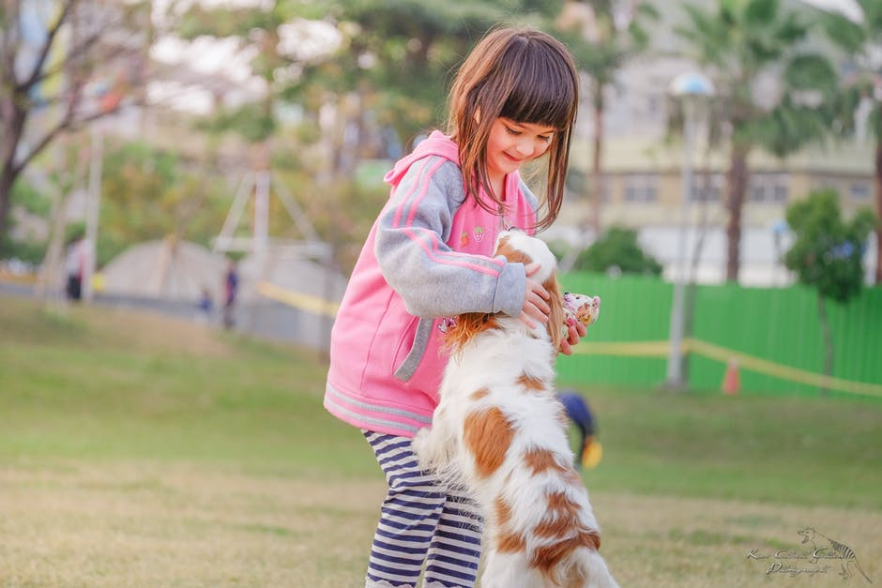

Your teacher will ask you the following three questions and then **two more questions** which you have not prepared.

* ¿Qué hay en la foto?
* ¿Tienes mascotas?

¿Qué hiciste con tu familia el fin de semana pasado?

**5. Home, town, neighbourhood and region – my home**

**Higher – Student’s card**

* Look at the photo during the preparation period.
* Make any notes you wish to on an Additional Answer Sheet.
* Your teacher will then ask you questions about the photo and about topics related to **home, town, neighbourhood and region.**



Your teacher will ask you the following three questions and then **two more questions** which you have not prepared.

* ¿Qué hay en la foto?
* ¿Quién cocina en tu casa?
* ¿Qué harás en tu casa hoy por la tarde?