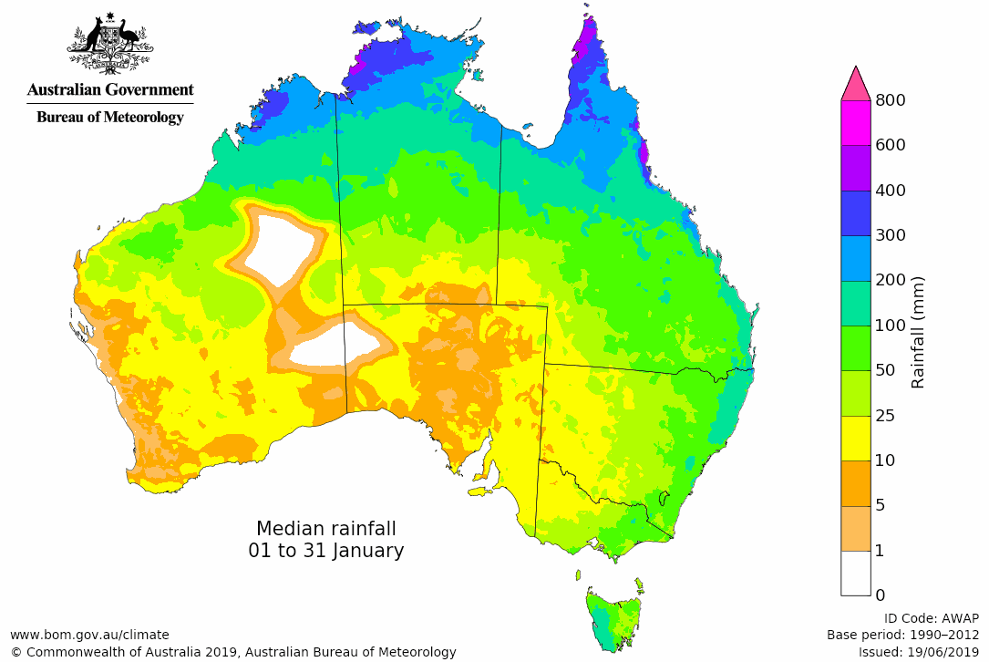
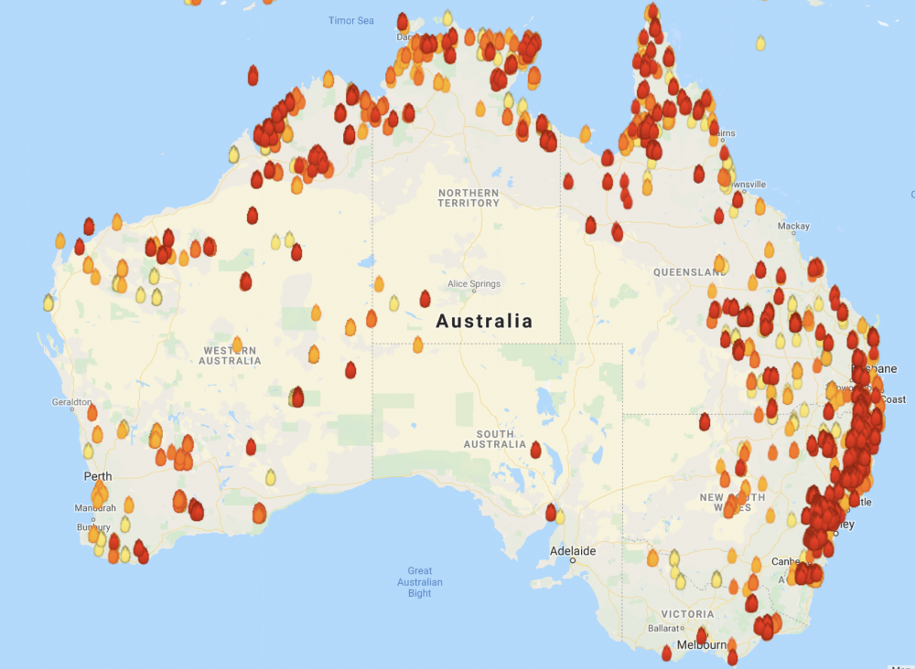

AUSTRALIA
BASIC FACTS

When: 11th November 2019

Where: Queensland, South Australia Tasmania and Western Australian

Why: Prolonged period of drought

Deaths: 29

Land
destroyed: 15.6 million acres.

CAUSES
(remember to think human and natural)

EFFECTS
(remember to think primary & secondary)
RESPONSES
(remember to think long and short-term)

