Year 8 Reading Recommendations

**You should be reading at least twenty minutes a day, so why not have a look at some of these and find your next favourite book?!**

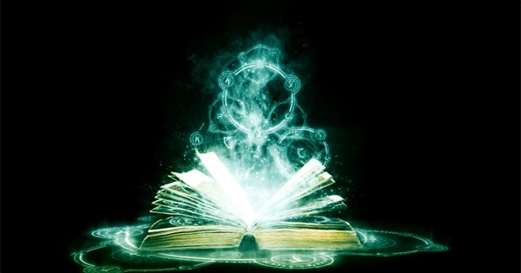

**Magic and fantasy:**

* *Percy Jackson and the Lightning Thief*
* The *Chrestomanci* series by Dianna Wynne Jones
* The *Divergent* series
* The *Eragon* Series
* *The Hitchhiker’s Guide to the Galaxy*

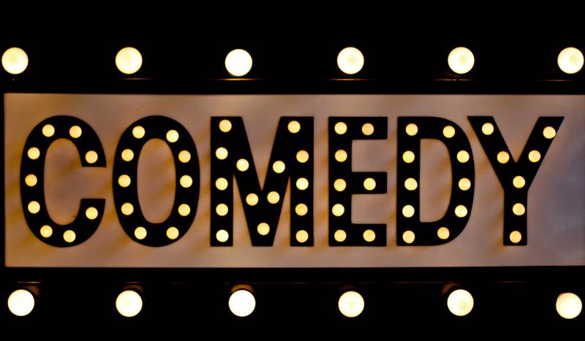

**Funny:**

* *Winger* by Andrew Smith
* *Pumpkinheads* by Rainbow Rowell
* *It Only Happens in the Movies* by Holly Bourne
* *The Absolutely True Diary of a Part Time Indian* by Sharman Alexie
* *Swim the Fly* by Don Calame

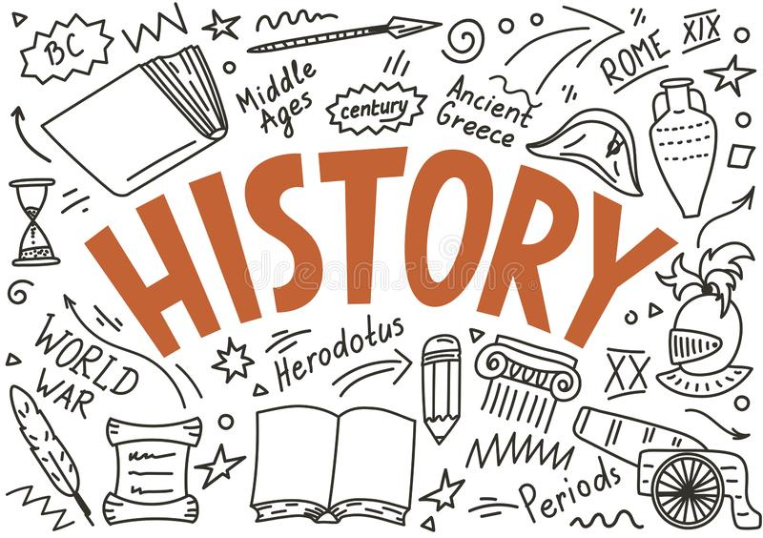

**History:**

* *Pirates!* and *Sovay* by Celia Rees
* *The Boy in the Striped Pyjamas* by John Boyle
* *The Kin* books by Peter Dickinson
* *Arthur, High King of Britain* by Michael Morpurgo
* *Ithaka* by Adele Geras

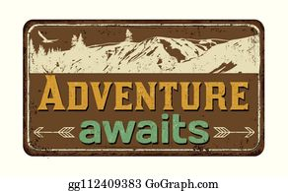

**Adventure:**

* *Alex Rider* series by Anthony Horowitz
* *The Secret garden* by Frances Hodgson Burnett
* *Journey to the River Sea* by Eva Ibbotson
* *Bridge to Terabithia* by Katherine Paterson
* *The Girl of Ink and Stars* by Kiran Millwood Hargrave



**Unusual circumstances:**

* *The Curious Incident of the Dog in the Night time* by Mark Hodden
* *Unique* by Allison Allen- Gray
* *Shell* by Paula Rawsthorne
* *Orangeboy* by Patrice Lawrence
* *How to be Luminous* by Harriet Reuter Hapgood



**Teen life:**

* *A Monster Calls* by Patrick Ness
* *Me Mam. Me Dad. Me.* By Malcolm Duffy
* *The Million Pieces of Neena Gill* by Emma Smith-Barton
* *The Art of Being Normal* by Lisa Williamson
* *I am Thunder* by Muhammed Khan

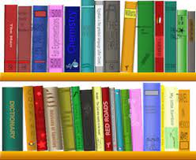

**Stories that stand the test of time:**

* *The Hobbit* by JRR Tolkein
* *The Woman in Black* by Susan Hill
* *The Hound of the Baskervilles* by Arthur Conan Doyle
* *A Kestrel for Knave* by Barry Hines
* *Frankenstein* by Mary Shelley

This list has been compiled by pupils.

Do you have any recommendations to add? We’d love to know!