Writing Nonfiction

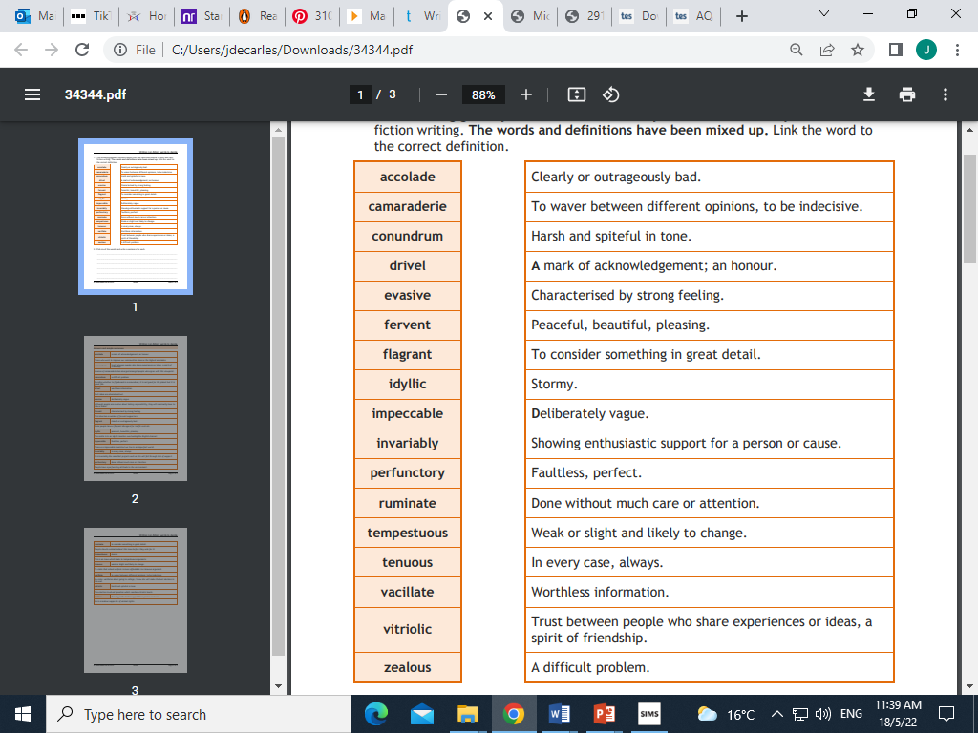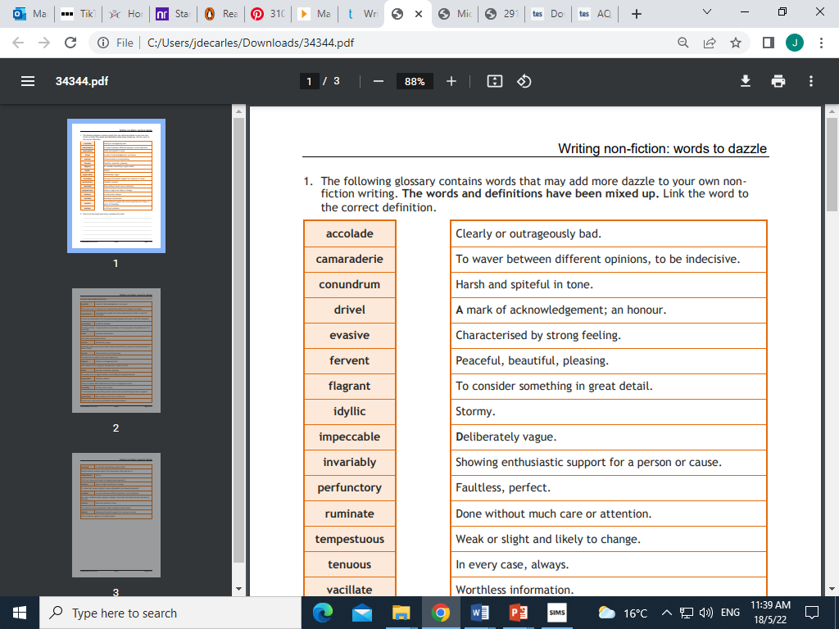



**Read the following extract and then answer the questions which follow**

**Tattoos: Too cool for school or looking like a fool?**

*Times are changing and our attitudes towards tattoos need to as well*

Imagine you’ve been told you’ve got a new teacher. You don’t know anything about them: not their age, race, gender, even their name. All you know is that they’re going to be teaching you for Physics.

Who are you expecting to walk through the door? And what are you hoping they’ll be bringing to your lessons? Maybe you’re expecting someone young; a smart, newly-qualified teacher just out of university, looking to ‘make their mark’ on your class (in other words, using your class as sacrificial lambs to make all their terrible new-teacher mistakes on). Or maybe you’re thinking you’ll get an old teacher: a seasoned old pro - an Albert Einstein or a Marie Curie. Maybe you’re hoping they’ll be relaxed, funny, clever, able to control the class. And hey, it wouldn’t hurt if they were up for a bit of banter, too…

You sit at your desk, rocking back and forth on the long stool in idle anticipation. The lab smells of old splints and uncertainty. There’s a buzz of indistinct chatter already in the air, as you and your classmates speculate about your chances of doing a runner before the teacher gets here. Just as you’re about to shout your own witticism across the classroom, in walks your teacher. She’s probably in her thirties, average height, dressed in short sleeved, white blouse and black trousers. Her hair is short and brown. Overall, she is dressed very smartly and professionally.

Oh, and every inch of flesh that you can see below the face is covered in tattoos.

What would your reaction be?

The truth is, it doesn’t really matter what your reaction would be, because the chances of this happening are – bizarrely – infinitesimal. That’s not because there aren’t female Physics teachers, or because females don’t get heavily tattooed: it’s because prejudice against tattoos in job interviews means someone with lots of visible tattoos is less likely to be appointed for ‘respectable’ professions like teaching.

What’s behind this? Why are some people so uptight about tattoos, and where does their reputation come from? The answer, in a word, is prejudice.

Tattoos are, often by older generations, associated with the rough and ready. They are the hallmark of the ex-inmate, whose tears, inked down his face, number the murders for which he was committed. They are the proud artworks of the sailor who misses his mother, or the ‘chav’, with her eight children’s names stained forever on her neck, with the long-gone ex’s now disguised as a dragon, slightly further down her clavicle.

This is pure stereotyping, of course. Some of the greatest minds of our generation are tattoo lovers; Professor Sandeep Robert Datta, a neurobiologist at Harvard Medical School, proudly shows off a colourful strand of DNA. Justin Trudeau, the President of Canada has a completely inked shoulder. Of course, every one of the Made in Chelsea lot seem to have them too… but we’re talking about great minds here.

Like any kind of permanent body alteration, you need to be one hundred percent sure before you have a tattoo. Design trends come and go and can look dated very quickly (think Chinese symbols in the early 2000s). It all comes down to whether the ‘you’ you are now will be the same as the ‘you’ you will be in forty years’ time. Will you still be into Skrillex so much in your sixties? Perhaps that’s why so many people choose to have their children’s names inked – chances are they won’t go off them.

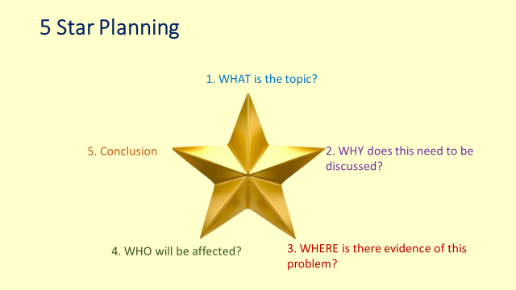Perhaps as the millennials become the employers rather than the employees the tide against tattoos will change. Until then, admire your cool new Physics teacher’s tattoos from afar, but what’s more of a marvel is the fact you’re seeing an inked-up professional in the first place.

1. **WHAT:** Can you clearly tell what the topic of this article is? Tell me what you think the topic is with at least one piece of evidence to prove this.
2. **WHY:** Can you clearly find evidence of the writer making it clear why this issue needs to be discussed? Note down this evidence and explain how it shows the writer explaining why this is an issue/ relevant.
3. **WHERE:** Can you find any anecdotes or stories of where there is evidence of this issue in life? Where has the writer suggested it is taking place?
4. **WHO:** Who do you think this article is aimed at and why do you think this? Write out at least one piece of evidence which you think proves this. Explain how it is proof.
5. **CONCLUSION:** What has the writer done to end this article? Why might this be engaging and what do you think the final message readers will take from it?
6. **OVERALL…** What is your opinion of how well this article has been written? Do you think it has been successful? Why?

Now it’s time to have a go at writing your own article using the worksheet below:

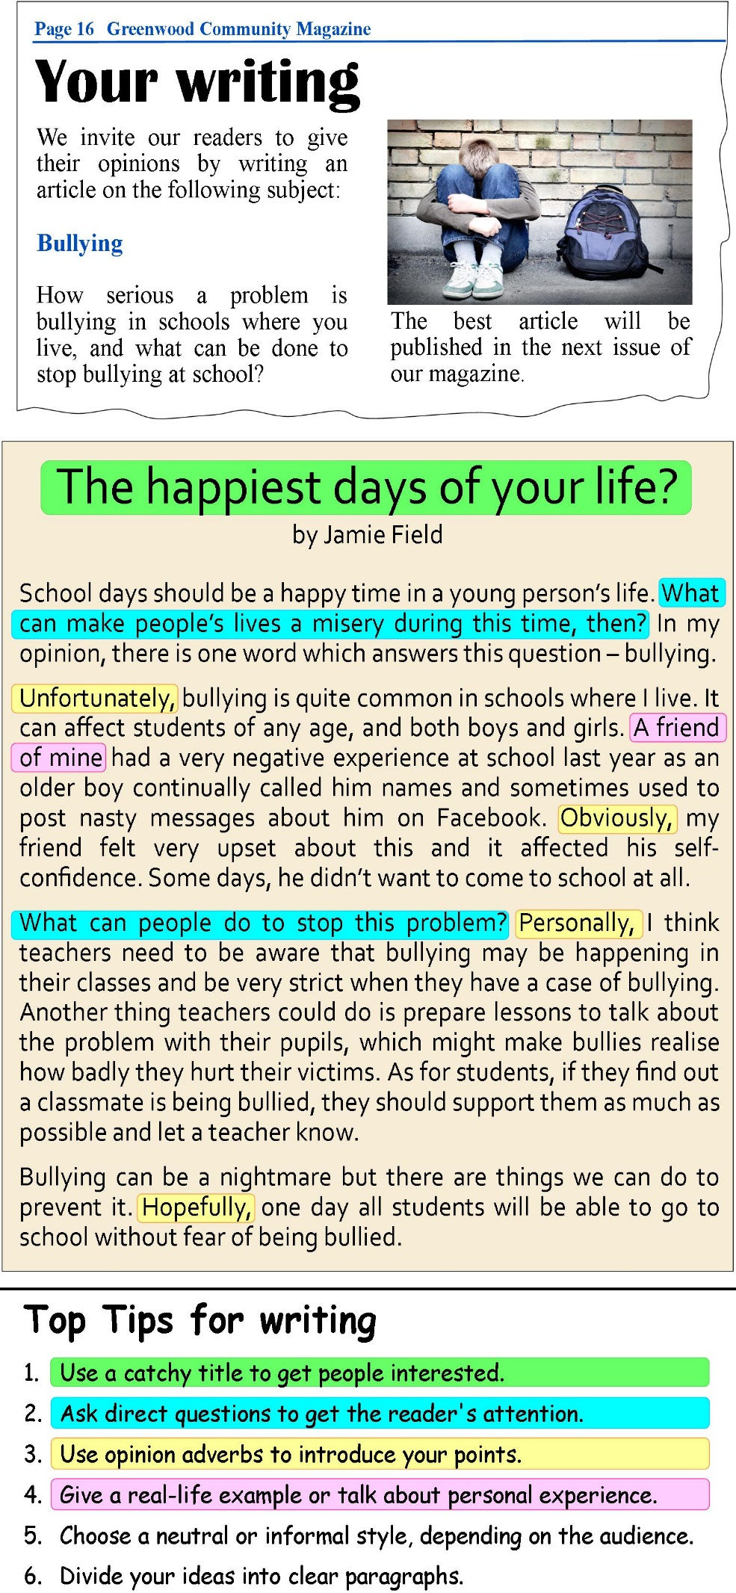

Writing the **perfect** magazine article

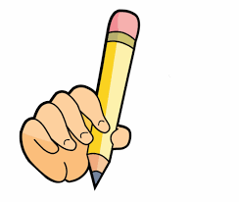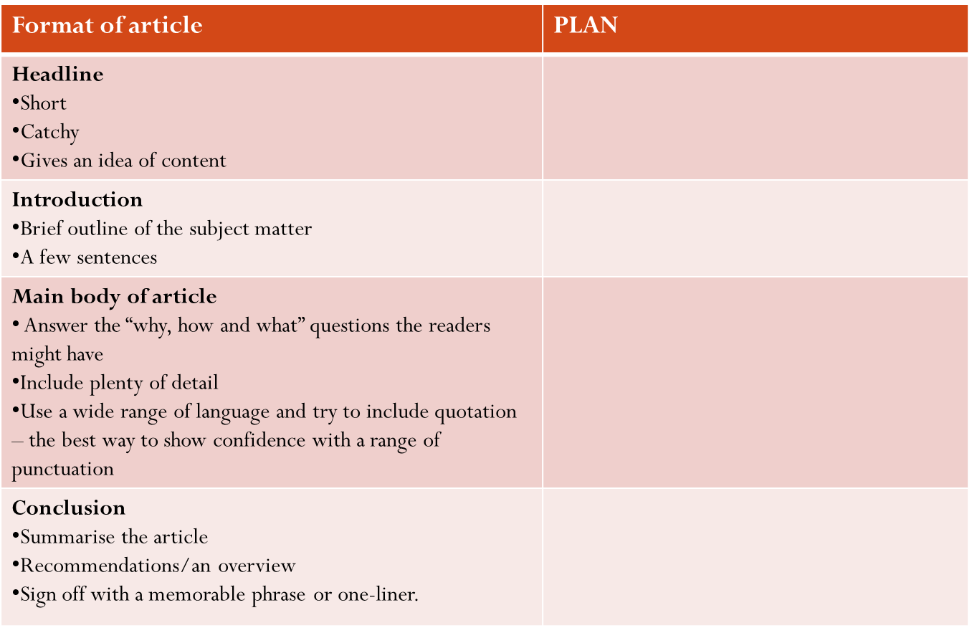

**LAYOUT** **CONTENT**

Direct/Personal Emotive language

Punning headline Facts/Statistics

Logo Imperatives

Clear headline Helpful hints

Sub-headings Quotations

*Use the bullet points you are given to form your paragraphs!*

Don’t forget this section is worth 40 marks!

24 = Content & 16= SPaG

Try to include:

* Rhetorical questions
* Use of person to engage
* A punning headline
* Emotive language
* Variety of punctuation and sentence length
* Imperatives
* Hyperbole