Holes 2020

Lesson 1-setting the scene-character and location

Objective: To set the location for Camp Green Lake using tableaux and an Artuadian Routine

Aims this lesson: To access and understand the beginning of Louis Sachar’s Holes.
To understand what an Artaudian routine is and create one.
To use a story as a stimulus for the drama.

PLTs- Question ,Explore, Analyse, Evaluate, Collaborate, Discuss, Respect, Take responsibility, Support, Feedback, Generate, Innovate, Explore, Question, Connect, Take risks, Adapt , Seek challenge, Persevere, Commit, Organise, Choose your attitude, Seek advice, Set goals, Review, Feedback, Evaluate, Inform, Communicate, Do something, Engage, Get involved, Negotiate and Persuade.

Discussion
What are American summer camps like?-show presentation.

Separate the class into groups. Ask them to make/ draw a still image of a American summer camp called Camp Green Lake. PHOTOGRAPH!!

Write out an “advert” for a typical camp. Focus on

Read pages 1-5 and have pupils circle any important information about Green Lake that may help them later on. Create an image summing up what life is really like at Camp Green Lake.

Individually create a routine about monotonous life in Green Lake. As at desks – work with levels and rhythm. Morning/ Noon/ Night

Join with a partner – create a routine which should be started in a round style building up the piece.

Homework
Write a letter home from Stanley (Writing in role) to his mum about how camp is going. (Use blank postcards and draw a picture on the other side showing Camp Green Lake. Does he tell her the truth? Or does he protect her feelings?

Lesson 2-Superstition

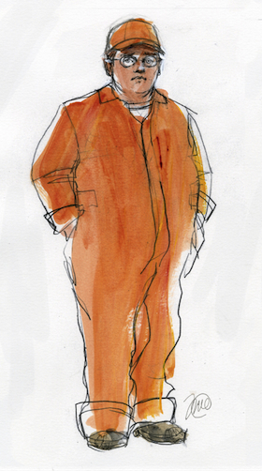
Objective: To develop background information on the protagonist Stanley Yelnats. Focusing on the theme of superstition

Aims this lesson: To use a story as a stimulus for the drama.
To consider superstition

In groups of 4 brainstorm a list of superstitions about good and bad luck. Present one to the class as a Mimed scene showing the consequence of the superstition.

Read the following to the class;
“Stanley was not a bad kid. He was innocent of the crime for which he was convicted. He’d just been in the wrong place at the wrong time.
It was all because of his no-good-dirty-rotten-pig-stealing-great-great-grandfather!
He smiled. It was a family joke. Whenever anything went wrong, they always blamed Stanley’s no-good-dirty-rotten-pig-stealing-great-great-grandfather.
Supposedly, he had a great-great-grandfather who had stolen a pig from a one-legged Gypsy, and she put a curse on him and all of his decendants, Stanley and his parents didn’t believe in curses, of course, but whenever anything went wrong, it felt good to blame someone.
Things went wrong a lot. They always seemed to be in the wrong place at the wrong time.”

Individually create a series of tableaux/ pictures of showing how unlucky Stanley is in everyday life. Stanley needs to narrate the tableaux with the phrase/thought in the head “Arghhh, my stupid no-good-dirty-rotten-pig-stealing-great-great-grandfather!!”.

Pupils listen to how the curse began. Ask pupils to make notes under the characters:
ELYA YELNETS/ MYRA MENKE/ MADAME ZERONI/ MR MENKE/IGOR BARKOV/ KISSIN KATE BARLOW

P28 - 38

“Four generations ago, in Latvia, the young Elya Yelnats fell in love with the beautiful but stupid Myra Menke. He sought the help of ancient Madame Zeroni to win Myra's hand in marriage. In return for Madame Zeroni's help, Elya promised to carry her up the mountain to drink from a special spring one more time before she died. Unfortunately for Elya, the courtship went wrong and in a fit of despair he boarded a ship bound for America to begin a new life before he had fulfilled his promise to Madame Zeroni.

Things never went right for long after that. Settled in America, Elya had one son who succeeded in making a fortune, but he lost it all when he was robbed by Kissin' Kate Barlow, the famous outlaw.
In the same groups have the class simplify the story down into chapters. Each group receives their own chapter to work on. E.G.
- Four generations ago, in Latvia, the young Elya Yelnats fell in love with the beautiful but stupid Myra Menke. She was a daughter of a wealthy farmer.
- He sought the help of ancient Madame Zeroni to win Myra's hand in marriage. In return for Madame Zeroni's help, Elya promised to carry her up the mountain to drink from a special spring one more time before she died.
- Unfortunately for Elya, the courtship went wrong and in a fit of despair he boarded a ship bound for America to begin a new life before he had fulfilled his promise to Madame Zeroni.
- Things never went right after that.

Write Yelnats letter to Madame Zeroni – explain why he did not come back

Lesson 3 Nicknames/finding something in the hole-conscience

Objective: To create and perform work explaining why a particular gang member has gained his nickname

Aims this lesson: To use a story as a stimulus for the drama.
To explore issues around bad behaviour and it’s consequences.

Read p16 – 20

Issue each group with a name of a character from Camp Green Lake. In their groups pupils must come up with a reason as to why their character came to be called by that nickname. What does that nickname say about them?

Perform

Explain the following if there is time, otherwise only introduce the characters of Zero and X-ray.

Zero - Zero is another camper at Camp Green Lake who becomes friends with Stanley. Zero is the best digger and generally thought to be stupid by the counsellors and the other boys. In truth, Zero is very smart, although he has never been taught how to read.
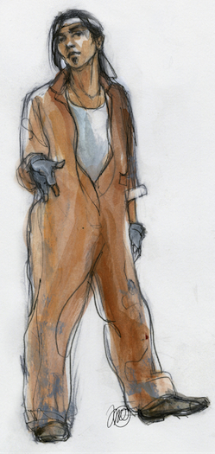
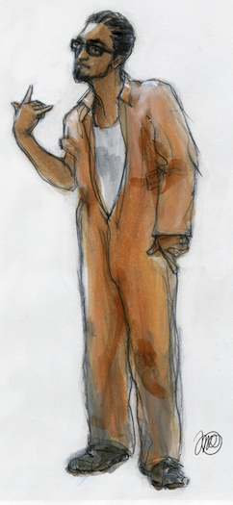
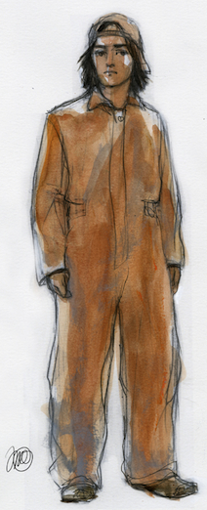
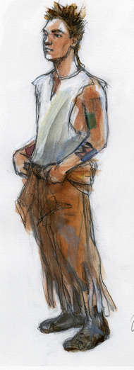
X-Ray - X-Ray is the leader of the group of boys at Camp Green Lake. Although he is small and cannot see well, he manages to take charge and have the other boys follow his orders.

Squid - Squid is another boy at the camp. He is as tough as X-Ray, although he often follows X-Ray's directions. Squid often taunts Stanley about receiving letters from, and writing to, his mother.

Magnet - Another boy at the camp, Magnet earned his nickname by his ability to steal things. "My fingers are like little magnets,“

Armpit- Along with Squid, Armpit seems to be one of X-Ray's closest companions. He is the one that pushes Stanley to the floor when Stanley forgets to call him by his nickname.

Zigzag- Stanley thinks Zigzag is the weirdest kid at Camp Green Lake. Zigzag is very violent and does not even apologize to Stanley after hitting him in the head with a shovel.

Create a “role on the wall” for your groups character and explain one of your scenes you produced this lesson.

In the same groups create a scene of Stanley finding something in his hole. Should he tell X-ray? Or the Warden. His conscience needs to help him make the decision.

Lesson 4: Digging Holes and writing home

Objective: To explore the use of story and letter. Cross cutting narration and truth

Aims of this lesson: To use a story as a stimulus for the drama.
To explore issues around “white lies” and their consequences.
Intro: Read p37 – 47.

Discussion: What is life like in the camp? Why does Stanley not tell his mother the truth?

Development: Create the actual timetable at Camp Green Lake. Using the letter as a stimulus discuss ideas of how you might explore the difference between what Stanley’s mother belief and the reality.

Write out as a script with lighting options

Lesson 5 Kissing Kate and Sam-cross cutting
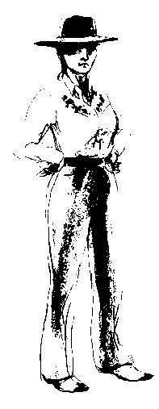
Objective: To perform an explanation of a characters behaviour using flashback and cross-cutting

Aims this lesson: To use a story as a stimulus for the drama.
To explore issues around bad behaviour and it’s consequences.
To think carefully about their own actions.

Intro: Recap the work so far. Issue post-it notes to 4 different groups. Explain post it note game. The winning team is the team with the most CORRECT post-its on the board at the end.
Question 1: What is Camp Green Lake like?
Question 2: Who is at Camp Green Lake?
Question 3: Why are they digging holes?

Discussion
Explain why the boys are actually digging holes. The Warden is continuing her families tradition/obsession with looking for the infamous Kissing Kate Barlow’s stash.

Read pages 101 – 103/ 107 – 115

Discuss the hatred and racism in America.

She was a famous outlaw about a hundred years ago who would hold men at gun point, steal their money and often leave them for dead with a red lipstick mark on their cheek identifying that she was the killer. She was an outrageous outlaw who didn’t care whether she got caught or not. Why would someone not care? Why would someone choose to behave like that? What has happened to her to change her behaviour. Tell the class Kate’s background. She used to be a well loved local teacher. But something changed.

Create a diary entry and Role on the wall for Kissing Kate. How does she feel on the inside and how do people feel about her?

Create a scene showing Kissing Kate’s outrageous behaviour. Finish the scene with her reflecting on WHY she chooses this behaviour. Then discuss in groups WHY Kate behaves like this, use cross cutting in your flashback scene to tell the story.

Lesson 6 Escaping and finding Zero/breaking the curse-marking the moment

Objective: To create and perform the moment the curse ends using Marking the moment and other dramatic techniques

Aims this lesson: To use a story as a stimulus for the drama.

Intro

Play clip from the film when Zero runs away followed by Stanley.

Task
Create a scene where Stanley breaks Madame Zeroni’s curse by carrying Zero up a hill to get water. Make sure you consider carefully which techniques to use to accompany your scene. ‘A year 7 would just act out the scene, a year 8 might add in one technique. What would a year 9 do?’-ask the class, they create criteria/year 9 standards.

Homework
What is marking the moment? Create a poster explaining it and listing all the ways in which we can accomplish it. What did your group choose to do? Was it successful? What could you have done better?

Lesson 7/ 8 Reversal of good fortune

Objective:To be assessed on the use of previous dramatic techniques in this unit in an end of term performance

Aims: To use a story as a stimulus for the drama.
To access and understand Louis Sachar’s Holes.

Stanley and Zero return to camp and decide to dig one last hole. Inside that hole they find an old trunk covered in lizards. They are then discovered by the warden, Mr Sir and Stanley’s lawyer who has come to take him home.

Objections-explain what an objection is. Hotseat

Warden-wants the trunk as she’s been searching for it for decades, making kids dig holes in the lake.

Lawyer-Just wants Stanley to get out of the hole and come home.

Zero/Stanley- Doesn’t want to be killed by the lizards
-Doesn’t want the warden to get the trunk

In groups of 4 role-play the scene. Then rehearse the role play for 25 minutes ready to perform at the end.

Finally sum up the ‘happily ever after’ with tabelaux of the following final events from the book.

- Zero and Stanley go home to their families
- They find treasure/money in the trunk
- Camp green lake closes and the warden and Mr Sir get punished

Homework
Evaluate work. What work did you really enjoy? What could you have done better?

