Elizabeth and her Image
Elizabeth I came to the throne in 1558. She needed to win the support of her people - both Catholics and Protestants, and those who believed that a woman could not rule a country by herself. One of the best ways for a monarch to win support was by making a tour of the country and showing themselves to the people. However, Elizabeth had many Catholic enemies and it was not safe for her to travel around the country. She chose, instead, to use portraits to show herself to her people. It was, therefore, essential that the portraits showed an image of Elizabeth that would impress her subjects.

What Elizabeth was really like:
- Elizabeth was short about 5'3 or 5'5 with brown eyes and red curly hair.
- She had a bad temper and would throw things or threaten to send people to the Tower if they upset her.
- She swore and spat when she was angry.
- Elizabeth's teeth were black with tooth decay.
- Her speech was sometimes difficult to understand because of missing teeth.
- She only bathed once every few weeks.
This was not an image that Elizabeth wanted portrayed to her subjects. At intervals throughout her reign the government issued portraits of Elizabeth that were to be copied and distributed throughout the land. No other portraits of the Queen were allowed.
The Rainbow Portrait is one of the most famous portraits of Elizabeth and Elizabeth used it to tell people what she stood for.
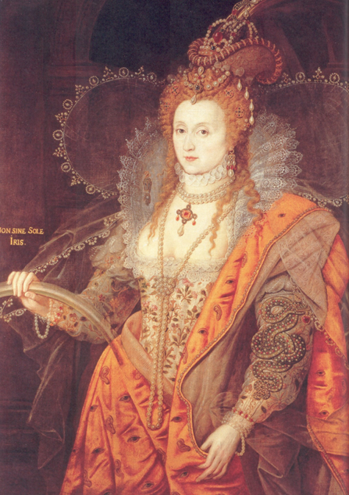

………………………

………………………

………………………

………………………

………………………

………………………

………………………

………………………

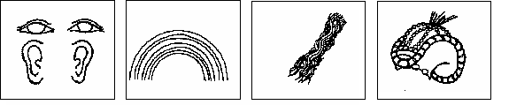

Can you find the following images in the picture? Once you have found them label them.

A. Eyes and Ears B. Rainbow C. Flowers D. Headdress like a food basket
E. Heart F. Angel Wings G. Serpent H. Jewelled Gauntlet
The images above were all put into the painting on purpose. In the Tudor times these images were associated with positive characteristics and so Elizabeth wanted people to associate her with these positive characteristics.
Can you guess what each image was meant to represent? – put the right letter in each box
1. Elizabeth is a messenger from God
2. Elizabeth brings peace after a storm
3. Elizabeth is a wise ruler
4. Elizabeth loves her country
5. Men are prepared to fight for Elizabeth
6. Elizabeth can see and hear everything in her country
7. Elizabeth will provide food for her country
8. A sign of youth

Extension Sheet
But why did Elizabeth feel it was necessary to tell people she was strong, wise, young etc?
There must have been something going on at the time that made Elizabeth want to reassure her people that she was a good queen. If we act as detectives, we can have a good guess at what problems must have been going on at the time of the painting. For example, the fact that Elizabeth wanted people to think she was a messenger from God suggests that people thought God would not have wanted her. Can you think why the other images might have been put in the painting? Again put the right letter in each box.
1. People thought God would not have wanted Elizabeth to be Queen
2. People thought She was getting old & needed to provide an heir to the throne
3. People thought Elizabeth was not strong enough to rule the England
4. People in England were poor and hungry
5. Elizabeth had many enemies and needed people to protect her & England
6. People were plotting against Elizabeth
7. She had suffered problems in the past & people thought she would in the future
8. People thought Elizabeth was not putting her people first

What message would you like to send out to people? Pick five things you would put in your own portrait to communicate with the viewer. What do you want them to know about you?
Your Turn!
E.g You might put a dove in to show you like peace and do not like to argue with people. OR You could put a sports trophy in to show you are good at sport.

………………………

………………………

………………………

………………………

………………………

