AN OBITUARY FOR ELIZABE TH
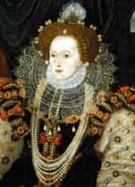
Make notes on the following aspects of Elizabeth’s life in order to write her obituary.

Introduction
When was she queen? Whose daughter was she?

Paragraph one
Who wanted to marry her? How did not getting married help Elizabeth?

Paragraph two
What was the Armada? How did it work in her favour?

Paragraph three
How did Elizabeth want to be seen? How did she promote her image through portraits?

Paragraph four
What qualities of leadership did she show?

Conclusion
What was it that made her the most successful queen in history? What do you think?

