7-

l

,, I • • .

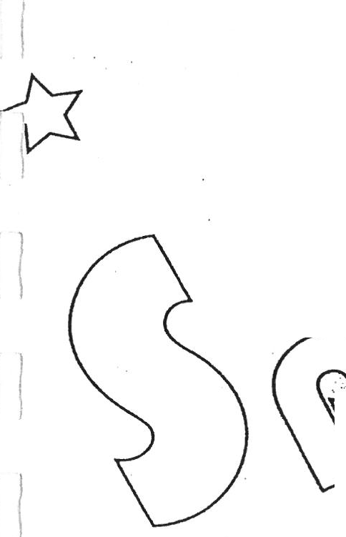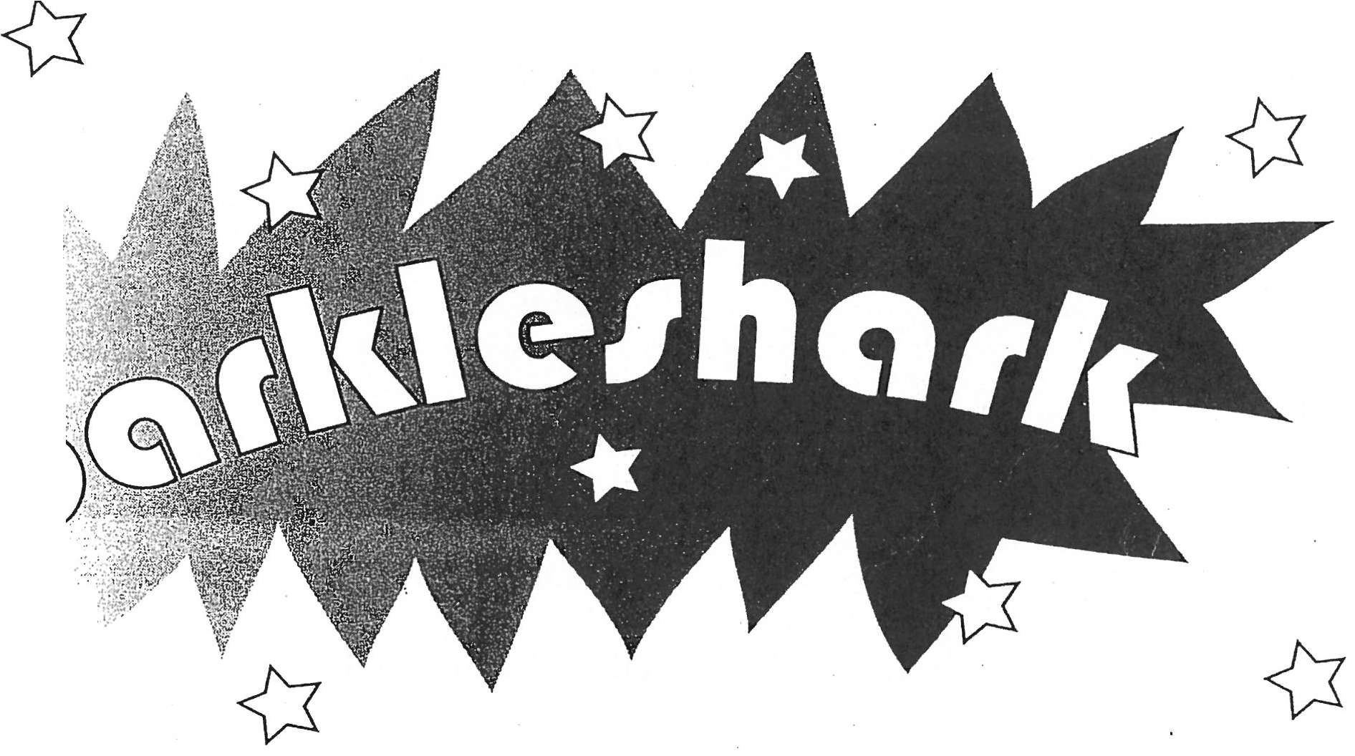

l

I .t'.

·.. ,

...·

. :.··

.*:*.*;*

* . ·

....I '

, ··

. .

:-·

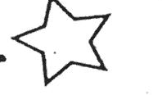. I

!

*I*

J **A play**

j **Philip Ridley**

j

I

f

**J**

J

. **SAMUEL FRENCH LTD**

J

I

### CHARACTERS

**Jake Polly Natasha Carol Russell Buzz Speed Shane Finn**

The action of the play takes place on the rooftop of a tower block

Time: a September afternoon. The present

For all the Jakes of the World

"We won't use guns, we won't use bombs,

we'11 use the one thing we've got more of-­ that's our minds."

(from *Mis-shapes* by Pulp)

lr

. l

I

## SPARKLESHARK

*The rooftop of a tower block in the East End of London. It is about 4.30 p.m. Mid-September. The weather is sunny*

*Many TV aerials and satellite dishes, a large puddle, discarded household furniture, a supermarket trolley, piles of rubbish and various scattered detritus. Some precarious metal steps leadfrom the main larger area of the roof up to a tiny platform. There's a doorway here, leading to the emergency stairs. This is the only entrance to the roof*

*Jake enters. He is fourteen years old, slightly built and clutching a satchel. He is wearing a well-worn, but still clean and tidy, school uniform and glasses (the left lens is cracked and the bridge held together by sticky tape). His hair is neatly cut*

*Jake makes his way down to the main area of the roof and sits in an old armchair. He is familiar and comfortable with these surroundings. It's a place he's been many times before-his secret hideaway. He takes a notebook from the satchel and reads, nodding and murmuring thoughtfully. Then he takes a pen from the inside pocket and writes*

**Jake** Big ... fish! Bigfish... ! No, no. *(He tears the page from the notebook, screws it up and throws it aside. He starts pacing the roof and continues to write)* Glitter! Glitterpiranha... ! No, no.

*Polly enters. She is fifteen years old and wearing the same kind of school uniform as Jake, although hers is obviously brand new (and has a skirt instead of trousers). Her hair is long, but held primly in place byan elastic band. She is clutching a tiny tool box*

*Polly watches Jake from the raised platform*

-

Shark! Yes! Shark ... glitter. .. *(He turns and sees Polly. He lets'outayelp*

*of surprise and drops his notebook) Loose pages flutter everywhere*

**Polly** Oh, I'm sorry.

j

2 Sparkleshark

*Jake starts picking up pages. Polly climbs down the metal steps and starts helping Jake*

**Jake** Don't bother.

**Polly** No bother. *(She picks a page from the puddle)* This one's a bit soggy.

Can't quite read--

**Jake** *(snatching itfrom her)* Don't! This is ... it's personal stuff. You can't just stroll up here and start reading things willy-nilly! Watch out! You're treading on one now! You should be in a circus with feet this size. What you doing up here anyway? This is *my* place! Go away!

*Pause*

**Polly** I've only got three things to say to you. One: what I'm doing up here is none of your business. Two: the roof is not your private property­ unless, of course, you have a special clause in your rent book, which I doubt. And three: I find it strange that someone who can write such magical words has such a spiteful tongue in his head... Now, I've got something I need to do, then I' 11 be gone. In the interim, I'd be grateful if you didn't speak to me again. *(She goes to the satellite dish that's positioned on the edge of the roof She opens the tool box, removes a screwdriver and-none too convincingly-starts fiddling)*

*Pause*

**Jake** Is it really magical?

**Polly** ... What?

**Jake** My writing.

**Polly** Bits.

*Pause*

**Jake** I. .. I was wondering whose dish that was.

*Pause*

I'm Jake.

**Polly** I know.

**Jake** How?

**Polly** Oh, please... Your eyes! Use them! *(She indicates her school uniform)*

**Jake** You go to my school!

**Polly** Started last wee k.

**Jake** Haven't seen yo u.

Sparkleshark 3

**Polly** Not surprised. All you do is hide between those two big dustbins at the back of the playground.

**Ja e** I like it there.

**Polly** But, surely, they're a bit wel1, smelly?

**Jake** Don't notice after a few deep breaths.

**Finn** *(off)* DATTSITPOLLLSUMMINSSSTARRTAPPENN!

*Polly leans over the ledge*

**Polly** All right, Finn! Tel1 me when it gets better.

**Finn** *(off)* KEEEPPOOOINNWHARRYARRROOOINNN!

*Polly continues fiddling with the satellite dish*

**Jake** That ... that voice! I've seen it-I mean, I've seen who it belongs to.

He joined my class last week.

**Polly** That's my baby brother.

**Jake** Baby! But ... but he's huge! He grabbed two desks. One in each hand.

And lifted them up. Above his head.

**Polly** I suppose even you would have to notice that.

**Jake** AH the boys are scared of him. They cal1 him the Monster.

**Polly** He's not a monster! Everyone calls him that. Everywhere hegoes. But he's not. He's very gentle. Cries easily, if you must know.

**Finn** *(off)* GEEEINBEEERPOLLL!

**Polly** *(calling)* OK, Finn! *(To Jake)* It's getting better.

**Jake** You understand him?

**Polly** It *might* sound like a meaningless groan to you but-believe me- once you grasp the nuances, it's a very subtle form of communication.

**Finn** *(off)* BEEERPOLLBEEER!

**Jake** Subtle? That?

**Polly** Wei], he's in a bad mood. Missing his favourite programme. That one with real life accidents. You know? Housewives setting themselves on fire with dodgy hairdryers.

**Finn** *(off)* NEEAREEAIRRPOLLL!

**Polly** All right, Finn ... ! And everyone watches these programmes because they' re supposed to be educational ...

**Jake** But all they really want to see is someone's head getting sliced off by

. i helicopter blades.

J

**Polly** Precisely.

**Finn** *(off)* DATSITPIKKERSPERRRFF!

**Polly** Thanks, Finn! That's it! He'll quieten now. Picture's perfect. **Well,** perfect as it'll ever be with this equipment. *(She starts packing up the tools etc. )* Dad got it cheap somewhere. I'm sure there's bits missing. And there

4 Sparkleshark

was no instruction manual. Haven't a clue what I'm doing really ... You know anything about this sort of thing?

**Jake** All I know for sure is you've got to aim the dish at a satellite up there...

**Polly** Perhaps I should put it even higher-oh!

**Jake** What?

**Polly** A dead bird... Poor thing. Only a baby. Must have fallen from one of the nests. *(She peers closer at the dead bird)* All mauve and scarlet. Little yellow beak. Come and have a look.

**Jake** ... Rather not.

**Polly** Can't hurt you.

**Jake** Not that. .. I can be seen up there. By people in the football pitch.

**Polly** There's no-one in the footba1l pitch.

**Jake** But there might be. Any minute now. If he sees me--oh, you won't understand.

**Polly** Try me.

*Pause*

**Jake** It's Russell.

**Polly** The turbo-dreambabe?

**Jake** Turbo *what?*

**Polly** That's what's written all over the toilets. "TICK HERE IF YOU THINK RUSSELL'S A TURBO-DREAMBABE."

**Jake** Bet the wall's covered.

**Polly** Everyone loves him.

**Jake** Love! I'll show you what your precious turbo-whatever has done­ come here! Come on!

*Polly goes to Jake*

Feel! *(He points at the top of his head) Gingerly, Polly feels*

**Polly** Oooo...

**Jake** An elbow did that. *(He rolls his trouser leg up)* And here!

**Polly** Very colourful.

**Jake** A foot! And look in my eyes. Does the left one look a little bloodshot?

**Polly** ... Yes.

**Jake** A fist!

*Slight pause*

**Polly** The turbo-dreambabe?

Sparkleshark 5

**Jake** Bingo! Hang on! You ticked! You like him!

**Polly** I don't know if I *like* him.

**Jake** You ticked! ·

l

**Polly** Yes, I ticked! The other day he took his shirt off in the playground and-yes, I admit-I felt a tingle.

1 **Jake** Animal!

*Pause*

**Polly** I'm sorry you're bullied. Russell is a nasty piece of work. It's like my mum used to say about Dad, "Sometimes the worst presents come in the nicest wrapping paper".

*Slight pause*

**Jake** Muscles! Who needs 'em? Idon't want to do six thousand sit-ups a day.

I don't care if I don't make people tingle.

**Polly** But you do! At least you do me.

**Jake** How?

**Polly** Your stories.

**Jake** How do you know about my stories?

**Polly** The other day ... when I was fixing up the satellite dish, I noticed...

*(She takes several folded sheets from her pocket)* I'm sorry, I'm sorry, I know I shouldn't have.But oh, Jake, there's such wonderful things here.

When I read them I ... I tingle as if a thousand Russells had revealed a thousand six-pack stomachs.

*Pause*

**Jake** You see the tower blocks? Over there! I imagine they're mountains! And other blocks-like this one-they can be Castles. Or mountains. Depending on the story. And ... those television aerials. They're a forest. I'm ... I'm working on this new story. Don't know what it's about yet. **But** it'll have a Dragon in it. A Dragon with a head like ... like a giant piranha. Or shark. And its skin is all shiny. It sparkles. Like.. .

I

J

**Polly** Sequins!

·' **Jake** Exactly! I'm trying to work out the Dragon's name. I was thinking of something like ... Glittershark.

j

**Polly** Not quite right.

*Slight pause*

Sharktwinkle!



6

**Jake** No.

Sparkleshark

*Natasha enters. She's fifteen years old and, although she's wearing the· same kind of school uniform as Polly, her skirt is much shorter, the shirt is bright pink and unbuttoned to reveal some cleavage, and her shoes are platforms. Her make-up is heavy and her hair, though not long, screams for attention. In place of a satchel, she has a handbag covered with gold sequins*

*Natasha watches Jake and Polly*

**Polly** Fishtwink]e--oh, no! That's terrible!

*Polly and Jake turn and see Natasha. They let out a yelp of surprise*

Natasha! How d'you get up here?

**Natasha** How did I? Oh, just my usual after-school abseiling. What d'ya mean, how did I get here, you silly cow? I walked up the bloody stairs. The last two flights need a bloody government health warning. Thought the boys' toilets at school were bad enough. *(She takes pe,fume from her handbag and sprays herself)*

**Polly** How d'you know I was up here, Natasha?

**Natasha** Your brother told me. Well, "told"'s a bit of an exaggeration. "Where's Polly, Finn?" "Uggghh!" *(She points up)* "What? She's in her bedroom?" "Uggghh!" *(She points up)* FinalJy, I work out it's either heaven or the roof. *(She takes lipstick and face compact from herhandbag and starts to re-touch her make-up)* And, Po1ly-pleasedon't take this the wrong way-but your brother stinks . The state of his hair should be punishable by law. And as for his breath! Phew! It could strip nail varnish at twenty paces. *(She starts to climb down the stairs)*

**Polly** What you doing, Natasha?

**Natasha** Oh, don't start that again! Give us a hand, Pol.

*Polly helps Natasha down*

**Polly** You should wear sensible shoes. **Natasha** No girl wears shoes to be sensible. **Polly** Wear them to get blisters, do they?

**Natasha** Beauty knows no pain. Now, Po], quick. A word. *(She pulls Polly to one side)* Looks like we've got a yellow alert situation here.

**Polly** Ye11ow alert?

**Natasha** Don't play dumb, Little Missy. Cast your mind back. Your first day at school. You're standing alone in the playground. You're close to tears--

SparkJeshark 7

**Polly** I was not!

**Natasha** Who saved you from total cred oblivion?

**Polly** You made friends with me, if that's what you mean.

**Natasha** And you know why? Because under your totally naff surface, I detected the *real* you. Theone who, by half-term, with my help and a make­ over--

**Polly** I don't want a make-over!

**Natasha** Park your lips! What did I tell you on that first day? Be careful who you talk to. Ask me who's in, who's out. Did I say that?

**Polly** Yes.

**Natasha** So why the geek?

**Polly** He's not a geek! He's very nice.

**Natasha** Orange alert! Niceness has nothing to do with it. It's like saying someone with measles is nice. It don't matter. Geekiness is contagious! Now, let's get away from here pronto.

**Polly** I like Jake.

**Natasha** Red alert! Pol, you'll be hiding between the dustbins before the term's out.

**Polly** I don't care! He's my friend. And if you can't accept that, then wel1,

you're not the deep, warm, sensitive, mature person I thought you were. Someone who's as beautiful inside as she is out.

*Pause*

**Natasha** : .·. Hiya, Jake.

*Pause*

I'm doing my hair different now. Had it cut since last term.

**Polly** Don't talk about yourself. Be interested in *him. Slight pause*

**Natasha** So, Jake... What do *you* think about my hair?

**Polly** I didn't mean that. **Natasha** Oh, I give up. **Jake** Looked better before.

I

*J Slight pause*

Your hair. When it was longer. Really suited you.

**Polly** Jake, I don't think-­

**Natasha** Let him finish.

J

8 Sparkleshark

*Slight pause*

**Jake** Every day you'd do it slightly different. Sometimes swept this way. Sometimes that. And no matter what style, it always looked ... oh, so perfect. A real work of art. The effort that went into that.

**Natasha** Hours, believe me.

**Jake** And you wore hairclips-my favourite! The one with yellow flowers. **Natasha** My favourite too. Stil1 got it. *(She searches in her handbag)* **Jake** But with shorter hair ... it'slikeyou'velostpartofyou.Andyourmake-

up's different. ·

**Polly** Stop flirting.

**Natasha** Heain'ttlirting. He's talkinglikeoneofthegirls. What's more, he's the only one who's had the guts to be honest. My hair was better longer­

- *(She finds the hairclip)* Jake?

**Jake** That's the one.

**Natasha** Won't suit me now.

*Slight pause*

You have it, Pol.

**Polly** ... Me?

**Jake** It'd suit you.

**Natasha** The voice of an expert.

**Polly** *(taking the hairclip)* Oh, Tasha, you know I can't. ..

**Natasha** There's nothing wrong with making the most of yourself, **Pol.**

*Slight pause*

You've got to ... express yourself now and then. Not bottle everything up. Otherwise ... you're gonna explode.

**Jake** It's just a hairclip.

**Polly** Try telling my dad that.

**Natasha** Dads! Dads! Dads! What've I told you, Pol? You mustn't let it bother you. Water off a duck's back. Just like mine.

**Jake** What's wrong with your dad?

*Slight pause*

**Natasha** ... Hardly says a word to me.

**Jake** Why?

**Natasha** Just doesn't ... like me any more, I guess. If I walk in the room he looks right through me. Or worse-I ike I've got a dog turd smeared on my forehead Oh, I know what he's thinking. What he thinks of me ... You

Sparkleshark 11

fancies you? It's the one *not* looking at you. "Can't keep his eyes off me!" Jesus! ShalI I tel1 you what your precious Russell told wonderful, brooding Shane kissing you was? Charity!

**Carol** Liar!

**Natasha** Ask him yourself.

**Carol** I .wiII! *(She leans over the edge of the roof)* Russell!

**Jake** Don't!

**Natasha** She's joking.

**Carol** *(calling)* Up here! With Natasha!

**Jake** She's not! He plays down there!

**Polly** The footbalI pitch!

**Carol** He's coming!

**Jake** Buzz and Speed wiII be with him.

1 **Polly** Hide, Jake.

*Jake starts looking for a hiding place*

**Carol** *(to Natasha)* And Shane!

**Natasha** What?

**Carol** Shane's with him! *Natasha looks over the edge* **Natasha** Oh, my God.

*Carol giggles excitedly*

Polly! It's Shane!

*Jake is unable to find a hiding place*

J

**Polly** Behind me, Jake! Quick!

*Jake gets behind Polly*

Tasha, we need your help! Quick!

**Natasha** What?

**Polly** We need to hide Jake. Russell wiII-­

**Jake** KiII me!

**Natasha** *(to Carol)* This is all your bloody fault, Little Missy.

**Polly** Quick!

*Natasha runs to stand beside Polly*

*I*

# I

12 Sparkleshark

**Carol** What's going on?

**Polly** Closer, Tasha-Carol, we need you too. Quick! Or do you want to see Jake hurt?

**Carol** Hurt? No.

**Polly** Hurry!

*Carol rushes to join Polly and Natasha. Jake hides behind them*

Close up, Carol. No gaps!

*Russell enters. He is fifteen years old, glossily good-looking, with a defined, hard body, created to flaunt. His school uniform (which would have been the same as Jake's) has been reduced to trousers and shirt, the latter being worn untucked, unbuttoned to reveal his chest, and with the sleeves rolled up. Instead of shoes, he's wearing trainers*

**Russell** *(in the voice of a sports commentator)* "The winner! Russell the Love Muscle adds Gold Medal for Tower Block Climbing to his long list of trophies. Is there any stopping this sex-machine, babe-magnet?" *(He calls down the stairs)* Come on, you two. Hear them panting down there? Pathetic. But, girls, feast your eyes! Am I breathless?

**Girls** ... No.

**Russell** Sweating?

**Girls** ... No.

**Russell** Tired?

**Girls** . ..No.

**Russell** Do not adjust your sets, girls. You are witnessing perfection. Look at you! Too dazzled to move. "The crowd cheers at this spunky, **funky,** hard-bod hunky. Women are throwing flowers. He blows one a kiss! She faints--"

*Buzz and Speed enter. They are fourteen years old and wearing the reduced school uniform favoured by Russell, although their shirts are not unbuttoned. They areboth shorter than Russell and, while not unattractive, lack the arrogant dazzle that makes Russell the natural leader. Both Buzz. and Speed are carrying very full sports bags instead of satchels. Buzz. is carrying an extra one which, presumably, belongs to Russell. This extra weight has no doubt contributed to their breathless condition*

Talk about fainting! Pathetic or what?

**Buzz** He kept pushing me, Russ. **Speed** He got in the way, Russ. **Buzz** I'm carrying your bag, Russ.

,

Sparkleshark 13

**Speed** He used it to trip me, Russ.

**Russell** Out of the way, losers. Time to greet the fans. *(He jumps to the main area of the roof)* I know what you're thinking, girls. Why can't my hair shine like his? And as for his eyelashes-they're wasted on a bloke! Don't blame me. I was born with these gifts. Others-I worked at! *(He lifts his*

. *shirt to reveal his stomach)*

*Carol lets out an involuntary squeal*

Know what these muscles are called?

*Slight pause*

Horny as hell!

*Buz;z and Speed go to descend the metal stairs*

You two! Jump like me! A man!

*Buz;z and Speed stand on the edge of the raised area, psyching themselves to jump. They are teetering, visibly wary and nervous*

Watchya, Natasha. All right?

**Natasha** Fine.

**Russell** Avoiding us lately?

**Natasha** Why should I? **Russell** Our Shane-boy. **Natasha** Ancient history.

**Russell** Exactly what I just said. When Shane heard what's-her-facecall you were up here. "Come up", I said. "Let bygones be bygones. So you split up! No big deal. What's it mean-not twiddling with each other's rude bits anymore?" *(To Buz;z and Speed)* Jump, you two!

**Buzz** Stop calling us "you two"!

**Speed** We've got names.

*Shane enters. He is sixteen years old and wearing black leather trousers, boots, red silk shirt-unbuttoned to reveal a razorblade necklace, a black jacket and sunglasses. His hair is longish and well groomed*

*Without missing a beat, Shane pushes Buz;z and Speed. They fall awkwardly to the lower level. Po lly, Natasha and Carol gasp. Russell burstsout laughing*

**Russell** Nice one, Shane!

. *,)*

I

14 Sparkleshark

**Buzz** Bloody stupid, that!

**Speed** Could have broken me neck!

**Russell** Shut up, you two!

*Shane sits at the top of the metal steps. Pause*

**Natasha** Hiya, Shane.

*Pause*

How's it going?

*Pause*

Have a good summer?

*Shane still doesn't respond. Pause*

**Carol** Russell! When you kissed me. Remember?

**Russell** No. .

**Carol** Yes, you do.

**Russell** If you say so.

**Carol** Natasha said that ... well, said you said. Said you said to Shane-­

**Russell** Said what, for chrissakes?

**Carol** Said ... it was charity.

*Buzz and Speed start laughing*

Stop it! Stop it!

**Natasha** Belt up, you scrotums!

*Buzz and Speed stop laughing*

**Russell** Well, to be honest with you-what's your name again?

**Natasha** Carol. Her name's Carol.

**Russell** We11, Carol, it's probably true. But let me explain. lam a dreamboat.

You are not. Now, when a dreamboat kisses a dreamboat challenged I person-it's always charity. This ain't a bad thing. I'm giving you something that-in normal circumstances-you wouldn't stand a hope in

I

he11 of getting. Don't tel1 me you didn't like the kiss.

**Carol** ... No. I mean, yes!

**Russell** Would you like another smackeroonie?

**Natasha** Control yourself, Carol.

**Russell** Come he re .

Sparkleshark 15

I, **Polly** Don't move!

*Carol is whimpering at the back of her throat*

**Russell** Oh, Carol! My tongue! It'll go deep enough to taste your cornflakes.

*Suddenly, Carol can resist no more and rushes at Russell. Immediately, Buu and Speed get a glimpse of Jake*

**Buzz** Geek alert!

**Speed** Geek alert!

**Russell** What? Where? Well, well, well, hiding behind the girls. How pathetic . How ... one hundred percent. ..

### Russell]

**Buzz** *(together)* Geek!

### Speed

**Carol** Where's my kiss?

**Russell** Get him, you two!

*Buu and Speed go to grab Jake. Jake runs. Buzz. and Speed chase*

**Jake** Help!

**Polly** Leave him!

**Natasha** Don't, Russ!

**Carol** Where's my bloody kiss?

*Buzz. and Speed catch Jake*

**Jake** Help!

**Buzz** Kick him, Russ!

**Speed** Punch him, Russ!

**Russell** I've got a better idea. Let's dangle him over the edge.

**Buzz** Wicked!

**Speed** Awesome!

**Jake** Polly! Help me!

*Buzz. and Speed take Jake to the edge of the roof*

**Polly** He's done nothing to you!

**Jake** Natasha! Help!

**Natasha** Stop it, Russ! Stop! Shane-tell him!

**Carol** My kiss!

**Russell** Shut up about your bloody kiss! Who'd kiss you anyway? Like dangling your tongue in a dustbin. Right, Shane?

16 Sparkleshark

**Carol** You bloody ... git! You! You liar! You-­

**Jake** Carol!

**Carol** Let him go!

**Russell** Hey, Shane! You should see his face! AH scared and ... He's pulling Buzz's hair! Ha! A geek with cheek!

**Speed** He's pulling *my* hair!

**Buzz** I'm Buzz.

**Speed** I'm Speed.

**Russell** Don't get touchy now, you two--lift him!

*Buzz and Speed lift Jake*

**Jake** Nooooo!

**Polly** Stop!

**Carol** Stop!

**Natasha** You're gonna really hurt him.

**Russell** Trying my best.

**Natasha** Shane!

**Polly** You can't! Please! He ... he was telling us a story.Wasn't he, Tasha?

**Natasha** ... What? Yeah! A good story. **Polly** We ... we want to know the end. **Russell** I hate stories.

**Jake** Help! Help!

**Natasha** Shane! Tell him! Please!

*Slight pause*

**Russell** What's it to be, Shane? Dangle or story?

*Pause*

**Shane** ... Story.

**Russell** But, Shane-­

**Natasha** You heard!

*Slight pause. Buzz and Speed put Jake down. Pause*

**Russell** So?

*Pause*

**Polly** It. .. It was about this Princess, wasn't it, Jake? Am I right? Yes? This Princess. What happened, Jake?

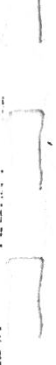Sparkleshark 17

*Slight pause*

That's right! Yes! She lived in a Castle. Well, I suppose all Princesses live in Castles, don't they?

**Natasha** Wouldn't be seen without one.

, **Carol** No way.

, I )

*Slight pause*

**Polly** And this Princess ... she lived in a Castle with her father.

**Natasha** The King, right?

**Polly** Exactly, Natasha! Thank you for reminding me. The Princess lived in a Castle with her father. Who was indeed the King.

**Russell** Bloody rivetting this! Now, don't tell me. Her mother was, indeed, the Queen.

**Polly** No. The Princess didn't have a mother. She died--

**Russell** At childbirth! Boring! Shane! Let's dangle the geek! He's not even telling it.

**Natasha** The Queen had been murdered, if you must know.

*Pause*

Very nastily.

*Slight pause*

Horribly.

**Buzz** ... How?

**Speed** Yeah. How?

**Polly** One day ... the Castle was attacked. By the King's enemies. The

f kingdom had been at war for a long time.

**Speed** The King should have been prepared then.

I **Polly** Well ... yes. He was. Usually. The King was a great soldier.

*)*

**Buzz** So how come the enemy surprised him?

**Natasha** ... The baby Princess.

**Carol** The Castle was celebrating. Right?

**Polly** Exactly right, Carol. It was the day for celebrating the birth of the Princess! A holiday for everyone. The Castle was full of food and music and flowers.

**Buzz** A good ol' booze up.

**Speed** Peanuts and sausages on sticks.

**Carol** Everyone strutting their funky stuff!

**Natasha** And that's when the enemy attacked!

18 Sparkleshark

**Buzz** Bet the Castle was slaughtered.

**Polly** The King was too good a soldier for that. In fact, the King defeated the enemy that day!

**Buzz** But the Queen!

**Speed** What happened to her?

**Polly** She was shot in the heart with a single arrow.

*Pause*

And then ... her head was chopped off.

*Pause*

And then ... her head was eaten by a hungry pig.

**Buzz** Wicked!

**Speed** Awesome!

**Carol** I feel a bit sick.

**Polly** After that ... the King never let his defences down again. Am I getting this right, Jake? The King banned pleasure from the Castle.

**Buzz** What? No telly?

**Russell** Wouldn't be telly in those days.

**Polly** No dancing. No singing. No flowers. Nothing pretty or frivolous at all!

He thought these things would turn the Princess weak.

**Russell** *(to Buv. and Speed)* Like you two!

**Polly** And, as she had to rule after him one day, and possibly fight many battles, he had to train her to be strong. Right, Jake?

*Jake nods and murmurs. Slight pause*

The King made the Princess wear a simple dress. And only one colour ... black!

**Carol** Not even citrus lemon?

**Polly** No.

**Natasha** I bet her shoes were sensible too.

**Polly** Very sensible. And guess what she had to drink... ? Vinegar!

**Buzz** Disgusting!

**Polly** And eat. ..? Plain bread!

**Speed** No butter?

**Polly** No.

**Buzz** What about margarine?

**Polly** No! Nothing! The King forbade it! And then, one night...

*Jake thumps the floor*