**Year 8**

**Shadow Curriculum Guide**



**Due to split classes this year, you may have more than one teacher and therefore more than one unit of work to complete work for. Please read the whole of this document to make sure you have seen instructions for all the units of work you are currently studying.**

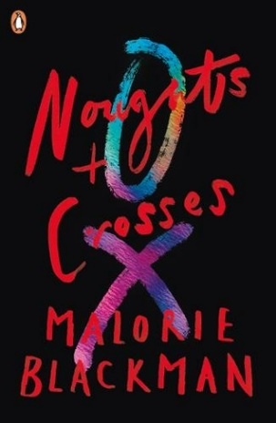**Dystopias (‘Noughts and Crosses’)**

* Use the table below to help you find which task you need to complete:

|  |  |
| --- | --- |
| **If you have recently read…** | **Then complete task…** |
| Callum struggles in Mr Jason’s history lesson, which seems to be all about Crosses | **Task 1** |
| The bomb at the Dundale shopping centre | **Task 2** |
| Ryan McGregor’s trial | **Task 3** |
| The kidnap | **Task 4** |
| The end (no spoilers here!) | **Task 5** |

* You should aim to spend the same amount of time on your task as you would in lessons, but don’t forget about silent reading time too! If this is two lessons it will be 1hr 20mins, if it is three lessons it will 2hrs and if it is four lessons it will be 2hrs 40
* Save work/ keep it safe and hand it in to your teacher when you’re back in school

**Nonfiction**

* There is also a nonfiction booklet linked. You should pick one of the tasks to complete (any one of them is fine)
* You should aim to spend the same amount of time on your task as you would in lessons, but don’t forget about silent reading time too! If this is one lesson it will be 40 mins
* Save work/ keep it safe and hand it in to your teacher when you’re back in school

**If you are doing something different in one of your split lessons you may need to contact your teacher, however you may only be missing one lesson, in which case you can catch up in the next lesson.**