

in Drama

to Flourishing

**Name: Group:**

Draw an ‘X’ on the lines between the faces below to show how you rate your skills in each area.

☺

☹

= Plot development and characterisation

= Use of topic specific conventions

= Voice and movement

= Growth mindset

= Team work

☹

☺

☹

☺

☹

☺

☹

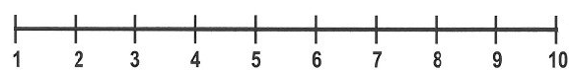

☺









I first self-assessed my skills on (date) using this coloured pen/pencil:

I reviewed my skills on (date) using this coloured pen/pencil:

**Lesson 2**

WWW 1:

WWW 2:



**Lesson 4**

WWW 1:

**Lesson 3**

WWW 1:

WWW 2:

EBI: 

EBI:



**Lesson 5**

WWW 1: 

WWW 2:

WWW 2:

EBI: 

**Lesson 6 – Evaluation of Progress**

Reflect on your self-assessment of your skills in Lesson 1. How have you progressed? Which skills do you need to improve in your future drama lessons and how will you do this?







EBI: 