Football league question sheet
Use your finished league table spreadsheet to answer these questions.

1 Matches this week finish with these results
Liverpool 2 Norwich City 1
Arsenal 0 West Ham United 0
Leeds United 3 Newcastle United 4
Manchester United 1 Everton 1
Southampton didn’t play this week
Update the league table by entering these results.
Save the updated league table.

2 Sort (see below for how!) your updated table to find out which team has most points.
Which team is top of the league? Which team is bottom?

Top team ………………
Bottom team ………………
Save your sorted league table.

3 Add a new team of your choice into your grid. Add in their number of games Won, Lost and Drawn.

4 Re-sort your teams.

5 What if the number of points for a draw is changed to 2? Which team is top of the league? Which team is bottom?

Top team ………………
Bottom team ………………
Save your sorted league table.
6 What if, in the next two games, Liverpool and West Ham win both, Arsenal and Everton lose both, and all the other teams draw both; who will be at the top of the league?

How to sort

- Select the main table area which you want to sort

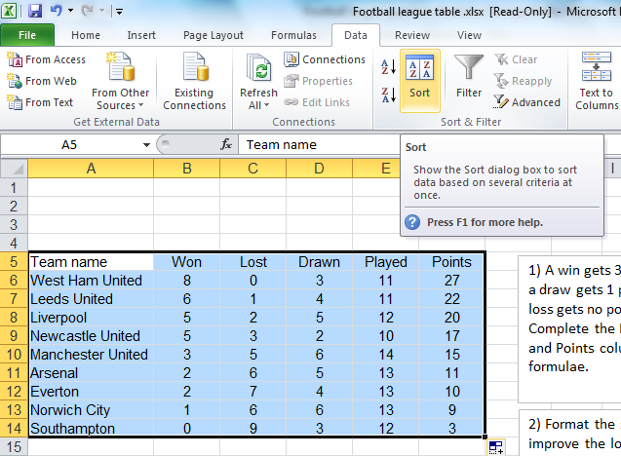

- From the Data menu, select Sort
- Decide which column you want to sort by

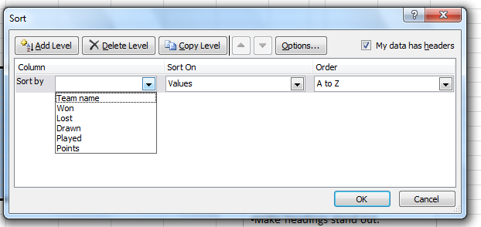
- Decide on the order

