**Fake News**

**Fight off**

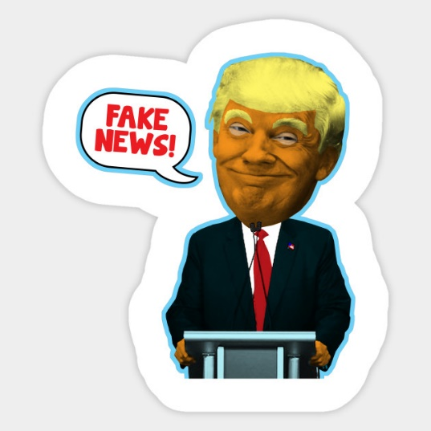

|  |  |
| --- | --- |
|  |  |
|  |  |
|  |  |
|  |  |
|  |  |
|  |  |

**Media Rights & Responsibilities**

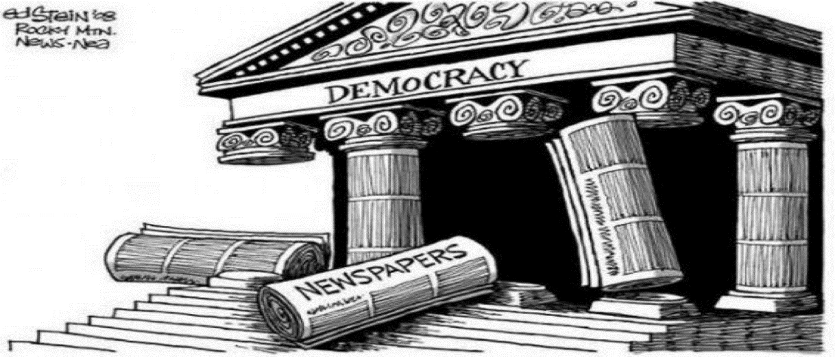

Legal Responsibilities

Legal Rights

|  |
| --- |
| Article 10 Of The Human Rights Act 1998 states…  Everyone has the right to freedom of expression. This right shall include freedom to hold opinions and to receive and impart information and ideas without interference by public authority and regardless of frontiers.  The exercise of these freedoms mays be subject to restrictions that are necessary in a democratic society – in the interests of national security, territorial disorder or crime, for the protection of health or morals, for the protection of the reputation or rights of others, for preventing the disclosure of information received in confidence, or for maintaining the authority and impartiality of the judiciary. |

**Eh?**

|  |
| --- |
|  |

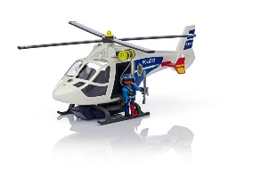 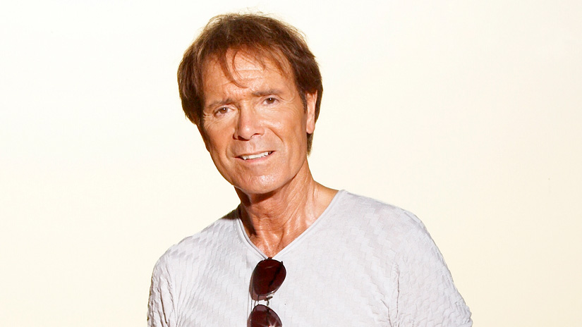

So what is in the public interest?

How do you decide what is in the public interest?

**The Role Of The Media In A Democratic Society**

|  |  |  |
| --- | --- | --- |
| 1. Informing and influencing public opinion. |  |  |
| 1. Exchanging ideas and opinions. |  |  |
| 1. Holding those in power to account. |  |  |

“Corbyn dodged kissing the Queen’s hand in Privy Council Ceremony by going HIKING in the Scottish Highlands.” (Daily Mail)

“David Cameron grins as he plunges 600,000 more people into poverty.” (Daily Mirror)

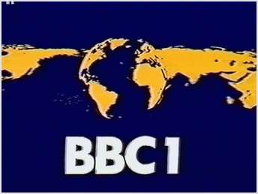

|  |  |  |  |  |  |  |  |  |  |
| --- | --- | --- | --- | --- | --- | --- | --- | --- | --- |
|  |  |  |  |  |  |  |  |  |  |
|  |  |  |  |  |  |  |  |  |  |
|  |  |  |  |  |  |  |  |  |  |
|  |  |  |  |  |  |  |  |  |  |
|  |  |  |  |  |  |  |  |  |  |
|  |  |  |  |  |  |  |  |  |  |
|  |  |  |  |  |  |  |  |  |  |
|  |  |  |  |  |  |  |  |  |  |
|  |  |  |  |  |  |  |  |  |  |
|  |  |  |  |  |  |  |  |  |  |

|  |
| --- |
|  |

The public purposes of the BBC are as follows:

* Sustaining citizenship and civil society
* Promoting education and learning
* Stimulating creativity and cultural excellence
* Representing the UK, its nations, regions and communities
* Bringing the UK to the world and world to the UK

Who Owns The Newspapers?

|  |  |  |  |  |
| --- | --- | --- | --- | --- |
| The Daily Telegraph | The Guardian | Financial Times | Daily Mail | Morning Star |
|  |  |  |  |  |
| Daily Mirror | The Sun | The Times | Daily Express | The Independent |
|  |  |  |  |  |

2015 Political Alliegiances

|  |  |
| --- | --- |
| Conservative |  |
| Labour |  |
| UKIP |  |
| None |  |

**The Leveson Enquiry**

|  |
| --- |
| The Case Of Milly Dowler |
|  |

|  |
| --- |
| Hacked Off |
|  |

|  |
| --- |
| Testimonies |
|  |

|  |
| --- |
| Findings |
|  |

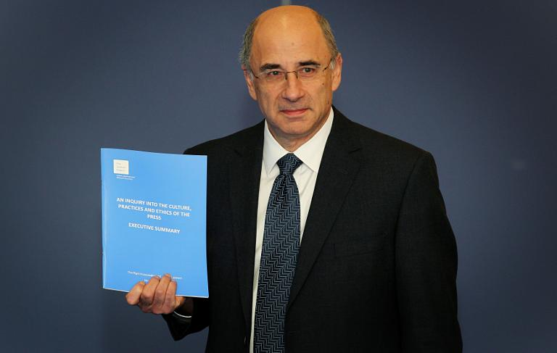

Why do some people say that the enquiry didn’t go far enough?

Would you agree? Why/Why not?

**Censorship & Blasphemy**

|  |
| --- |
| What sort of things do you think should be restricted? |
|  |

CURRENT RESTRICTIONS

|  |
| --- |
|  |
|  |
|  |
|  |
|  |
|  |
|  |

Do you agree with these restrictions?