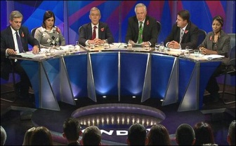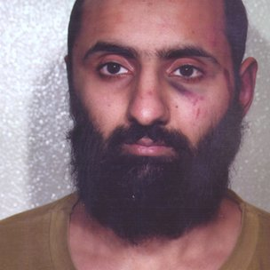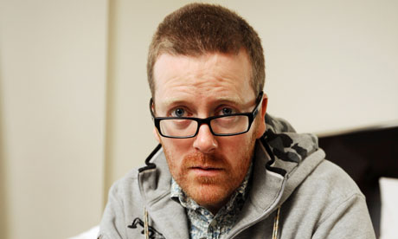

Should this man be punished for setting up a website which talks about terrorism?

*Should comedians be allowed to make jokes about whatever they like?*

*What has Ahmad been accused of*?

Who is Nick Griffin and what does he believe?

*Should right-wing politicians be allowed to speak on TV?*

Why has Frankie been offensive and accused of supporting racism?

*What is Banksy trying to say in his artwork?*

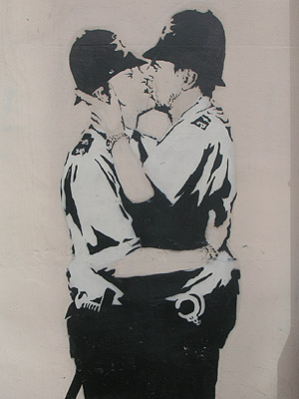

*Should Banksy’s work be banned? Does it*

*Achieve something positive?*

**To what extent should humans be entitled to ‘freedom of speech’?**

Is there anything people shouldn’t be allowed to say?