**Culture wars!**

**You may have heard people on YouTube, on TV or in magazines or social media – and let’s not forget through memes too – referencing a ‘culture war’ recently. What do people mean by this?**

**Culture Wars case study – BLM and ‘Defund the Police!’**

Over the past few decades there have been vast amounts of progress made in numerous countries around the world when it comes to equality and social justice – from the Civil Rights Act, to the Equal Pay Act, to the Equality Act of 2010. However – as you will no doubt be aware, there are occasions when it becomes clear that some people are still treated terribly by people in positions of authority. A good instance of this would be the George Floyd case.

The world was shocked to see a policeman in America kneel on the neck of a citizen he was arresting for over eight minutes whilst that citizen repeatedly stated he could not breathe – and eventually, we know that Mr Floyd died. Because the video clip of George Floyd’s death went viral, this made many people around the world want to protest against police brutality – and what many saw as systemic racism (racism embedded within a societal structure – such as the police force), in America.

This instance, many said, including the Black Lives Matter political group, was another example of how black Americans are treated differently to white Americans by the police. Many joined BLM in protests around the world. The vast majority of protests brought some real good to the world – we saw in Bristol in the UK that the statue of figure who had made a fortune from the slave trade come toppling down. We saw confederate statues in America meeting the same fate too.

There weren’t many loud voices in the media – or perhaps a very small minority, arguing that this wasn’t a good thing.

Yet, since then, some argue, the demonstrations seem to have changed in tone. In the UK, the mass demonstrations finished. Most of the peaceful protesters went home in the US too. Some of the less peaceful ones didn’t. In Portland, Seattle, Chicago, New York and other US cities, many news agencies have described riots, police being attacked and killed by mobs, courthouses burning and anti-government groups throwing explosions. Yet, oddly, other media news outlets are reporting almost the exact opposite – focusing on the violence of state troops arriving to quash protests and forcibly moving protestors. Whether people are reported as ‘rioters’ or ‘protesters’ also changes, depending on which media outlet is reporting.

So what’s all this got to do with a ‘culture war’? Well the reporting of the BLM / anti-police protests in America is a very good example of two different ways of perceiving and thinking about the world (cultures) being pitted against each other, by the media – who benefit monetarily from there being a culture war. Can we think of some UK examples of Culture Wars?

**The general arguments on both sides of the ‘defund the police’ debate go like this:**

**Defund police** – If funds are put into mental health care, drug rehabilitation, community services and further education, there will be less crime. People commit crime largely because they are impoverished, mentally ill, poorly educated with no prospects or drug addicts. We won’t need a large police force if we can prevent crime. The system is at fault – it may be racist or stacked against minority groups. This tends to be more of a liberal or left-wing view.

**What might an EXTREME version of this view be? Discuss now.**

**Another viewpoint:**

**Fund the police well** – A lot of the problem of rising crime is down to a lack of role-models in poorer areas, an increase in single-parent families (meaning mom or dad is always working and can’t watch what kids are doing), lack of aspiration and personal responsibility and lack of people in full time employment. This something that is unlikely to change just by funding community services. People need police to protect them – in fact they need more police in areas with high crime rates, not less. People themselves are at fault, they need to be responsible for their own actions – the system can always be improved, but is not entirely at fault. This is largely a conservative or right -wing view.

**What might an EXTREME version of this view be? Discuss.**

Now here’s where the culture war comes in. In order to gain clicks, sell newspapers, increase viewing figures and gain subscribers, people who work in the media need to cultivate **outrage culture.** This is what makes us stop scrolling, read an outrageous headline (clickbait) and think ‘OMG that is terrible, I can’t believe it! I must read the whole thing, like, and then share,’

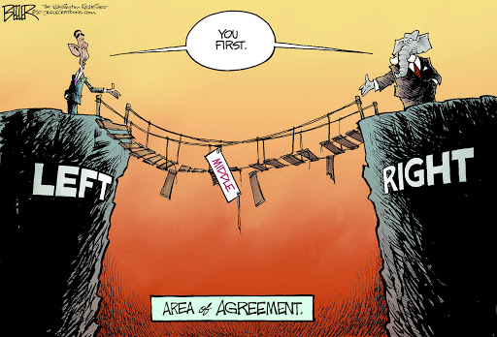**Right-learning media will always present the extreme version of the left-wing view. Left-leaning media will always present the extreme version of the right-wing view.**

So how can you trust what the media tells you? Unfortunately, you can’t. The best thing to do is read as many different articles on a subject from BOTH sides of a debate and come to your own conclusion on the matter. This is called **critical thinking.**