Nick Griffin

Leader of the British National Party

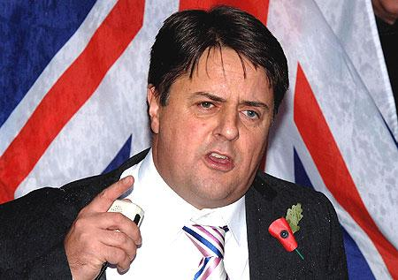

Extracts taken from **The Times**, 2009

“Griffin, who is an MEP, arrived in London from Strasbourg and will begin preparations for the show at a secret location this morning before travelling to Television Centre by car in time for the planned 6pm recording. The BNP is so concerned about its leader's security that it explored chartering a private helicopter to get him to the studio, but was told by the BBC there was nowhere for it to land. Anti-fascist protesters are planning a rally outside Television Centre with members of the broadcasting union Bectu.”

Hain described Thompson's position as "plain wrong". He said: "He is dodging the fact the BNP is a racist, fascist party in complete contradiction to the BBC's own equal opportunities and anti-racist policies. The BBC are in total denial about their gifting of a massive early Christmas present to the BNP. This is probably the worst decision the BBC has made in recent times."

Griffin told the Guardian he admired Thompson's "personal courage" by inviting him. He described one of his fellow panellists, the Conservative peer Lady Warsi, as "a token Asian Muslim woman" and, in a message to supporters, said the debate was his chance to "take on the corrupt, treacherous swine destroying our beautiful island nation".

Ben Bradshaw, the culture secretary, said: "I have always thought we have to take the BNP on. I have always thought they condemn themselves as soon as they open their mouths. In a democracy where they have elected representatives not just at European level but at local level it is very difficult for a broadcaster to exclude them … We should not give these people the opportunity to claim they are being gagged."

**"The BNP is committed to putting the interests of the British people first. I invite you to review our policies and make your choice."**

The British National Party pride themselves on putting the UK’s population at the centre and is the biggest of its kind in the UK. They have been described as racist, fascist and Nick Griffin has frequently spoken about his desire to concentrate attention on ‘pure’ UK citizens. His speaking on National television lead to much controversy!

**Nick Griffin, the leader of the far-right, arguably fascist, extreme right party were given the opportunity in 2009 to speak on national television.**

The programme had 8 million viewers!

