Babar Ahmad
Pro-Jihad = in favour of religious war
- Has been held in custody since 2004 for creating a website with the aim of encouraging terrorist behaviour.
- He denies these allegations and still has not been trialled.
- Officials are trying to get him extradited to the US. He claims it means more than anything to have a trial in the UK, where he was born.
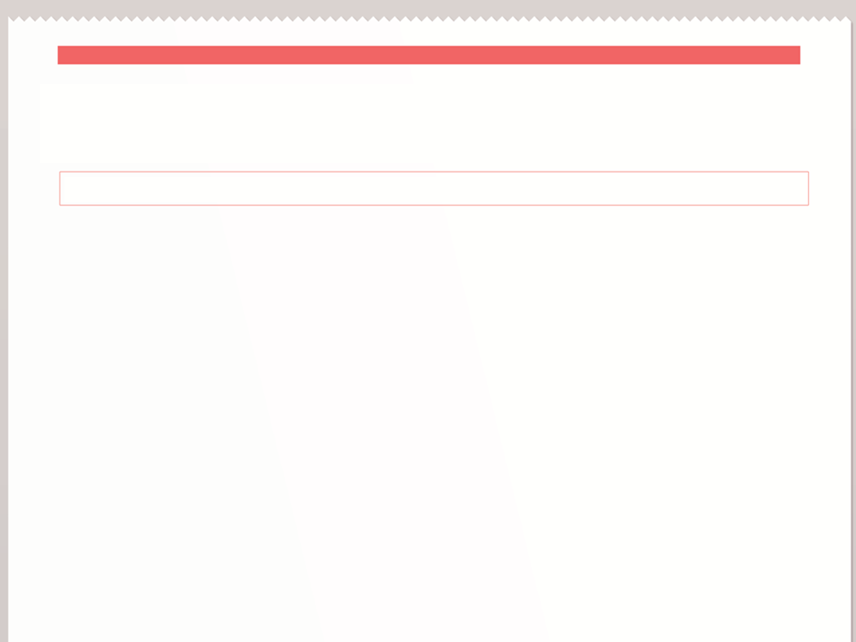
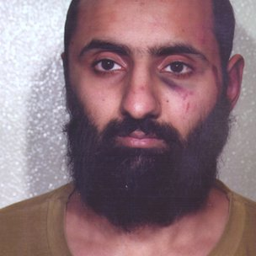
In August 2004, he was arrested again, pending
extradition. This time he was wanted by America.
He has been in prison ever since, setting what
appears to be a record for the longest time that
a British national has been detained without
trial in modern times.

The US authorities accused Mr Ahmad of running an important pro-jihad website called Azzam.com. During the 1990s and early 2000s the English-language website played a key role in encouraging young Muslims in the West to support Mujahideen causes in Bosnia, Chechnya and Afghanistan.

The US accuses him of providing material support to terrorists, money laundering through the website and plotting with US nationals. He is accused of receiving classified US Naval plans. The first UK judge who examined the case said it was a "difficult and troubling case" because the alleged crimes all took place on websites allegedly run in London, not the United States.

But the US says the websites were technically hosted by a company based in the US State of Connecticut, giving them jurisdiction.

The Crown Prosecution Service separately concluded that Babar Ahmad could not be prosecuted. Mr Ahmad has had a long-standing campaign behind him involving Muslims across the UK who says that he has been unfairly treated. He has always denied any links to al-Qaeda.
ACCORDING TO THE NEWS
- Since 1879

