|  |  |
| --- | --- |
| NAME |  |
| TUTOR GROUP |  |
| LESSON DAY AND TIME |  |
| TEACHER |  |

**RESPECT**

**Religion**

**V**

**Science**

RELIGION AND SCIENCE

LEARNING TARGETS

|  |  |  |  |  |
| --- | --- | --- | --- | --- |
|  |  |  |  |  |
| 1 | I will know one scientific theory about the creation of the universe. |  |  |  |
| 2 | I will know the Biblical creation story. |  |  |  |
| 3 | I will understand evolution and natural selection. |  |  |  |
| 4 | I will understand how religion and science clash. |  |  |  |
| 5 | I will know about stewardship and dominion |  |  |  |

At the start of the topic, draw a line on the confidenceometer to show how confident you are about the subject matter. At the end of the topic draw another line to show how confident you are after the lessons on the topic. Don’t forget to label your lines “1” and “2”.

VERY CONFIDENT

NO CONFIDENCE

YOUR QUESTIONS

Think of three questions about this topic that you would like answered by the end. Write them down.

|  |  |  |
| --- | --- | --- |
| 1 |  |  |
| 2 |  |  |
| 3 |  |  |

Notes, ideas, scribbles, thoughts and doodles

|  |
| --- |
|  |
|  |
|  |
|  |
|  |
|  |
|  |
|  |
|  |
|  |
|  |
|  |
|  |
|  |
|  |
|  |
|  |
|  |
|  |
|  |
|  |
|  |
|  |
|  |
|  |
|  |
|  |
|  |

Teacher dialogue page

KEY WORDS AND DEFINITIONS

Once you’re sure they are right, write the key words and their definitions into the table below.

|  |  |
| --- | --- |
| WORD | DEFINITION |
|  |  |
|  |  |
|  |  |
|  |  |
|  |  |
|  |  |
|  |  |
|  |  |
|  |  |
|  |  |
|  |  |
|  |  |

Challenge one

KEY WORD TEST

**STICK TEST SHEET HERE**

|  |  |
| --- | --- |
| My score |  |
| Re-test score |  |

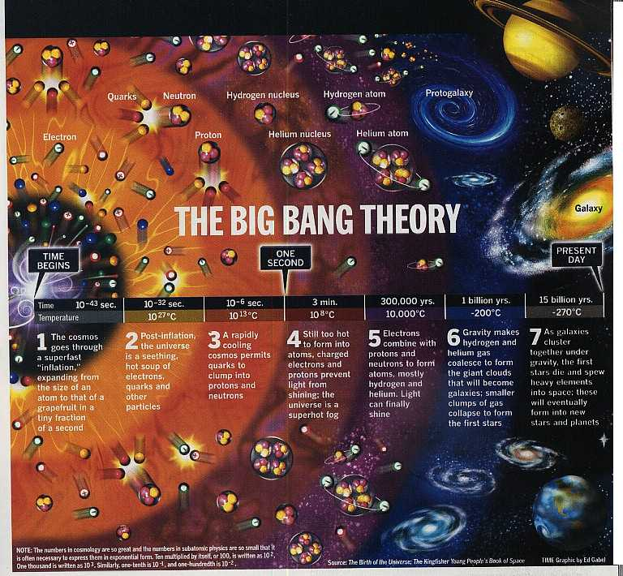

THE BIG BANG (A SIMPLE VERSION)

Draw your own pictures into the third column to illustrate the Big Bang.

|  |  |  |
| --- | --- | --- |
| 1 | Over 18 billion years ago, the universe is tiny – everything in it is compressed into the size of an atom. |  |
| 2 | Suddenly, for some unknown reason, this atom-sized universe expands like a balloon at an extremely fast rate. In a fraction of a second it becomes the size of a grapefruit. |  |
| 3 | Within the expanding universe is a seething mad-hot soup of crazy particles and electrons and quarks and stuff. |  |
| 4 | It starts to cool down and all particles begin to clump together and hold on to each other (they might be scared because it is still too hot to allow light to shine through). |  |
| 5 | It gets even cooler. Atoms form and light begins to shine through the soup. Gravity makes gases and stuff stick together to form whole galaxies and stars etc. |  |
| 6 | Billions of years later planets like ours begin to form. The universe is still expanding now. Many scientists believe that one day the process will reverse and the universe will contract again – The Big Crunch. |  |

Questions

**Proof Or Theory?**

**PROOF MEANS….**

**A THEORY IS…**

My alternative theory

|  |
| --- |
|  |
|  |
|  |
|  |
|  |
|  |
|  |
|  |
|  |
|  |
|  |

|  |
| --- |
|  |

The biblical creation story

|  |  |  |
| --- | --- | --- |
|  |  |  |
|  |  |  |
|  |  |  |
|  |  |  |

And on the seventh day…

Key points from the biblical creation story…

Road Trip

**Conspiracy**

|  |  |  |
| --- | --- | --- |
|  | What is the theory? | What are your thoughts? |
| 1 |  |  |
| 2 |  |  |
| 3 |  |  |
| 4 |  |  |
| 5 |  |  |

**Evolution & natural**

**selection**

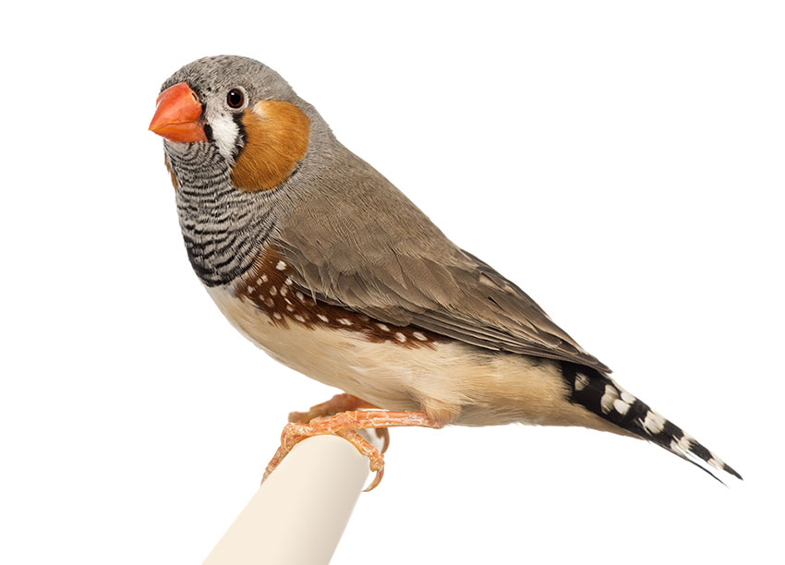

Explain what Charles Darwin discovered about finches.

|  |
| --- |
|  |

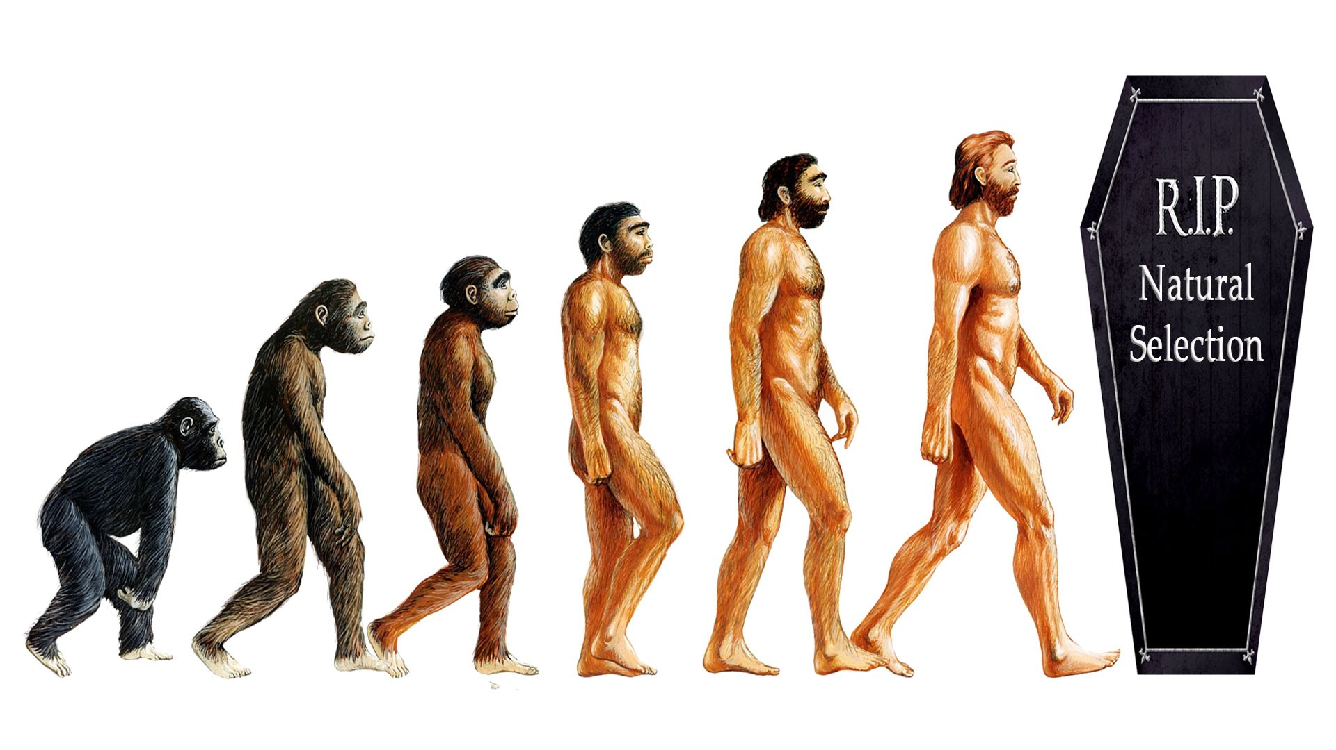

What is this picture telling us?

|  |
| --- |
|  |

FILL IN THE BLANKS!

|  |
| --- |
| The theory of _____________ is widely accepted by scientists as how ___________ came into existence. It was made famous in the nineteenth ___________ by the work of Charles ___________. He said that all life evolves by ___________ ____________. For example, on an island where the main food supply is hard ____________, only the finches with the best nut-cracking ________ survive to breed more ________-beaked __________. The animals or plants that are best ___________ to their ____________ survive. Those that are not ________ out.  According to this theory, human, ____________ and plant life had __________ itself! However, Darwin never attempted to explain where the original ___________ blocks of life on __________ came from, just how they adapted and changed once they were here. |
| Words to help (but watch out for the one that shouldn’t be there!):  designed evolution humanity century beaks building  animal Earth Darwin natural selection strong suited  pies nuts finches environment die |

WHAT REALLY UPSETS CREATIONISTS ABOUT THE BIG BANG AND EVOLUTION?

Write down the order you think these following statements should come in, with 1 being the most offensive to Christian Creationists (those who believe the biblical story of creation is right), 2 being slightly less offensive, 3 being even slightlier less offensive…etc. Then, in your own words, explain why you have put them in this order.

|  |  |  |
| --- | --- | --- |
| STATEMENT | RANK  (IN ORDER OF OFFENSIVENESS TO CHRISTIAN CREATIONISTS) | YOUR REASON FOR RANKING. |
| The Big Bang is full of chaos and nothing is in control. Everything is random. |  |  |
| It took such a long period of time – hundreds of millions of years. |  |  |
| The universe is uncaring and full of things that can destroy us. There are no rights and wrongs. |  |  |
| Human beings are just another form of animal. |  |  |
| Humans have evolved and developed into our current form so that we are best suited to our environment. We look like this because of the world in which we live. |  |  |

CAN YOU BE A CHRISTIAN AND A SCIENTIST AT THE SAME TIME?

Yes!

Many Christians accept the scientific versions of creation and evolution. Many scientists are Christians. It would be wrong to think that no Christians accept Big Bang theory as most of them probably do. Those who don’t are called Creationists.

* Many Christians see the Genesis creation story as myth. They do not look for scientific truth in the bible. They see it as a kind of poem or hymn to be used in worship. It tells them something about God, not about how the universe was created.
* Many Christians accept that when the bible was written, people did not have the scientific knowledge we have now, so it was never going to be an accurate explanation of how the world was made.
* Many Christians believe God is “Transcendent” – he exists outside the universe. He was the one who started the Big Bang, and he designed the universe to develop without his input. Humans might have evolved, but that was part of the process that God “programmed” into the universe.

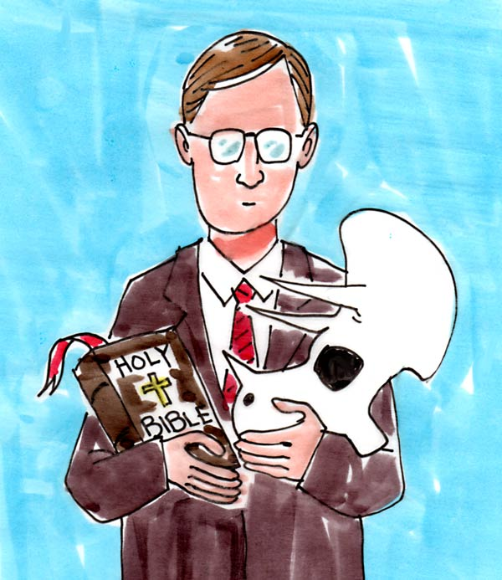

HUMANS

|  |
| --- |
| made God men women and as a creation special In bible the. |
|  |
| them gave He place pride of. |
|  |
| made were They God image of in the. |
|  |
| were They given of live to in The Of Eden Garden. |
|  |
| perfect was Everything! |
|  |

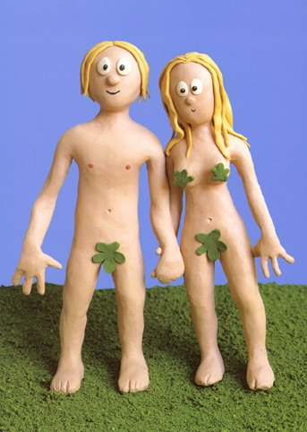

SO WHAT WENT WRONG?

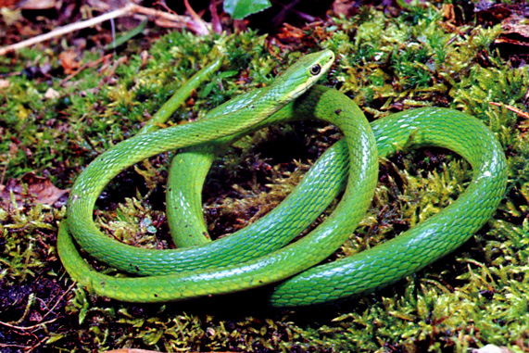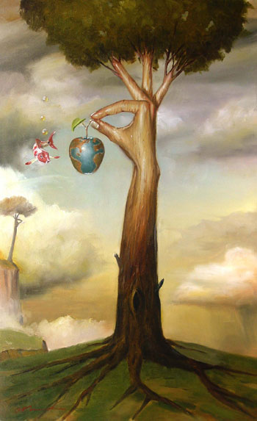

According to the bible, God’s perfect and good world was tainted with evil and suffering when a serpent tempted Eve to eat the fruit from the Tree Of Knowledge in the Garden Of Eden. This explains why the world we now know is not as perfect and good as God says it is during the story of the creation.

challenge Two



The motion is…

“This house believes that science will save us from climate change.”

INSTRUCTIONS

You will work in teams of three. Your team will either be proposition (for the statement) or opposition (against the statement). Each member of your team will stand up and speak for three minutes. You should prepare your speeches together so that you are not repeating or contradicting each other.

Each three minute speech is split as follows:-

* Minute one = protected (no interruptions).
* Minute two = Points Of Information (interruptions from the team playing against you) are allowed, but you don’t have to accept them.
* Minute three = protected.

You will be playing against another team of three people who will hold the opposite view to you. Speeches run in the following order:-

|  |  |  |  |
| --- | --- | --- | --- |
| PROPOSITION |  |  | OPPOSITION |
| P1 | first | second | O1 |
| P2 | third | fourth | O2 |
| P3 | fifth | last | O3 |

As you listen to the speeches of the team against you, you must also give them a score out of ten. At the end of the debate each member’s scores should be added up.

MY TEAM

Speaker One________________________________________________

Speaker Two________________________________________________

Speaker Three_______________________________________________

We are……………. .PROPOSITION/OPPOSITION

(Delete as appropriate)

SCORE SHEET (FOR THE TEAM AGAINST US)

|  |  |  |  |
| --- | --- | --- | --- |
| Speaker (name). | Evidence And Technical Terms  /5 | Debating Skills  /5 | Total  /10 |
|  |  |  |  |
|  |  |  |  |
|  |  |  |  |

MY SCORE (OUT OF 30):___________

DEBATE SCORING

|  |  |
| --- | --- |
| USE OF EVIDENCE/TECHNICAL TERMS | SCORE |
| One mark for each technical term or word used, up to a maximum of five marks. No marks for repetition of the same word or term. | 0 - 5 |

|  |  |  |
| --- | --- | --- |
| What To Look For | At this level the student… | SCORE |
| Nothing relevant/nothing said. | * *Shows no knowledge or understanding of the issue.* * *Has misunderstood the concept or has not prepared.* | 0 |
| A basic point made on the subject or a statement of opinion without any real explanation. | * *Shows a little, but not much understanding of the issue.* * *Has some awareness of what the statement means* * *Can see that people can have an opinion about it.* | 1 |
| A fully explained argument or opinion BACKED UP with reasoning and some explanation  OR…  More than one basic, outlined argument or statements of different opinions without any real explanation. | *Can either:*   * *demonstrate knowledge and understanding of one key aspect of the debate*   *or*   * *show an awareness that there are a number of different points of view/ideas.* | 2 |
| Fully explained argument(s) or opinion(s) BACKED UP with reasoning and some explanation, together with an attempt to ARGUE AGAINST opposite views. | * *Shows understanding of the issue* * *Shows understanding that there are two sides to the argument* * *is able to make some attempt to argue against the opposite view* | 3 |
| A number of different views/arguments are addressed. All points made are well argued and successful. The speech is persuasive. | * *Knows the arguments for and against and can explain/criticize them.* * *Can confidently explore and support or attack a number of the arguments for and against the statement.* | 4 |
| A number of different views/arguments are addressed. All points made are well argued and successful. The speech is persuasive AND REFERENCES ARE MADE TO CURRENT AFFAIRS/REAL LIFE ISSUES. | * *Knows the arguments for and against and can explain/criticize them.* * *Can confidently explore and support or attack a number of the arguments for and against the statement.* * *Understands the relevance of the issues to the real world.* | 5 |

Debate Speech

|  |
| --- |
|  |
|  |
|  |
|  |
|  |
|  |
|  |
|  |
|  |
|  |
|  |
|  |
|  |
|  |
|  |
|  |
|  |
|  |
|  |
|  |
|  |
|  |
|  |
|  |
|  |
|  |
|  |
|  |

**Climate change**

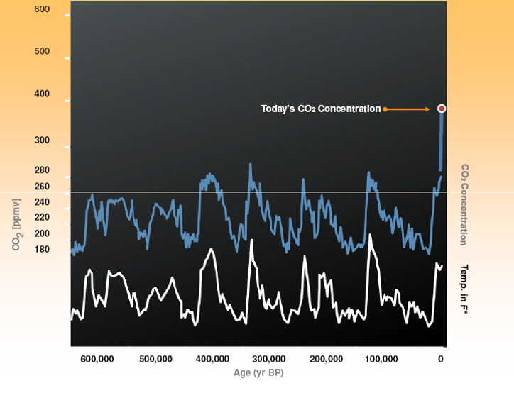

|  |
| --- |
| What does the chart tell us? |
|  |

|  |
| --- |
| Notes from the video. |
| **Living With The Enemy** |

|  |  |
| --- | --- |
| STEWARDSHIP | DOMINION |
|  |  |