**A letter to the *Missouri Gazette* newspaper in 1847.**

Mr. Editor; Below you will find a list of the main articles necessary for a one-way trip to

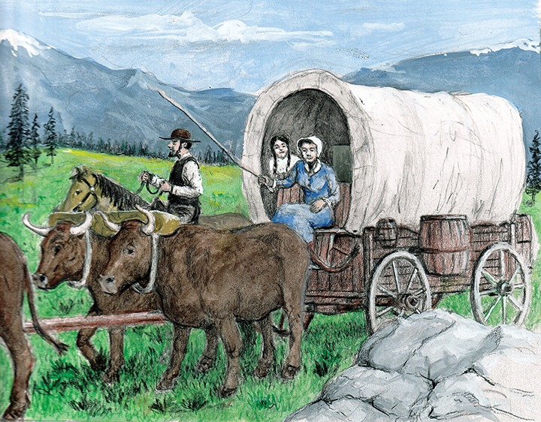Oregon or California, which may be useful to some of your readers. It has been carefully prepared with correct information from intelligent persons who have made the trip.

The wagons should be new, made of thoroughly seasoned timber, and well ironed and not too heavy; with good tight beds, strong bows, and large double sheets. There should be at least four yoke *(pairs)* of good oxen to each wagon - one yoke *(pair)* to be considered as extra, and to be used only in cases of emergency. Every family should have at least two good milk cows, as milk is a great luxury on the road.

*A typical wagon used by pioneers*

The amount of provisions should be as follows; **for each person** except infants:

200 pounds of bread stuff (flour and crackers)

100 pounds of bacon

12 pounds of coffee

12 pounds of sugar

**Each family** should also take the following articles in proportions to the number as follows:

From 1 to 5 pounds tea

From 10 to 50 pounds rice

From 1/2 to 2 bushels beans

From 1/2 to 2 bushels dried fruit

From 1/2 to 5 pounds saleratus (baking soda for cooking pies and cakes)

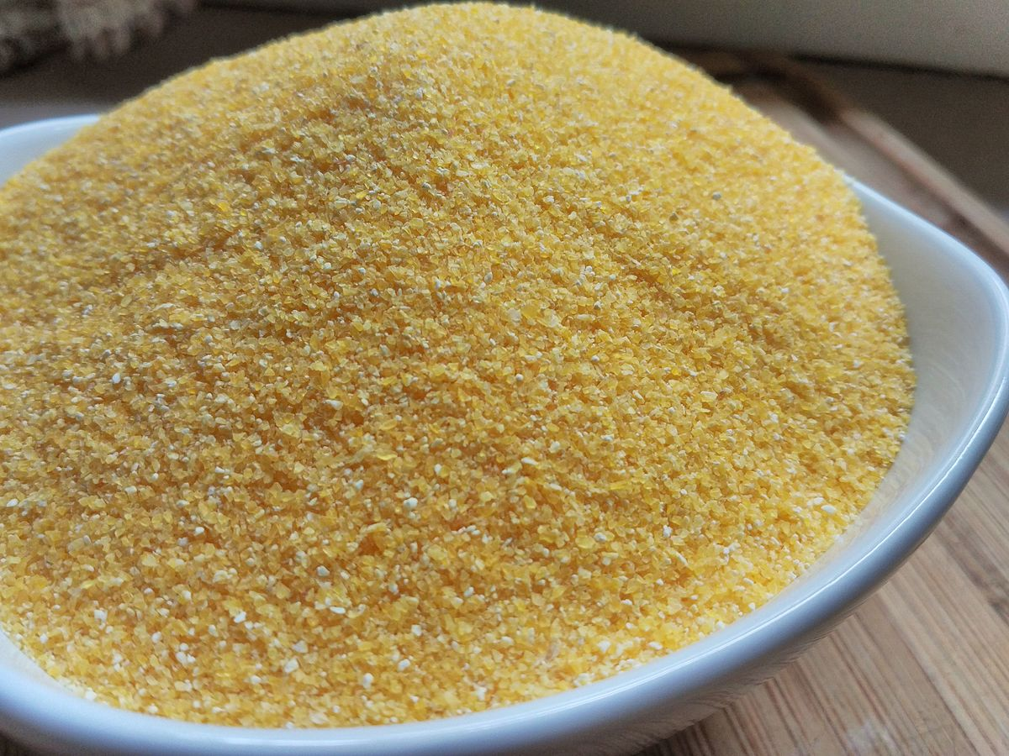From 5 to 50 pounds soap

Cheese, dried pumpkins, onions and a small portion of corn meal may be taken by those who desire them. The corn meal, however, does not keep well. A few cattle should be taken for beef and to start your farm on arriving West, but much loose stock will be a great annoyance.

No furniture should be taken, and as few cooking utensils as are needed for day-to-day cooking. I would suggest to each family taking a

*Cornmeal*

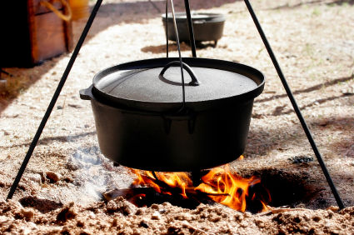small sheet-iron cooking stove with fixtures, as the wind and rain often times renders it almost impossible to cook without them, they are light and cost but little. Every family ought to have a sufficient supply of clothing for at least one year after their arrival, as everything of that kind is high in those countries. Some medicines should also be found in every family, the kind and quantity may be determined by consulting the family physician. All the other articles may be purchased on good terms in this place.