

***Shadow Curriculum Year 9***

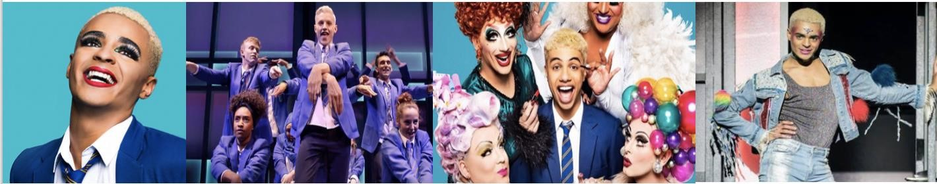

***Everybody’s Talking About Jamie***

In this project you will do some independent learning about Theatre skills and context through looking in more detail at *Everybody’s Talking About Jamie.*

The musicalwas inspired by the story of Jamie Campbell and his mother, Margaret Campbell. When Jamie was 15, he wrote to a TV documentary company asking them to make a programme about him. He wanted to wear a dress to his end-of-year prom. He didn’t know what reaction he would get, from his fellow class mates, or even the school and teachers, but he wanted to do it to be true to himself. The documentary aired on BBC Three in 2011, telling his story and how he found the courage to do it.

This musical is inspired by Jamie Campbell’s story, but set in Sheffield. We see the build-up to the school prom and the challenges he and his family are faced with. And we also discover that it is his true friendships that give him the bravery and loving support to carry out his ambitious drag queen act. Watch this clip to give yourself an idea of the context/creative intentions of this musical:

<https://www.youtube.com/watch?v=yhGAVyxuY9c>

## TASK ONE: Synopsis

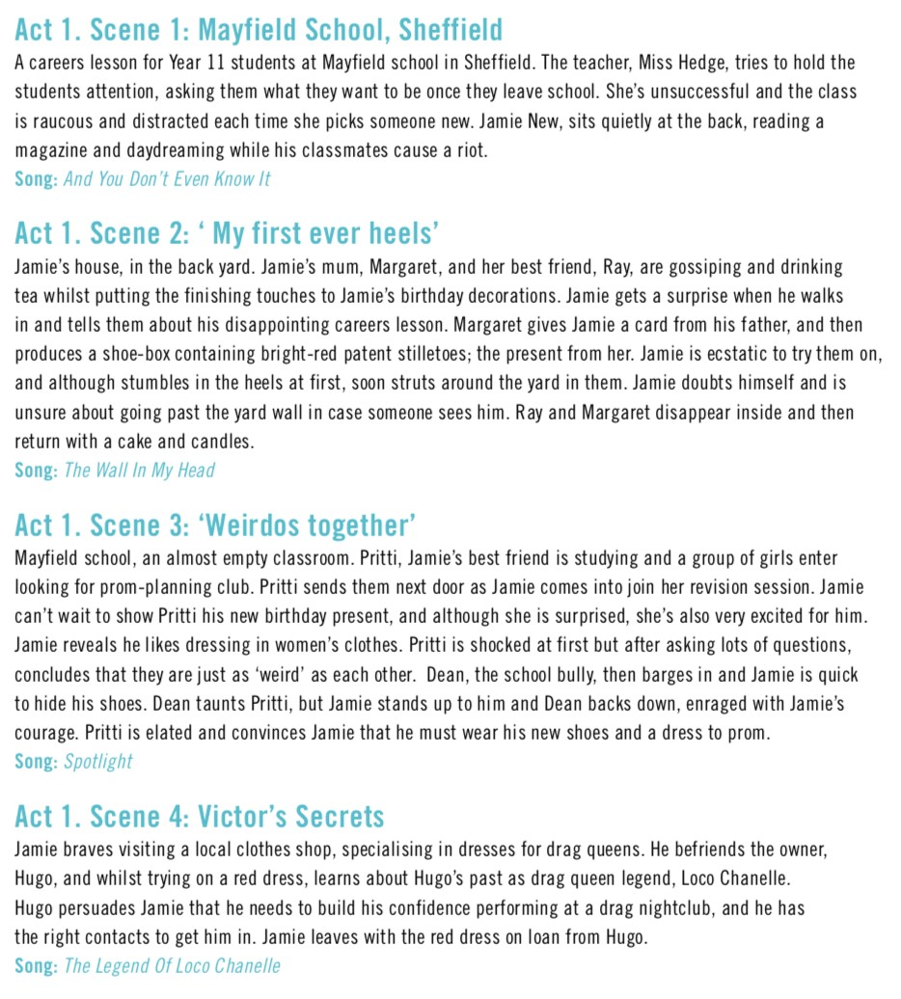

**SYNOPSIS (continued)**

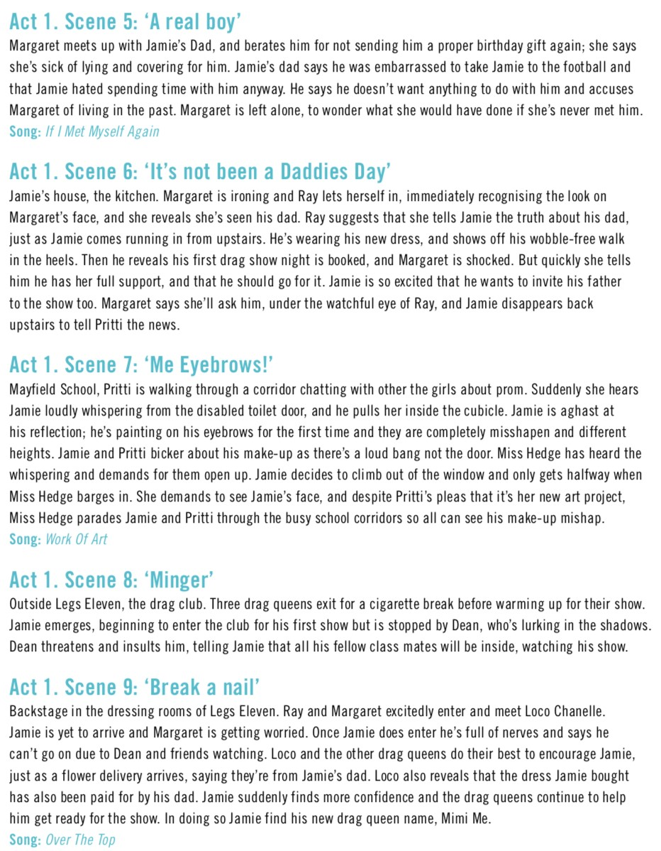



**SYNOPSIS (continued)**

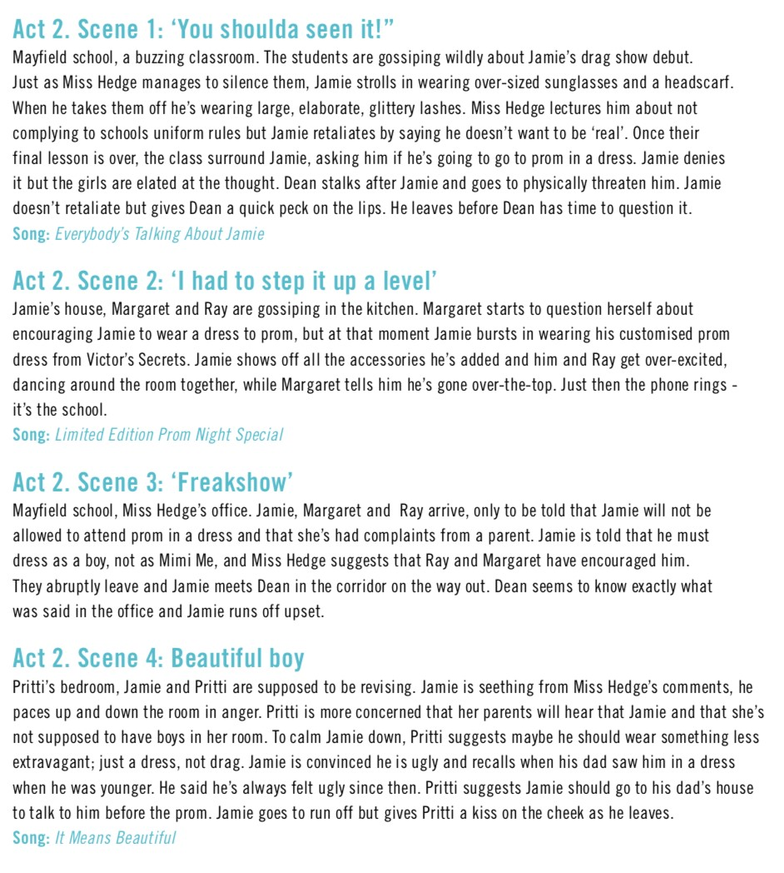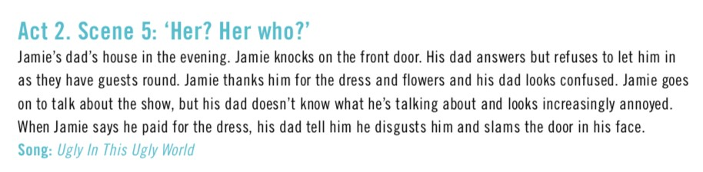

**SYNOPSIS (continued)**



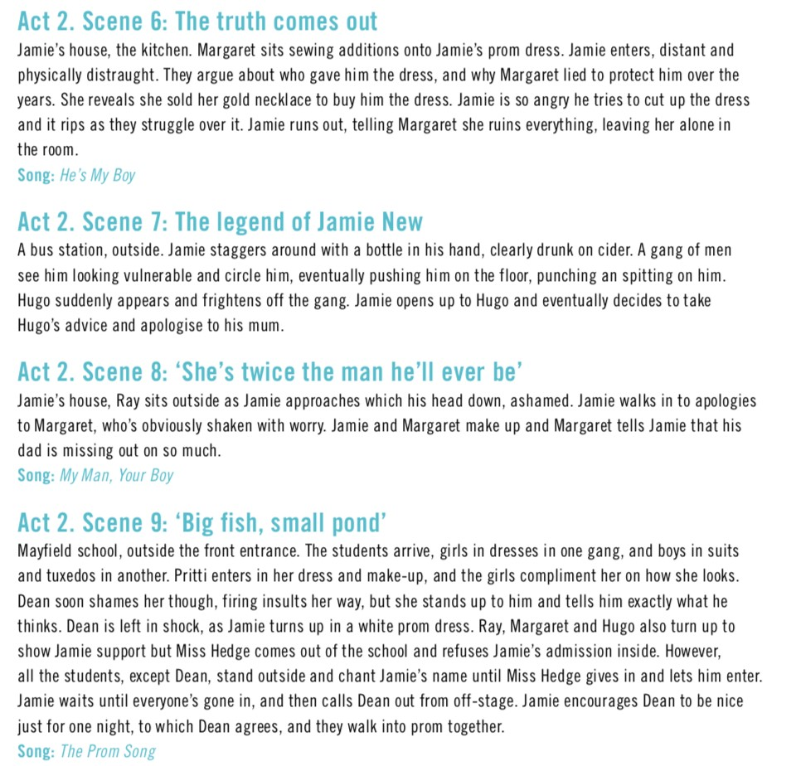

Now that you have read the synopsis, summarise what you think the storyline of the musical is in your own words.





## TASK TWO: Characters

*ETAJ* features several lead characters who have different relationships with Jamie. Your task is to fill in the last two columns. In the ‘Relationship with Jamie’ column, consider if it is a positive or negative relationship and why. In the last column list some words such as ‘brave’ or ‘kind’.

**These scenes will help to give you a better idea of the central characters:**

* **SCENE 1** – Jamie, Pritti, Dean, Miss Hedge:<https://www.youtube.com/watch?v=SktfkVTkNEQ>• **SCENE 2 –** Jamie, Margaret, Ray (watch from 1:56 to 7:58):

<https://www.youtube.com/watch?v=9vKbOXy6-vo>

* **SCENE 3** – Jamie, Pritti, Dean, Bex and Becca: <https://www.youtube.com/watch?v=HQ3yd-Ff5ZU>
* **SCENE 4**- Jamie, Hugo: <https://www.youtube.com/watch?v=xTNut38c60Y>
* **SCENE 6** – Jamie’s Mum: <https://www.youtube.com/watch?v=zP7N-nKZSFc>

|  |  |  |  |
| --- | --- | --- | --- |
| **CHARACTER** | **DESCRIPTION** | **RELATIONSHIP WITH JAMIE** | **CHARACTERISTICS** |
| **Jamie New** | Jamie is a Year 11 student at a school in Sheffield. He is openly gay, but he has a dream to go to the school prom in drag. He wants to be fabulous and no one is going to stop him. |  |  |
| **Margaret New** | Margaret is Jamie’s mother. She has had a hard life bringing Jamie up on her own after his father abandoned them. She is fiercely protective and supports Jamie wholeheartedly. |  |  |
| **Ray** | Ray is Margaret’s best friend. She is a constant feature in the household, and tries to encourage Margaret to put herself first once in a while |  |  |
| **Pritti** | Pritti is Jamie’s best friend. She is quite geeky, and is only really interested in studying and obeying her parents. Jamie reveals his plans to her and she tried to help him. |  |  |

## TASK TWO: Characters (continued)



|  |  |  |  |
| --- | --- | --- | --- |
| **CHARACTER** | **DESCRIPTION** | **RELATIONSHIP WITH JAMIE** | **CHARACTERISTICS** |
| **Dean** | Dean is the class bully, and is not impressed by Jamie’s desire to become a drag queen. |  |  |
| **Hugo/Loco Chanelle** | Hugo works in the dress shop where Jamie goes to find his prom dress. Hugo was a drag queen in his younger life (Loco Chanelle) and imparts his wisdom to Jamie. |  |  |
| **Jamie’s Dad** | Jamie’s dad left when he was very young. He abandoned Jamie and his mum to start a new relationship and family with someone else. Since he left he has had no contact with Jamie. His mother has tried to hide this. |  |  |
| **Miss Hedge** | Miss Hedge is the Headteacher at Jamie’s school. She has a very traditioanl attiude about careers options. Upon hearing Jamie’s intentions she bans him from the prom. |  |  |

Watch a video interview with the Director here:

<https://www.youtube.com/watch?v=kBwUmPZPYYU&feature=youtu.be>

## TASK THREE: Creative Intentions (Themes)



The production presents a number of different relationships, from strong friendships, to difficult family structures and negativity. These relationships are not just central to Jamie, but between other lead characters too. As the central characters react to, Jamie’s revelation, he is both surrounded by negativity, and love/respect from the people who care about him.

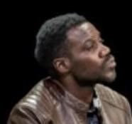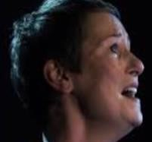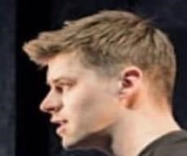

Watch this video interview with the director about relationships: [https://www.youtube.com/watch?v=x_eVxypBPaI&feature=youtu](https://www.youtube.com/watch?v=x_eVxypBPaI&feature=youtu.be)  [. be](https://www.youtube.com/watch?v=x_eVxypBPaI&feature=youtu.be)

Draw lines to connect the people who have relationships with each othe r – use green for positive and red for negative.

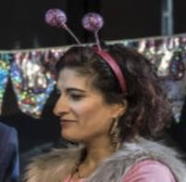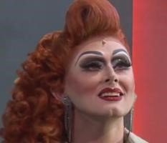



The idea of finding out who you really are and being true to yourself is an important theme in *Everybody’s*

*Talking About Jamie.* The lead character, Jamie, is on a journey to discover who he is and who he wants to

be, despite the adversities of his school mates, teacher and his father. It is his inner passion to share his

authentic self with the world, and prove that he can stand up and take the criticism and arrogance. We also

see his class mates and best friend Pritti discovering who they are, and what they want to be once they leave

the confines of their small worlds and move into adulthood. Margaret, Jamie’s mum, also reaches a moment

where she needs to leave her past-self behind, and move forward with her life, discovering who she is without

the burdens of her own past holding her back. Watch these clips from the director and Jamie:

<https://www.youtube.com/watch?v=rlr7H4E-HOY&feature=youtu.be>

<https://www.youtube.com/watch?v=nQj7nopteOE&feature=youtu.be>

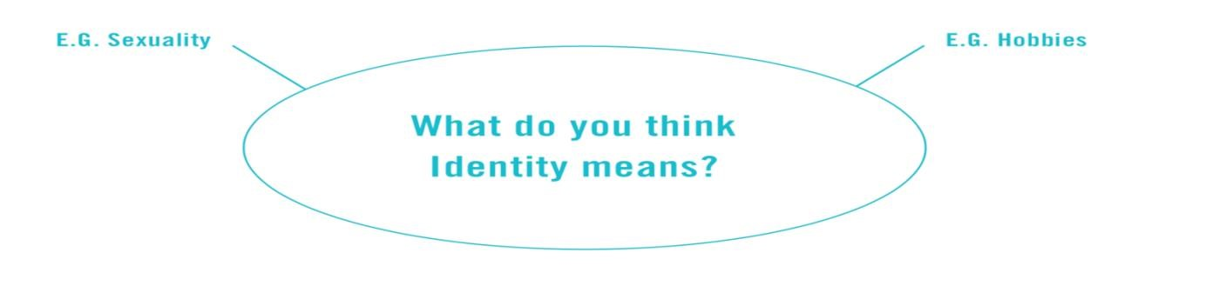

## TASK THREE: Creative Intentions (Themes)



Resilience is defined as the capacity to recover from difficulties quickly. In the storyline, this is linked implicitly to the theme of relationships, and how Jamie uses the positivity of those that care and understand him, to power through the resistance of others in order to fulfil his dreams and be himself. Use the table below to show how you think the different characters have shown resilience.

|  |  |  |
| --- | --- | --- |
| **CHARACTER** | **HOW HAVE THEY SHOWN RESILIENCE?** | **WHO HAS HELPED THEM?** |
| **Jamie New** |  |  |
| **Margaret New** |  |  |
| **Pritti** |  |  |
| **Hugo** |  |  |

## TASK THREE: Creative Intentions (Themes)



Jamie is comfortable with being gay. He has confidence in this and therefore others accept and respect him. The characters of Pritti and Margaret really highlight their understanding and compassion towards their friend and son. Pritti is initially wary about Jamie’s choice to wear women’s clothes but after seeing how much it means to him and that it won’t hurt others, she fully supports him and actively encourages him. Jamie is rarely victimised and not pitied because he is determined to celebrate who he is and doesn’t mind being different.



There are many other important themes explored in *Everybody’s Talking About Jamie*. Select a theme from the list below and explain why it is important to Jamie’s story. How is it represented in the storyline?

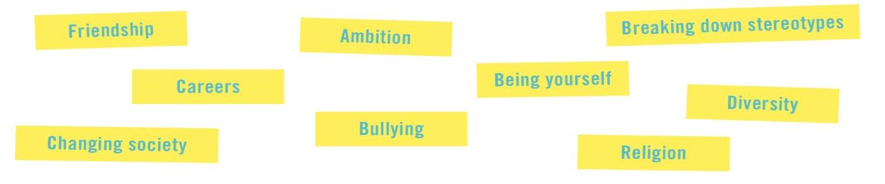



## TASK FOUR: Creative Intentions (Purpose)

What do you think the purpose of this musical is? Several headings on this list could apply. Complete the table below indicating why you think it was written.

|  |  |  |
| --- | --- | --- |
| **PURPOSES** | **TICK** | **REASON WHY YOU THINK THIS** |
| To educate |  |  |
| To inform |  |  |
| To entertain |  |  |
| To provoke |  |  |
| To challenge views |  |  |
| To raise awareness |  |  |
| To celebrate |  |  |

## TASK FIVE: How the Musical was created

ONCE UPON A TIME in a small, former mining village in County Durham lived a boy called Jamie Campbell. Jamie always knew he was different and from a young age he liked to dress in girls’ clothes.

At school, Jamie was mostly able to dismiss the taunts about being gay from the nastier children – “I mean, it was stating the obvious” he says. Besides, the ash of originality in his hairstyles or minor adjustments to the dull uniform they all had to wear – but mostly his exuberant approach to life – had long given the game away that he *was* different, and happily so.

So whilst everyone knew he was gay, Jamie had a big, big secret – his ambition was to be a drag queen and, deep breath, he wanted to attend the school prom in a dress when he and his classmates graduated in 2011. It’s surely a sign of how remarkable this young man is that he believed his prom ambition story should be shared with the wider world. “I just wanted to do this thing and when I want to do something I’ll do whatever it takes,” says Jamie.

Being a resourceful 15-year-old, Jamie went on the internet and typed “how to get a documentary made” into a search engine, sending an email to all the companies that came up on the results. But none replied, until – only a few months before the prom in 2011 – one, Firecracker, contacted him. It turned out he had sent his email to an account that was checked only sporadically.

## TASK FIVE: How the Musical was created

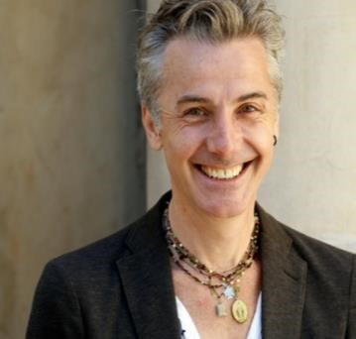Chance intervened again for Jamie: theatre director Jonathan Butterell was channel-hopping that night and came across the documentary. He immediately knew he had to put Jamie’s story on stage, and as a musical.

Jonathan stated in an interview: “*The documentary was my originating inspiration. However, I watched it with the MD and book writer once and once only. We needed to be free as a creative team to tell Jamie’s story in our own way, so we deliberately did not meet Jamie Campbell and his mum, Margaret, until after the show had been written and workshopped. I moved the setting from Durham to Sheffield, where I grew up, and where the production would be created. I changed Jamie’s surname from Campbell to New. I wanted to create Jamie’s world and expand the characters in it. In particular we invented the school and Jamie’s friends who were not part of the documentary.*

*The first time Jamie and Margaret Campbell saw the show was on opening night. They loved it. When they came onstage at the end of the show, they just hugged each other and cried. The audience went wild. It was an incredible moment.”*

Watch an interview with Jonathan Butterell here:

<https://www.youtube.com/watch?v=Tg3srvPox2k&feature=youtu.be>

**Use the space below to summarise the creation process in the order it happened:**

|  |  |
| --- | --- |
| **1** |  |
| **2** |  |
| **3** |  |
| **4** |  |
| **5** |  |
| **6** |  |
| **7** |  |
| **8** |  |

## TASK SIX: Analysing Examples

Now that you’ve had a chance to familiarise yourself with the storyline, characters and context, let’s take a closer look at some examples from *Everybody’s Talking About Jamie*. Watch each of the scenes and then answer the questions below.

**ACT I SCENE 1:** *And You Don’t Even Know It -* <https://www.youtube.com/watch?v=SktfkVTkNEQ>

1. What is happening in this scene. Why is it an important part of the story?

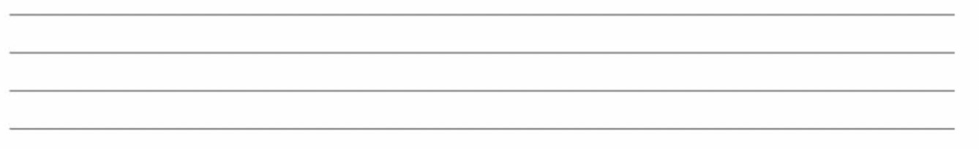

1. What does this scene tell us about the listed characters. Why do you think this?

1. Jamie New



1. Pritti Pasha



1. Miss Hedge



1. Identify some examples where you think technical skills have been used effectively

|  |  |  |
| --- | --- | --- |
| **PHYSICAL SKILL** | **EXAMPLE** | **HOW / WHY HAS IT BEEN USED?** |
|  |  |  |
|  |  |  |
|  |  |  |

|  |  |  |
| --- | --- | --- |
| **VOCAL SKILL** | **EXAMPLE** | **HOW/ WHY HAS IT BEEN USED?** |
|  |  |  |
|  |  |  |
|  |  |  |



|  |  |  |
| --- | --- | --- |
| **INTERPRETATIVE SKILL** | **EXAMPLE** | **HOW/ WHY HAS IT BEEN USED?** |
|  |  |  |
|  |  |  |
|  |  |  |

1. Name something that stood out for you in this scene (this could be a design element. Why does it stand out?



**ACT I SCENE 2:** *Wall in my Head (from 1:56) -*<https://www.youtube.com/watch?v=9vKbOXy6-vo>

**1.** What does this scene tell us about the listed characters. Why do you think this?

1. Jamie



1. Margaret



1. Ray



1. Identify some examples where you think technical skills have been used effectively

|  |  |  |
| --- | --- | --- |
| **PHYSICAL SKILL** | **EXAMPLE** | **HOW HAS IT BEEN USED?** |
|  |  |  |
|  |  |  |
|  |  |  |

|  |  |  |
| --- | --- | --- |
| **VOCAL SKILL** | **EXAMPLE** | **HOW HAS IT BEEN USED?** |
|  |  |  |
|  |  |  |
|  |  |  |

1. *In Wall in My Head*, what is Jamie singing about? How does the performer use skills to communicate this meaning to the audience?



1. What does the set design in this scene tell us about Jamie’s lifestyle?



**ACT I SCENE THREE:** *Spotlight* -<https://www.youtube.com/watch?v=HQ3yd-Ff5ZU>

1. The scene opens with Bex and Becca discussing prom plans whilst Pritti is revising. What vocal skills do they use to show their character and excitement about the prom?



1. Jamie shares his secret with Pritti by showing her his shoes. How do you think Jamie feels about sharing this? What physical and vocal skills tell us this? How does he use them effectively?



1. How does Jamie use technical skills to add humour to this scene and show us his character (include physical, vocal and interpretative)?





1. What do we learn about Pritti’s character in this scene? How does she use physical and vocal skills to show us who she is?



1. Name something that you liked about the song *Spotlight*. This could be any element you can see or hear. Why is it effective?



**ACT II SCENE FOUR**: *He’s my Boy -*<https://www.youtube.com/watch?v=zP7N-nKZSFc>

1. This song follows the scene when Jamie confronts Margaret about the lies she has told about his Dad. The performer has used a lot of skills to express emotion in this song. Tick the ones you can identify and give an example of where it has been used.

|  |  |  |
| --- | --- | --- |
| **VOCAL SKILLS** | **TICK** | **EXAMPLE – How has it been used?** |
| Breath control |  |  |
| Clarity/Articulation |  |  |
| Musicality |  |  |
| Pace |  |  |
| Phrasing |  |  |
| Projection |  |  |
| Tone |  |  |

|  |  |  |
| --- | --- | --- |
| **PHYSICAL SKILLS** | **TICK** | **EXAMPLE – How has it been used?** |
| Characterisation |  |  |
| Facial Expression |  |  |
| Gesture |  |  |
| Mannerism |  |  |
| Posture |  |  |
| Spatial Awareness |  |  |
| Stamina |  |  |

|  |  |  |
| --- | --- | --- |
| **INTERPRETATIVE SKILLS** | **TICK** |  |
| Awareness of audience and performance space |  |  |
| Characterisation |  |  |
| Focus, energy and  commitment |  |  |
| Interaction with and response to other performers |  |  |
| Stage presence |  |  |
| Use of space |  |  |

1. Name something that you liked about the song. This could be any element you can see or hear. Why is it effective?

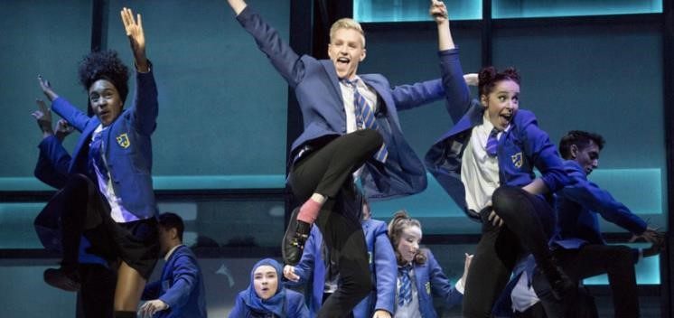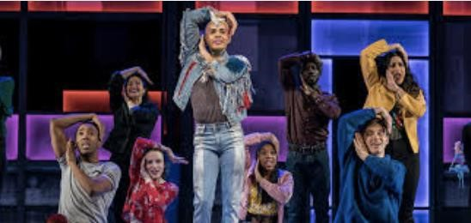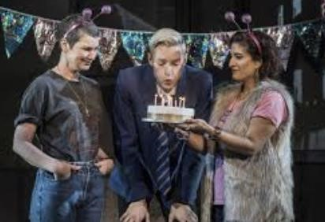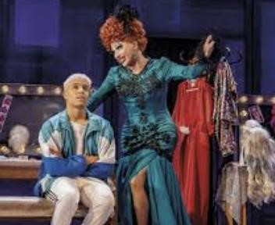

## TASK EIGHT: From Page to Stage

Now you have had a chance to explore the characters and the storyline of *Everybody’s Talking About Jamie*, your next task is to assume the role of the Director, and decide how you think a scene from the musical should be interpreted. Use this website to read more information on the process involved: <https://www.bbc.co.uk/bitesize/guides/zygqsbk/revision/1>

Before you begin the task, take a closer look at the central characters and complete the Role on the Wall below. The outside of the gingerbread man represents physical characteristics whilst the inside represents the personality or feelings of the character. Consider who they are and how the performers use characterisation to emphasise their personality.

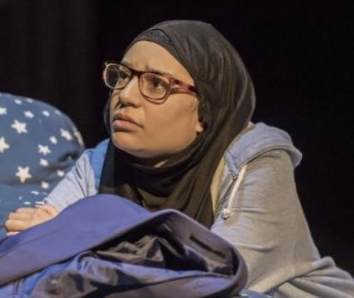

**USE OF TECHNCIAL SKILLS**

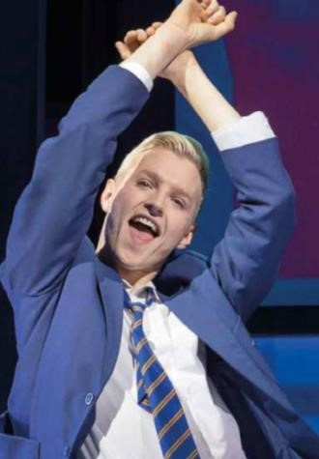

**USE OF TECHNCIAL SKILLS** You can watch the scene from the West End performance here (staring at 06:15):

<https://www.youtube.com/watch?v=Ru5B0GirYhA>

In this task we are going to focus on **line delivery**. Read the script below, and **annotate** it with the following:

1. the objective of each character in the scene

|  |
| --- |
| **What do we mean by objective?**    As in real life, characters have an objective or something they are trying to achieve.    Various barriers or obstacles can get in the way of that objective but nonetheless as a character you are aiming for something specific.    This is the objective, or ‘action’ that you play. Your objective should be a verb (not a noun) and start with “I want to...” or “I wish...”.    Ideally you should pick a ‘transitive verb’, which is a type of verb that impacts another person or object present. E.g. “I wish to intimidate...”. |

1. the objective of individual lines (to make the audience laugh, to feel empathy for a character, etc)
2. which physical, vocal and interpretative skills you would use for each line. Refer back to the key skills earlier in the booklet. You do not have to use all of them, but instead select the best choices to ensure effective line delivery. Try to make your performance more interesting by varying your choices.

**TIPS:**

* If you are doing this task on paper, use different colours for each task/type of skill.
* If you are doing this task on computer, use textboxes to annotate and colour code them.
* There is additional space at the end of the script if you need to make more notes.



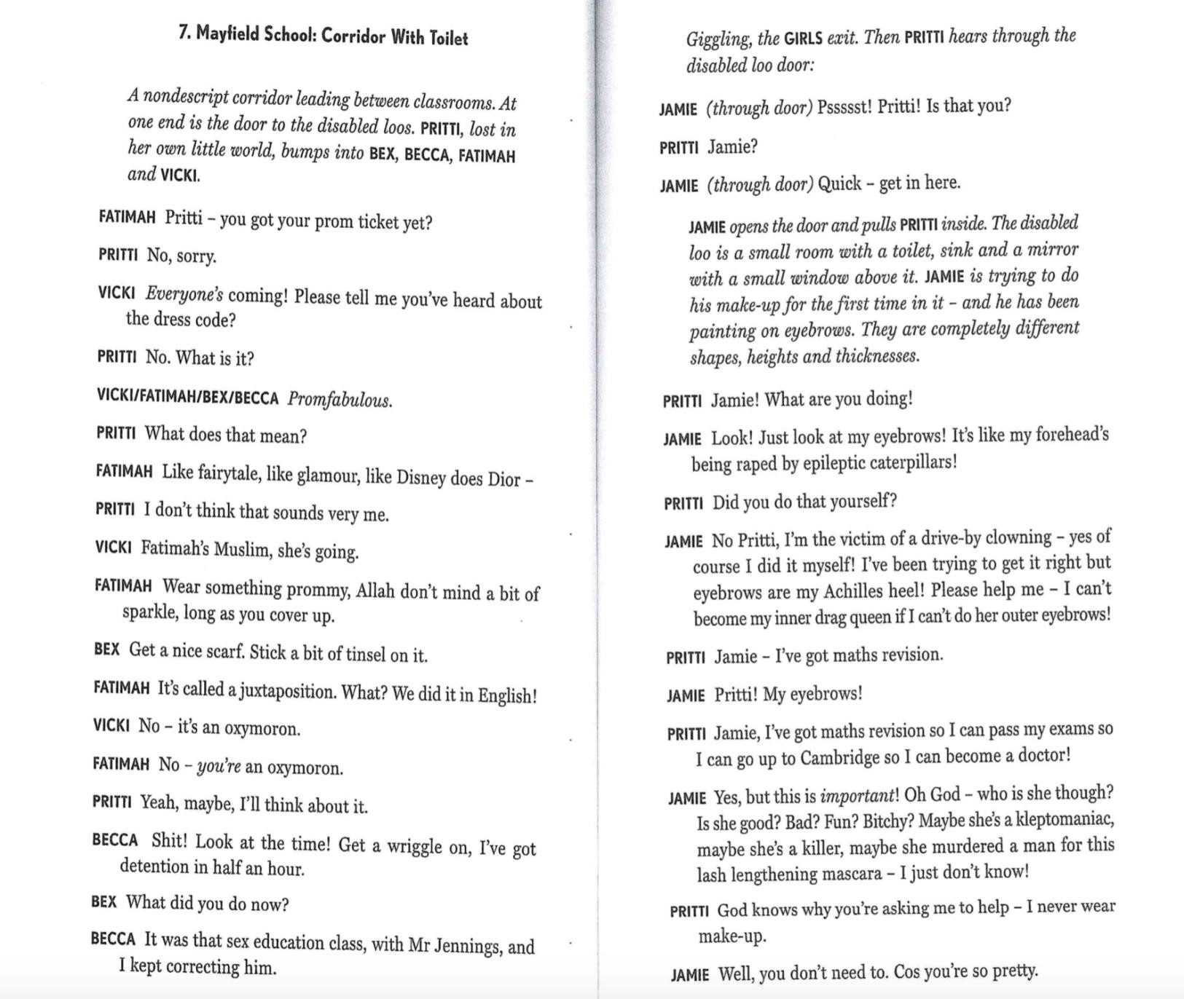

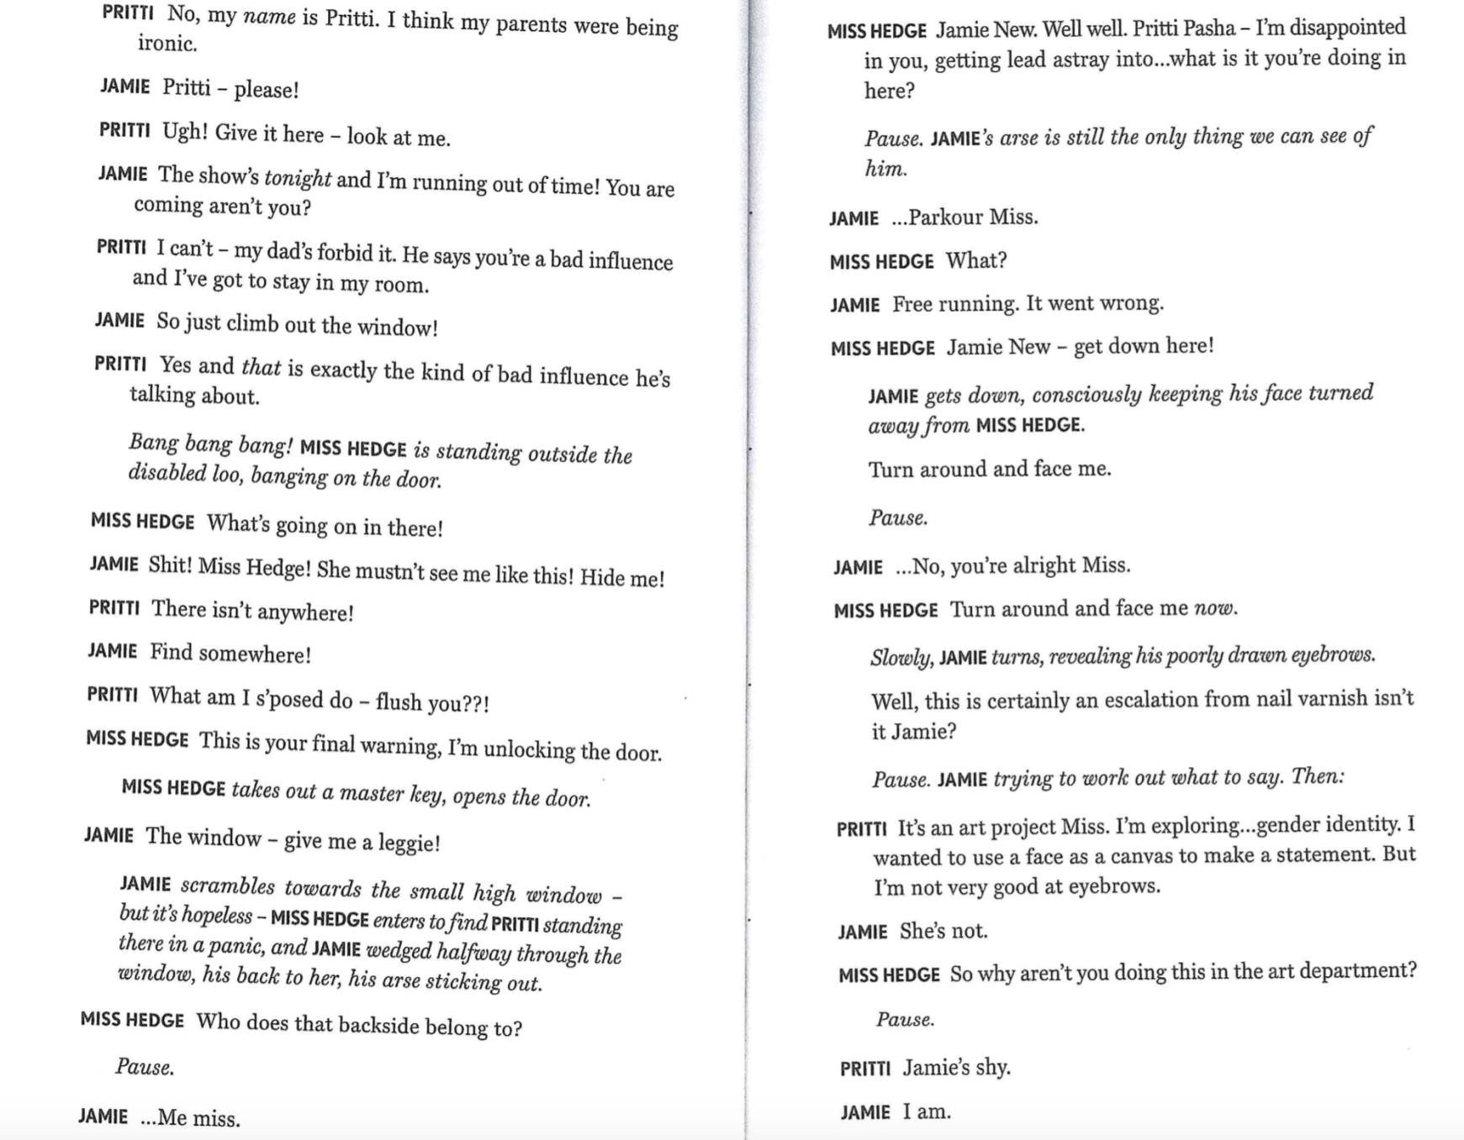

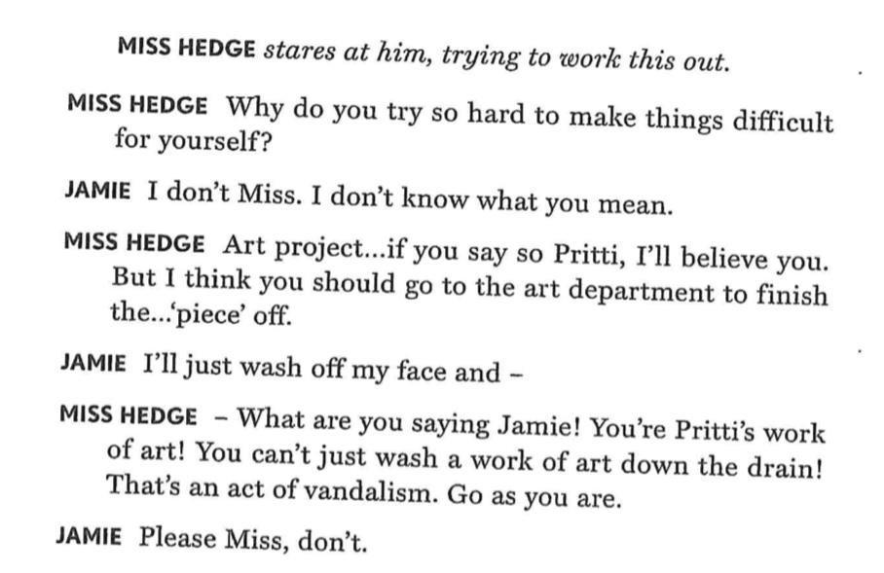



## TASK NINE: Creating a new character

Your next task is to create a new character that could be integrated into the musical. This could be another teacher, or school student, a drag queen that Jamie meets in Legs Eleven, or somebody completely different of your choice.

**Things to consider:**

* What is your character’s name?
* What is their relationship to Jamie? Is it positive or negative?
* How do you think the character should be portrayed?
* What will the character look like?

Use the space below to record your ideas. There are some prompts to help you.

**Character Name:** _____________________________________________

**Relationship to Jamie:** _________________________________________



What will they look like? Consider costume, hair and makeup:

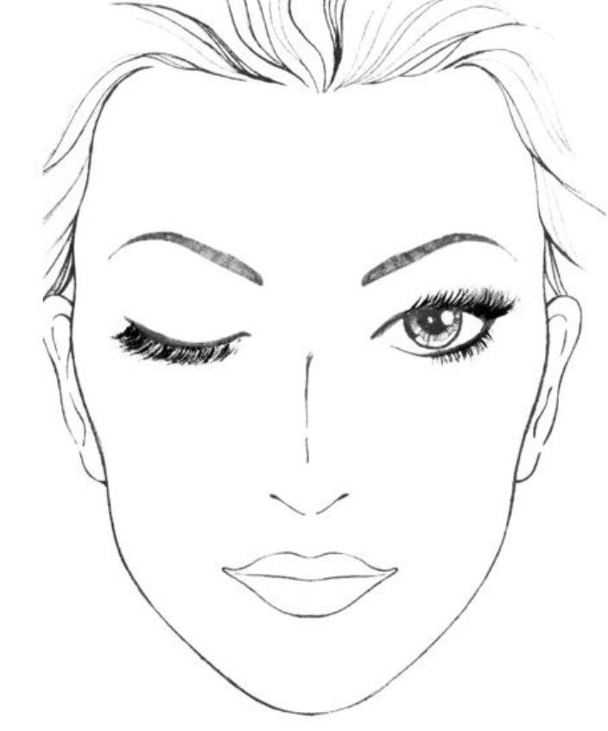

**Description of my ideas:**

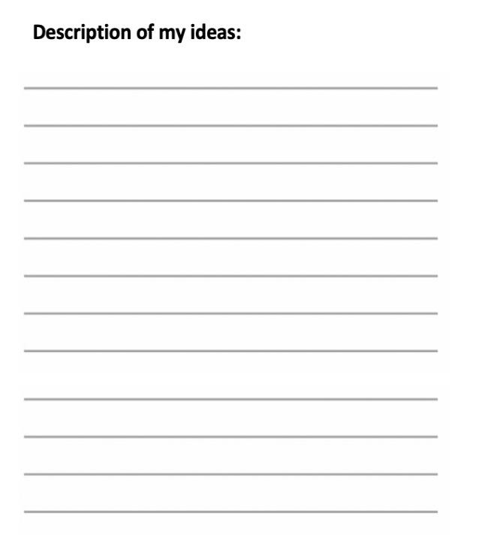

## TASK TEN: Writing a new scene

Your final task is to devise a new scene that could be used in the musical. This scene should include the new character you have created. Below are some tips to help you with this:

* identify the purpose of the scene – what do you intend to accomplish?
* identify the high moment. What is the key moment your scene is going to build toward? • conflict – what is the conflict what this conflict will do
* how will characters change by the end of the scene.
* leave out the boring stuff – think carefully about how line delivery would be used to make your scene more entertaining
* add narrative tags that are helpful and revealing
* make sure you have an engaging beginning and ending to the scene

Use the space below to plan your ideas and create a final draft of your scene. These will be acted out in lessons in the future.











## TASK Six: Theatre Performance Skills

As a musical theatre performer, you are expected to demonstrate **physical**, **vocal** and **interpretative** skills. Below is a list of skills that you need to develop in order to be a competent Musical Theatre performer. Based on your work in Musical Theatre so far, identify which skills are areas of strength, and which ones need further development, using ‘S’ for strength and ‘D’ for development.

|  |  |  |
| --- | --- | --- |
| **PHYSICAL SKILLS** | **DEFINITION** | **S/D** |
| Accuracy | ability to perform accurately – both in acting and dancing |  |
| Characterisation | ability to use physical skills to embody a character |  |
| Coordination | ability to move limbs independently of each other, and sing and dance **at the same time.** |  |
| Facial Expression | use of your face to express the mood/reactions of a character |  |
| Gesture | a movement of part of the body, especially a hand or the head, to express an idea or meaning |  |
| Mannerism | a characteristic gesture or way of speaking or behaving |  |
| Movement Memory | ability to perform choreography accurately |  |
| Posture | the position in which someone holds their body when standing or sitting |  |
| Spatial Awareness | showing an awareness of the space around you – other performers/set |  |
| Stamina | Being physically able to perform without running out of breath |  |

|  |  |  |
| --- | --- | --- |
| **VOCAL SKILLS** | **DEFINITION** | **S/D** |
| Accent | a distinctive way of pronouncing words, especially associated with a particular country, area, or social class |  |
| Breath control | ability to sing long notes, or a fast-paced song without running out of breath |  |
| Characterisation | Use of the voice to embody a character |  |
| Clarity/Articulation | ability to deliver lines clearly |  |
| Musicality | Use of musical expression to show the emotions of the character/communicate the meaning of a song |  |
| Pace | speed of dialogue – can be used for comic/dramatic effect |  |
| Pause | can be used during line delivery for comic/dramatic effect |  |
| Phrasing | shaping a song with pauses at the ends of phrases |  |
| Pitch | how high/low the voice is |  |
| Projection | ability to make sure your voice is heard clearly within the acting space |  |
| Tone | adding light and shade to vocals to emphasise specific words or communicate emotion |  |

|  |  |  |
| --- | --- | --- |
| **INTERPRETATIVE SKILLS** | **DEFINITION** | **S/D** |
| Awareness of audience and performance space | communicating a performance effectively to the audience, for example, by making sure you are facing them at all times |  |
| Characterisation | use of skills to communicate a character |  |
| Focus, energy and commitment | ability to remain energetic throughout a performance – indicated through use of skills |  |
| Interaction with and response to other performers | reaction to other actors on the stage |  |
| Stage presence | showing that you are confident and comfortable |  |
| Use of space |  |  |

Now identify **TWO** skills from each list that you think need further development, and suggest ways that you think you could improve. For example, you could improve your CLARITY by practicing tongue twisters. You can find lots of exercises for this on YouTube.

|  |  |  |
| --- | --- | --- |
|  | **PHYSICAL SKILL** | **WAYS I COULD IMPROVE** |
| **1** |  |  |
| **2** |  |  |

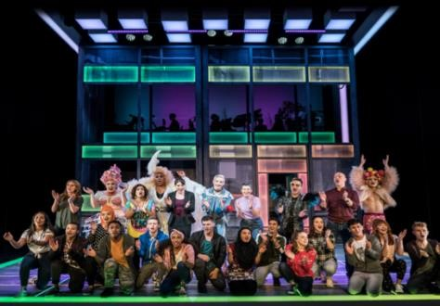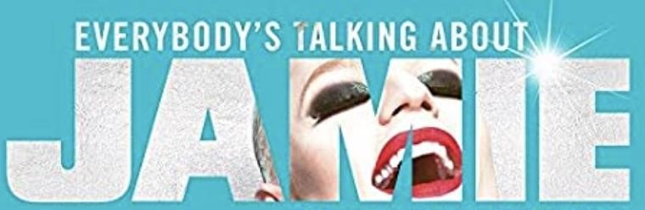

|  |  |  |
| --- | --- | --- |
|  | **VOCAL SKILL** | **WAYS I COULD IMPROVE** |
| **1** |  |  |
| **2** |  |  |

|  |  |  |
| --- | --- | --- |
|  | **INTERPRETATIVE SKILL** | **WAYS I COULD IMPROVE** |
| **1** |  |  |
| **2** |  |  |