Modelling Project – Victoria Sponge Cake Recipe

Version for Secure or Confident pathway students

You are to design and make a model that will calculate the costs of making sponge cakes. The model must be well presented and be easy to use. You may begin with the recipe template spreadsheet on O:\ or you can begin your own new spreadsheet.

- Find a recipe, on the Internet, for making a Victoria sponge cake, make sure the recipe tells you ingredients and amounts.

- Enter the recipe details into a spreadsheet. Edit and format the information to show the list of ingredients and amounts clearly. Separate all numbers to be used in calculations from text.

e.g. 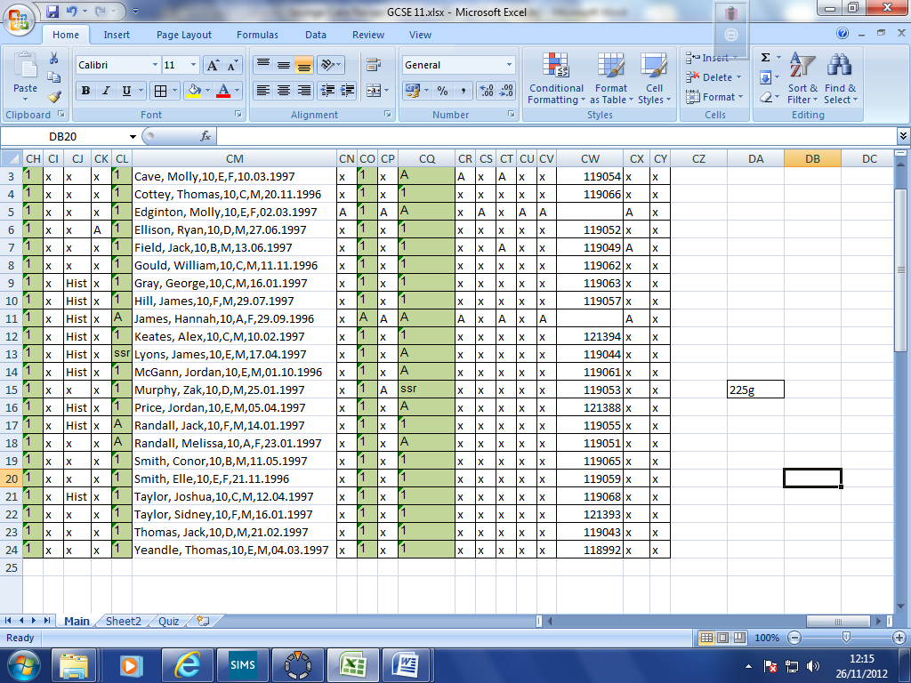 becomes 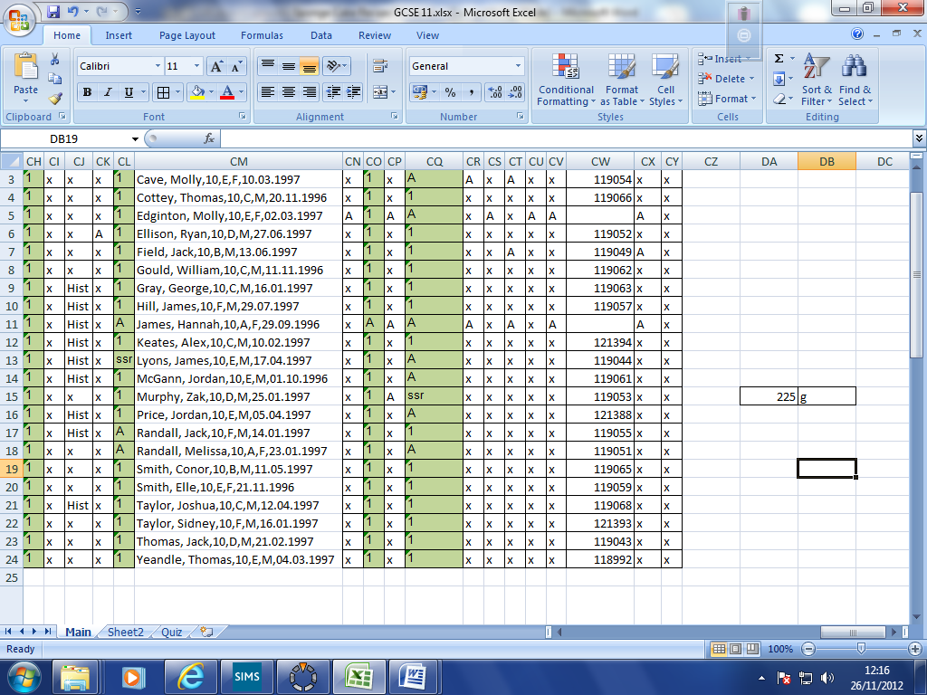

This worksheet should be called “Recipe”.

- Find out the costs of the ingredients needed and add this information to your spreadsheet. Make sure you are recording how much of the ingredients you get for your money.
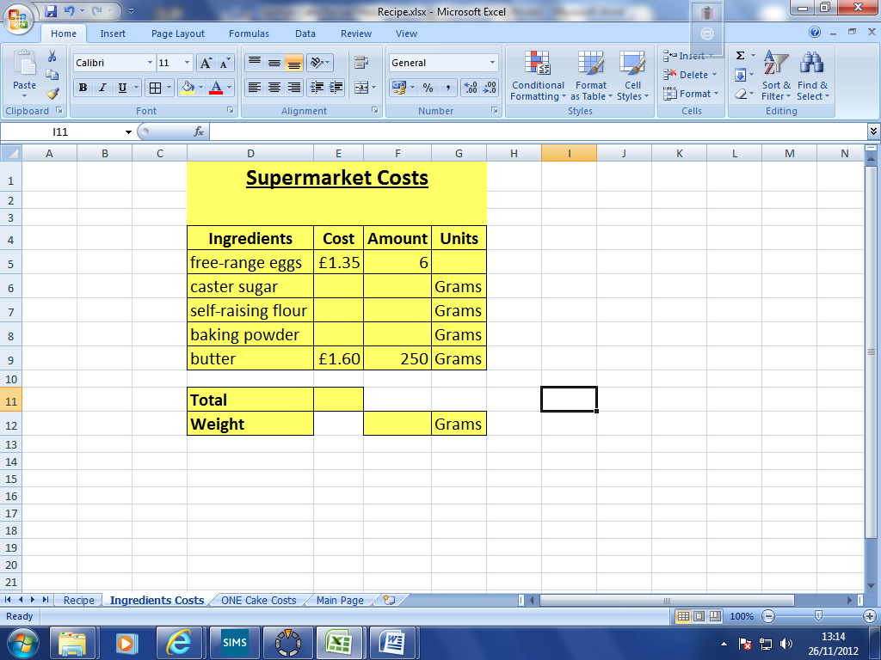

It should look like this above and should be on a separate worksheet tab.

- Use a formula to add up the ingredient costs

- Find out the weight of an egg. Then, see if you can calculate the total weight of all this shopping by adding all the weights together using a formula.

Extensions

Try to create a little converter on your spreadsheet to convert between pounds, US dollars and Euros. This will allow you to show your cake costs in 3 different currencies.

Add some pictures to your recipe and make it look fantastic.

Take a look at the Hard sheet, see if you can do any of the things mentioned on there.

