Spreadsheet Project – Victoria Sponge Cake Recipe

Version for Foundation and Secure pathway students

You are to make a spreadsheet that will help calculate the costs of making sponge cakes. The spreadsheet must be well presented and be easy to use.

- Find a recipe, on the Internet, for making a Victoria sponge cake, make sure the recipe tells you ingredients and amounts.

- Enter the recipe details into the recipe template spreadsheet on O:, on the Recipe tab. Edit and format the information to show the list of ingredients and amounts clearly. Separate all numbers to be used in calculations from text.

e.g. 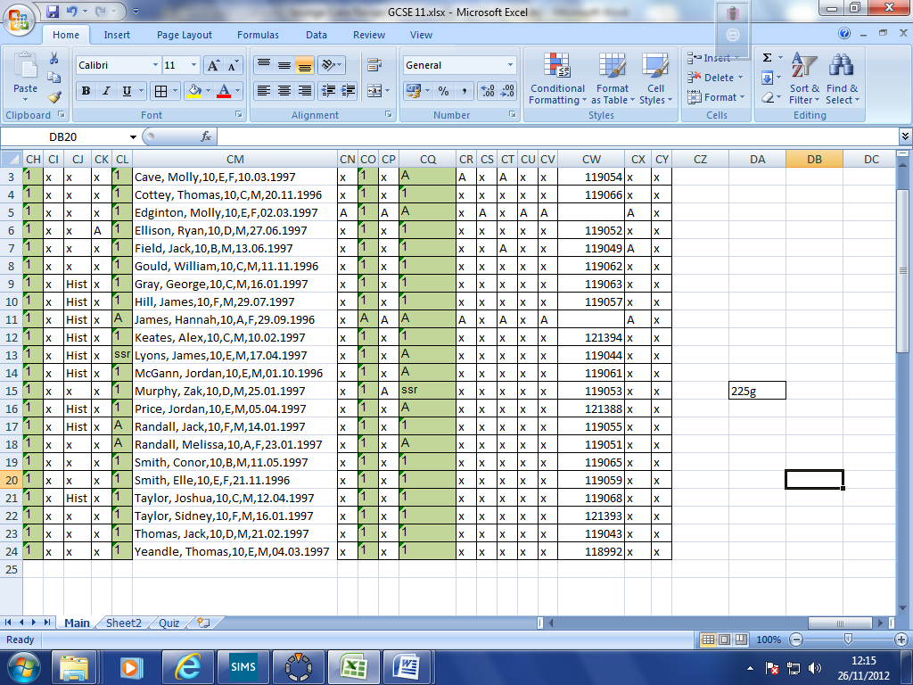 becomes 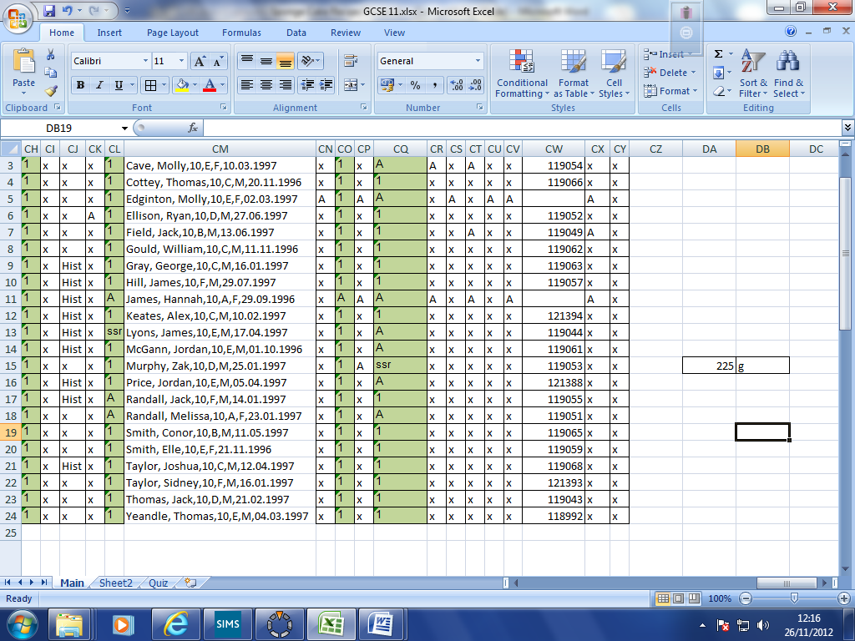

- Find out the costs of the ingredients needed from a supermarket website and add this information to your spreadsheet. Make sure you are recording how much of the ingredients you get for your money. Do this on the Supermarket Ingredients Costs tab.
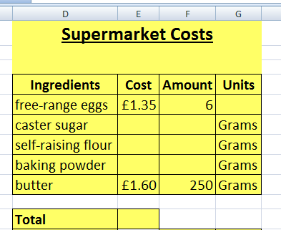

Use the grid like this one

- Create a formula to add up the ingredient costs

Extension

Add some pictures to your recipe and make it look fantastic.

Take a look at the Medium Difficulty sheet and try to do some of the things mentioned there.

