Modelling Project – Victoria Sponge Cake Recipe

Version for Confident or Exceptional pathway students

You are to design and make a model that will calculate the costs of making sponge cakes. The model must be well presented and be easy to use.

- Find a recipe, on the Internet, for making a Victoria sponge cake, make sure the recipe tells you ingredients and amounts.

- Enter the recipe details into a spreadsheet. Edit and format the information to show the list of ingredients and amounts clearly. Separate all numbers to be used in calculations from text.

e.g. 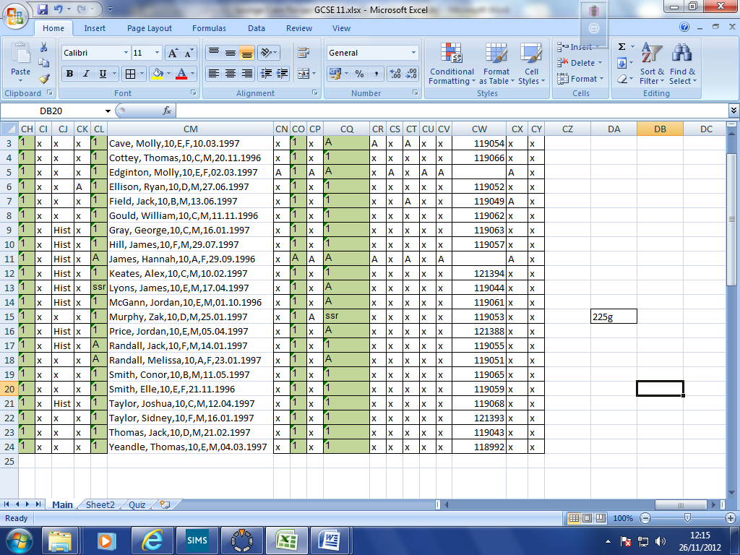 becomes 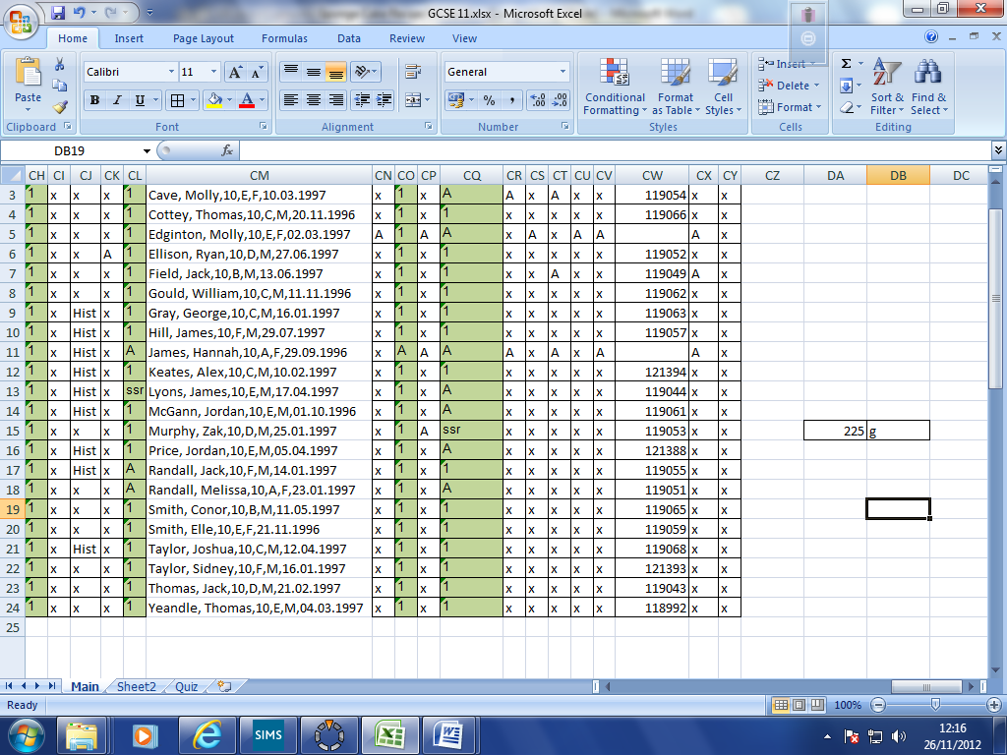

Rename the worksheet “Recipe”.

- Find out the costs of the ingredients needed and add this information to your spreadsheet on a new worksheet (call it “calculations”). Make sure you are recording how much ingredient you get for your money.
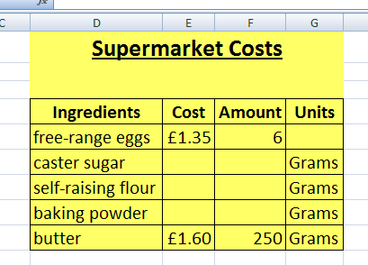

It should look like this above

- Create another similar grid to work out the costs of making one sponge cake. Place it next to the first one.

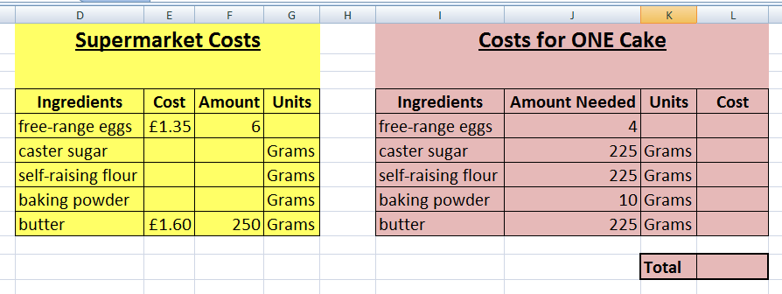

- Use the supermarket costs that you’ve found to calculate the costs of the amounts of ingredients needed to make ONE sponge cake. Use this to help:

=“Cost of ingredient at supermarket” ÷ “Amount you get” x “Amount you need for recipe”

e.g. a 250g pack of butter costs £1.25 at the supermarket, and you need 200g for your cake. So, £1.25 ÷ 250g x 200g = a cost of £1.00.

- Use a formula to calculate the total cost of making ONE Victoria sponge cake.

- Create a third section on your sheet to show costs and ingredients for any number of cakes.

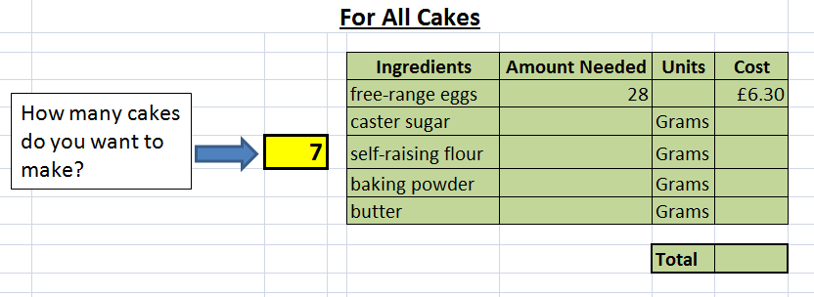

- Setup up this section of the model so that the number of sponge cakes wanted can be entered in and the model calculates quantities of ingredients needed and total costs.

- What other information might you want to include? Make your model look professional and appealing.

- Use your model to predict the cost and ingredients needed to make10, 50 and 200 sponge cakes.

Extensions

IF function
IF functions can be used to create warning messages if a number grows too large.
e.g. If (G6>40, “Over Budget”, “Within Budget”)
this formula would look at the cell G6 and decide if it was greater than 40; if it is then the message “Over Budget” would be displayed; if not, then “Within Budget” would be shown. Add an IF function to your model to produce a warning message if the total cost of making sponge cakes goes over £30.

Selling Cakes
Let’s say that you want to sell your cup cakes to make a profit. Set up your model so that you can enter a percentage profit, e.g. 10%, and the model will tell you the selling price.

