Name:_________________________ Tutor Group:_______

**Objectives: E & C student pathways must complete ALL tasks. S should complete New Folders. For F, all these tasks are optional.**

**Tick off each task that you do:**

**Making New Folders in your Inbox**

Making folders helps you organise your e-mails better. E-mails from particular people or about particular things can be put into folders.

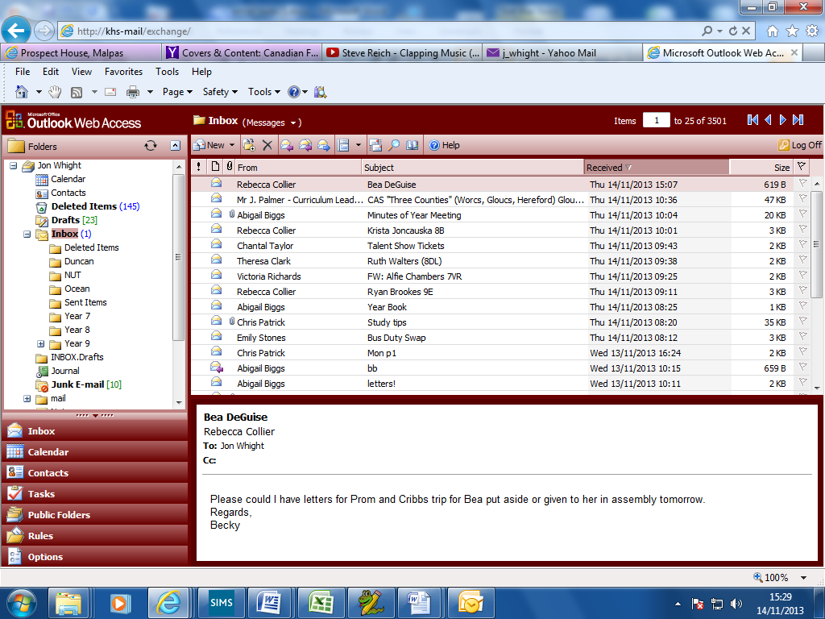 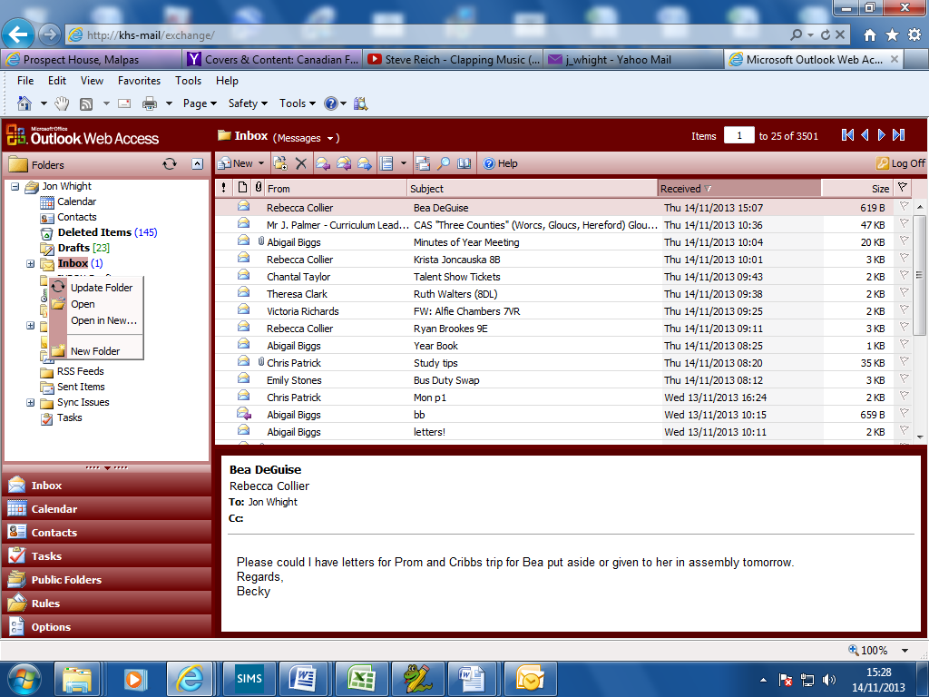

Click on the little + sign to expand the list

Right click on your Inbox and choose New Folder.

|  |  |
| --- | --- |
| **Task** | **Completed?** |
| Create 3 new folders in your Inbox. Name one after the person next to you; name one after another friend in the group; name the third after a group already made (e.g. “My Mates”) |  |

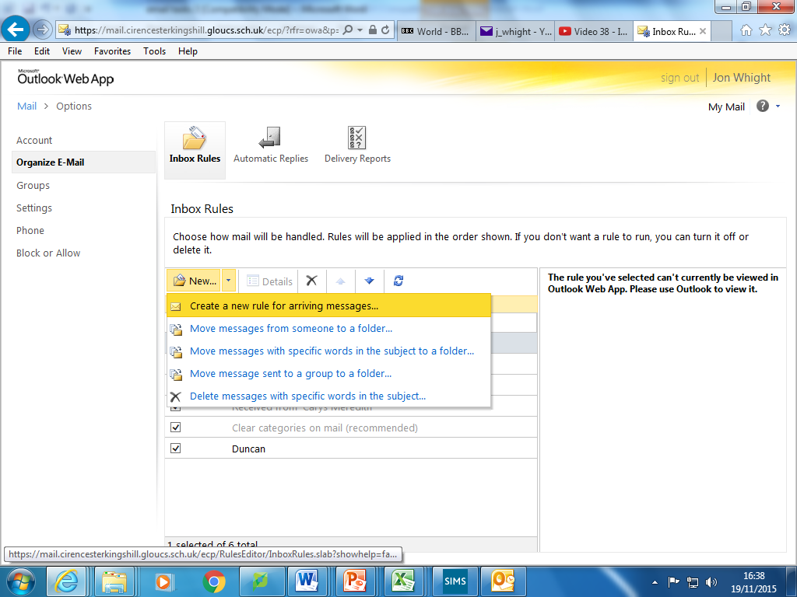

**Rules Tasks**

Click New.

Choose to make a new rule.

Then go through the setup.

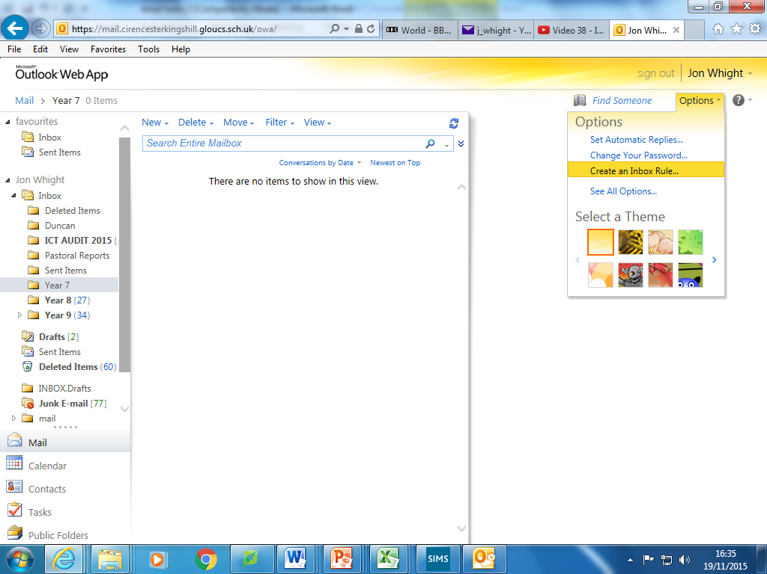

Click options. Then select Create an Inbox Rule

**Rules are used to control where e-mails sent to you end up. You will be making some rules to direct incoming e-mails into specific folders.**

|  |  |
| --- | --- |
| **Task** | **Completed?** |
| Create a new rule to redirect e-mails from the person next to you into the folder named after them. Get them to send you a message to test it. |  |
| Create a new rule to redirect e-mails from your other friend into the folder named after them. Get them to send you a message to test it. |  |
| Create a new rule to redirect e-mails from someone else sitting near you into the Deleted Items folder. Test this. Then delete the rule (it was only a test!) THIS IS HOW YOU WOULD BLOCK AN E-MAIL ADDRESS. |  |
| Create a new rule to redirect e-mails from a distribution list into the folder named after it. Get someone from the list to send an e-mail to test it. |  |

**EXTENSION 1: Investigate and try out some of the other things in the Options menu**

**EXTENSION 2: Add some people to your Contacts**