Name:_________________________ Tutor Group:_______

**Objectives: E, C & S student pathways must complete ALL tasks. F should attempt all and achieve most.**

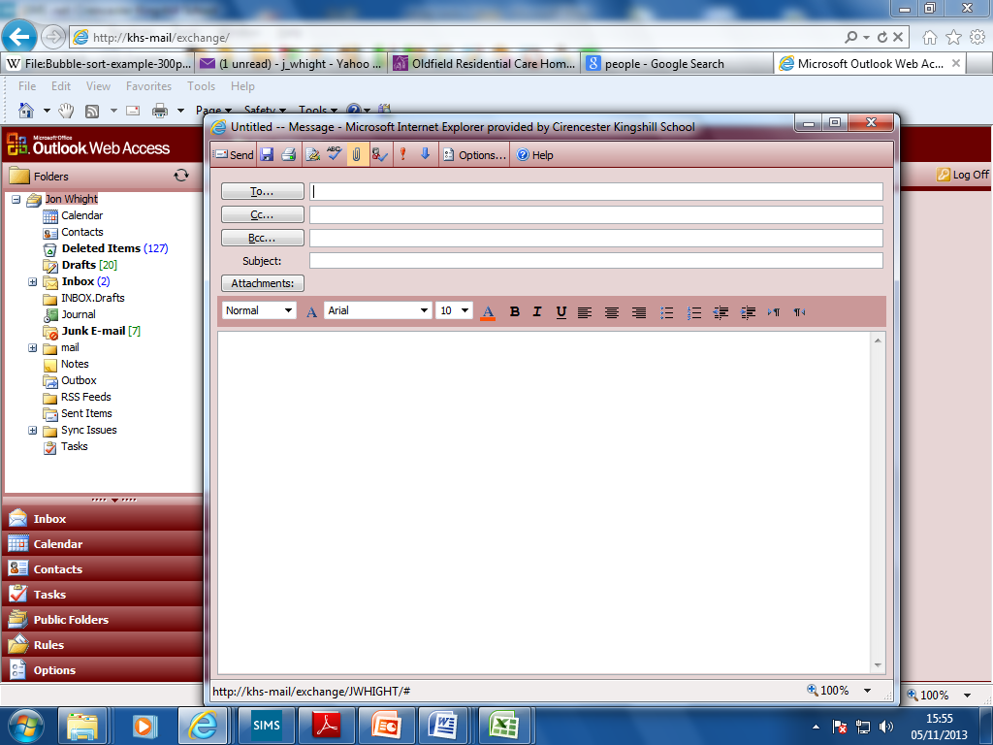**Tick off the tasks in the lists that you have done:**

**Attachments Tasks**

|  |  |
| --- | --- |
| **Task** | **Completed?** |
| Create a new e-mail and attach the document called “TEST ATTACHMENT” (the document is in **O:\ICT**). Send it to **jwhight** and bcc it to the person sitting next to you. |  |
| Find a picture of someone you admire on the internet. Save that picture into your Computing folder. |  |
| Attach that picture to an e-mail and send to someone else in the group asking that person to reply. Task is complete when you receive the reply. |  |

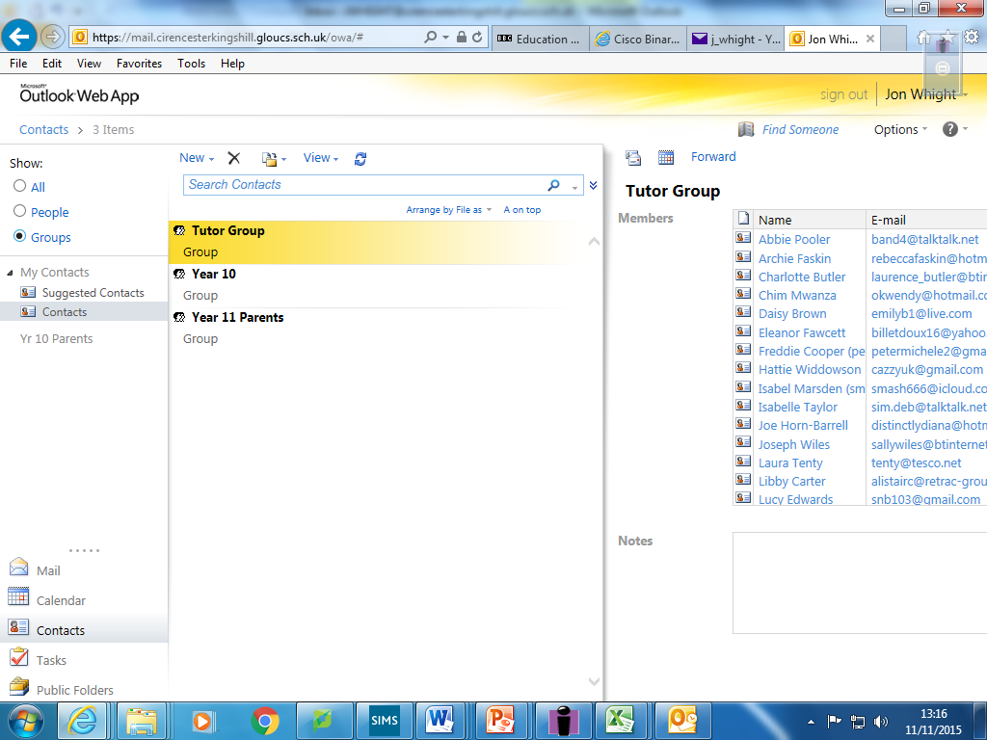**Contact Groups (or “Distribution Lists”) Tasks**

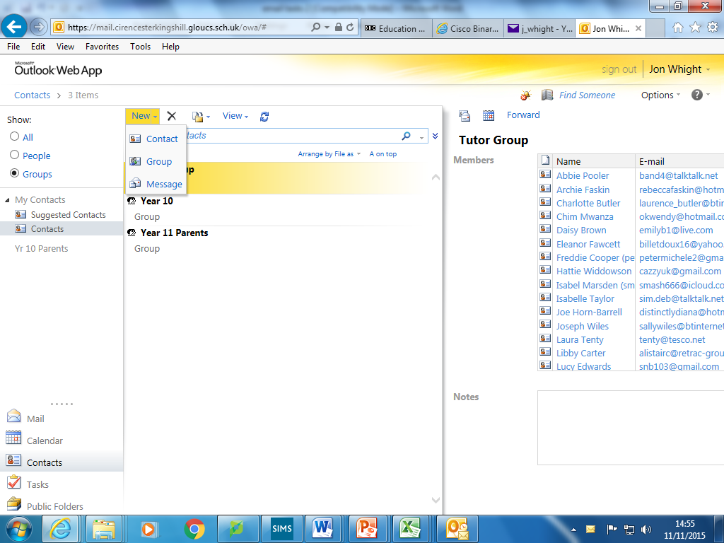

Click next to New to create a Group

First, switch to Contacts. Contacts is where you can make your own address book. You can also set up Groups here.

|  |  |
| --- | --- |
| **Task** | **Completed?** |
| Create a new Group and add 5 e-mail addresses to it of people in your tutor group. Name the list and save it. |  |
| Create an e-mail asking for a reply and address it to your Group. Send the e-mail. Task is complete when you receive the reply. |  |
| Create a second Group containing e-mail addresses of friends from any tutor group. |  |
| Delete any e-mails that you don’t want from your mail box. |  |

1. Why are Groups useful? How do they save time?

_______________________________________________________________________

1. Can you think of an example where a Group may cause you problems?

_______________________________________________________________________

1. Why are attachments useful?

_________________________________________________________________________