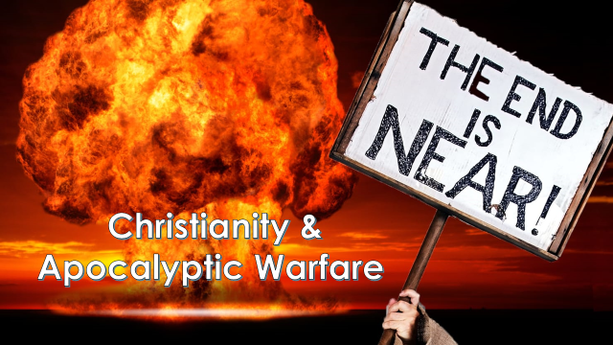

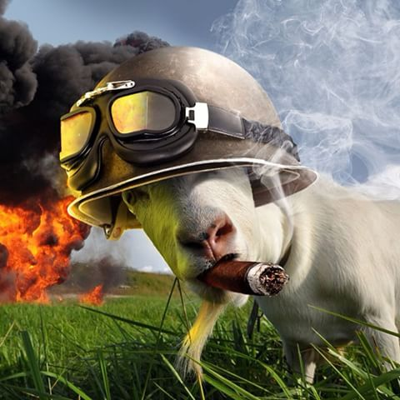

**How Scared**

**Should We**

**Be?**

**It’s The End Of The World As We Know It…**

|  |
| --- |
|  |
| 1. Nuclear Holocaust |
|  |
| 1. AI robots attacking humanity |
|  |
| 1. A new civil war in the UK |
|  |
| 1. Wars fought with electronic zombie bacteria |

|  |  |  |  |
| --- | --- | --- | --- |
| **ISSUE** | **CHRISTIAN VIEW 1** | **CHRISTIAN VIEW 2** | **OTHER** |
| Nuclear  Weapons |  |  |  |
| Use of armed drones |  |  |  |
| Biological  warfare |  |  |  |

Do these advancements make the world a safer or more dangerous place?