

|  |  |
| --- | --- |
| Absolute Pacifism | Conditional Pacifism |
|  |  |





|  |
| --- |
| Some of Jesus’ Teachings |
| **Let him who is without sin cast the first stone.** |
| **Don’t judge the speck in your brother’s eye when you’ve got a whopping log in your own eye.** |
| **Forgive us our sins as we forgive those who sin against us – The Lord’s Prayer.** |
| **The parable of the Unforgiving servant** |

The parable in pictures:

|  |  |  |
| --- | --- | --- |
|  |  |  |
|  |  |  |

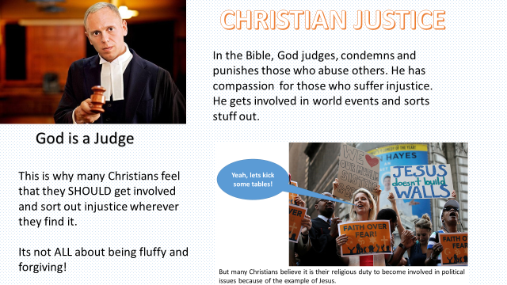

Do Christians have a duty to stand up against social injustice?

Find out more about…

Fair Trade

The Salvation Army

Amnesty International

Liberation Theology

Oscar Romero