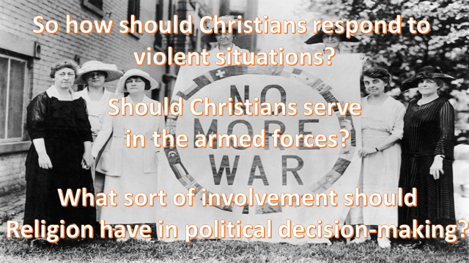

**How does religion and faith influence the decisions of the President of the USA?**

**Do you agree with St Paul’s view on the people who lead countries?**

**How does religion and faith influence the governing of the UK?**

**Do you think this makes the USA and the UK more or less likely to get involved in wars?**