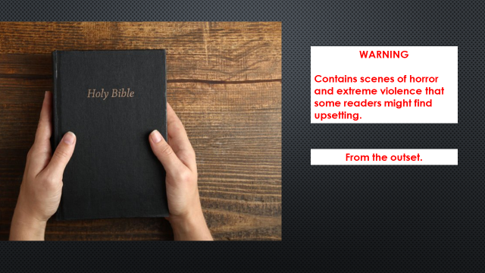

Cain and abel – whats the beef?

|  |
| --- |
|  |

Wrathful Old Testament God

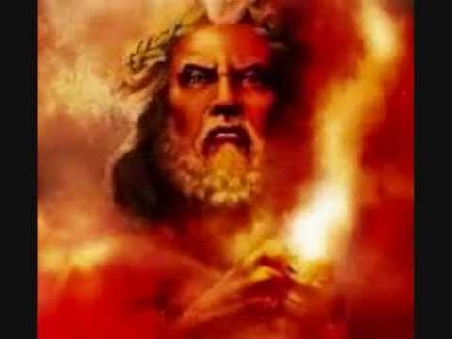

Peace Lovin’ Jesus



I prefer……………………………………………………………………………………………………

because……………………………………………………………………………………………………