WAR AROUND THE WORLD

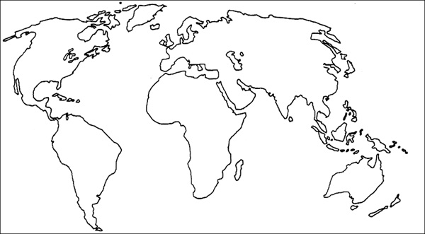

HOW DOES WAR AFFECT PEOPLE?

|  |  |  |
| --- | --- | --- |
| Children | Combatants | Combatants’ families |
|  |  |  |

In what ways are wars around the world affecting your life?

What sort of world would you say we are living in?