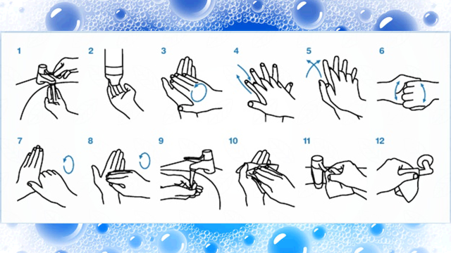

|  |
| --- |
|  |

**How to Brush your Teeth**

* **Brush your teeth with fluoride toothpaste twice a day for about two minutes to help keep your teeth and mouth healthy.**
* Plaque is a film of bacteria that coats your teeth if you don't brush them properly. It contributes to gum disease and tooth decay.
* Tooth brushing stops plaque building up. Try to make sure you brush every surface of all your teeth.

When should I brush my teeth?

* Brush your teeth for about two minutes last thing at night before you go to bed and on one other occasion every day.

## Should I use an electric or manual toothbrush?

* It doesn't matter whether you use an electric or manual toothbrush. They're both equally as good, as long as you brush all the surfaces of all your teeth and you use fluoride toothpaste. However, some people find it easier to clean their teeth thoroughly with an electric toothbrush.

## How to brush your teeth

* Make sure you brush all the surfaces of all your teeth, which should take about two minutes. Remember to brush the inside surfaces, outside surfaces and the chewing surfaces of your teeth.

## Don't rinse with water straight after toothbrushing

* After brushing, spit out any excess toothpaste. Don't rinse your mouth immediately after brushing, as it will wash away the concentrated fluoride in the remaining toothpaste so it cannot work as well.

## How to use dental floss

Flossing isn't just for dislodging food wedged between your teeth. Regular flossing may also reduce [gum disease](https://www.nhs.uk/conditions/Gum-disease/Pages/Introduction.aspx) and [bad breath](https://www.nhs.uk/conditions/Bad-breath/Pages/Introduction.aspx) by removing plaque that forms along the gum line. It's best to floss before brushing your teeth.

* Take 12-18 inches (30-45cm) of floss or dental tape, and grasp it so you have a couple of inches of floss taut between your hands.
* Slip the floss or dental tape between the teeth and into the area between your teeth and gums, as far as it will go.

Floss with 8-10 strokes, up and down between each tooth, to dislodge food.