|  |  |
| --- | --- |
|  |  |
|  |  |
|  |  |

**Year 8 Terms 5 & 6 PSHEE**

**SUBSTANCE ABUSE**

PSHEE YEAR EIGHT

SUBSTANCES QUIZ

PART ONE: TRUE OR FALSE?



PART TWO: MULTIPLE CHOICE

|  |
| --- |
|  |
|  |
| |  | | --- | | 1. **Most adults who smoke started smoking after age 18.** | |
| |  | | --- | | True | | False | |
| |  | | --- | | 1. **When a person gradually needs a larger dose of a drug to get the same effects, it's referred to as:** | |
| |  | | --- | | Relapsing | | Tolerance | | Withdrawal | |
| |  | | --- | | 1. **Drinking hard liquor makes people much more drunk than drinking beer.** | |
| |  | | --- | | Absolutely | | No way | |
| |  | | --- | | 1. **When you smoke a cigarette or chew tobacco, you ingest or absorb which of the following harmful chemicals:** | |
| |  | | --- | | Cyanide (a poison) | | Benzene (a toxic liquid sometimes used as motor fuel) | | Formaldehyde (a substance used to preserve dead things) | | All of the above | |
| |  | | --- | | 1. **This drug, which is used as an animal tranquilizer, can cause users to hallucinate, vomit, lose their sense of time, and even stop breathing.** | |
| |  | | --- | | Cocaine | | Ecstasy | | Ketamine | |

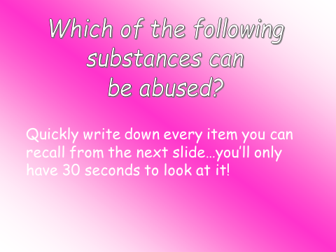

|  |
| --- |
|  |

|  |
| --- |
| Times you have seen or been aware of substance misuse. |
|  |
| Why do you think people choose to misuse/abuse substances? |
|  |

What is happening in the picture?

What are the potential dangers?

|  |
| --- |
|  |
|  |
|  |
|  |
|  |
|  |
|  |
|  |
|  |
|  |
|  |
|  |
|  |
|  |
|  |
|  |
|  |
|  |
|  |
|  |
|  |
|  |
|  |
|  |
|  |
|  |
|  |
|  |
|  |
|  |
|  |

Information From The Bottles

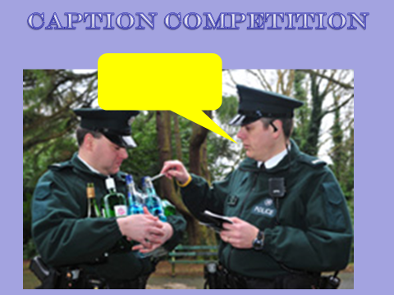

**ALCOHOL AND THE LAW**

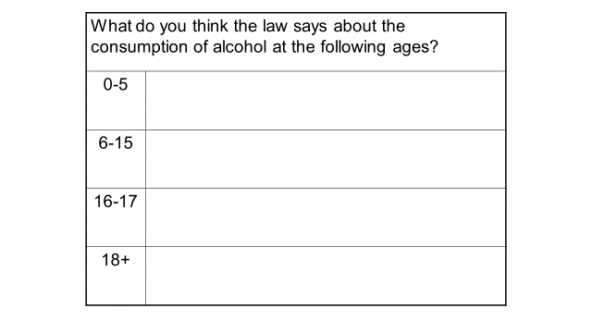

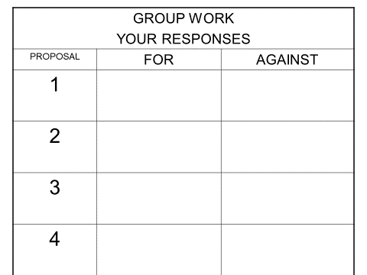

The effects of smoking on the Body

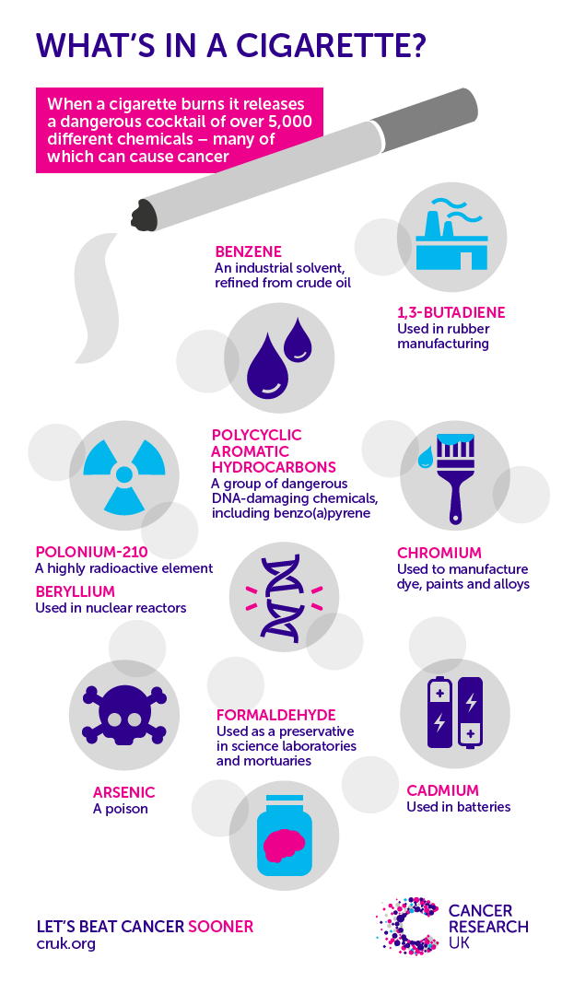

**E - Cigarettes**

