

**GCSE SUPPORT PROGRAMME**

If you are off the school, your first point of contact is your teacher. Check your school email or ShowMyHomework for any set work first. Use this to support your learning in the event you are off school – you also have full use of HegartyMaths.

Use the links below to access the files for each chapter. Use it to review learning on topics you have covered.

This support material is designed around our course textbooks with support material through

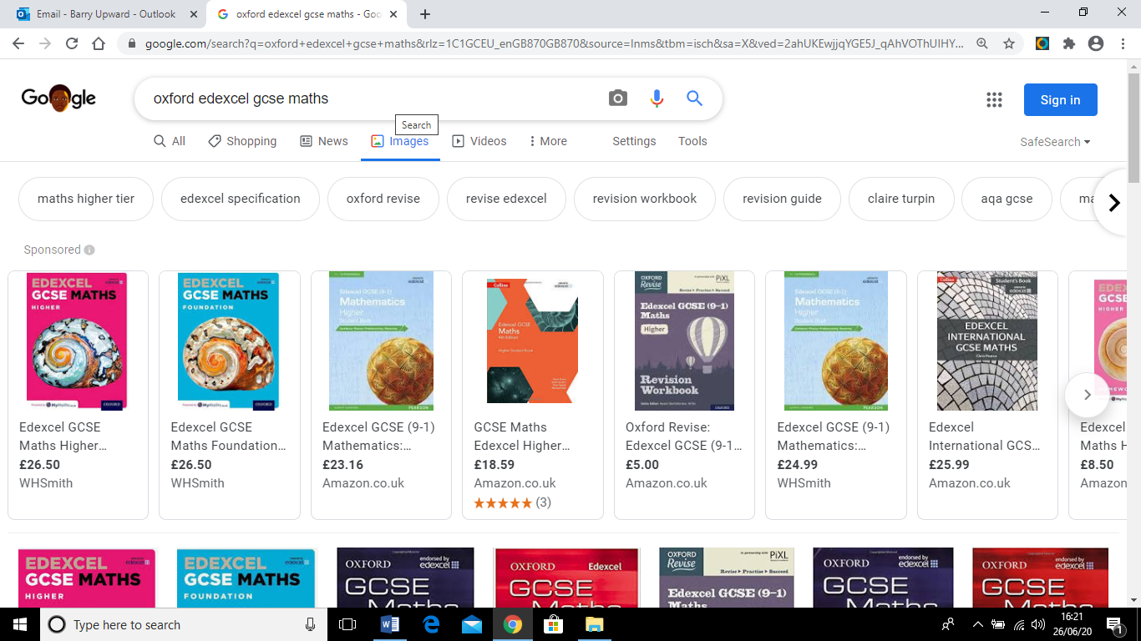







**OVERVIEW**

This material is designed to support your GCSE studies. Each link below will take you to video teaching, practice questions (and answers) and MyMaths assessment for each chapter in the text book.

|  |  |
| --- | --- |
|  |  |

**Chapter 2**

**Expressions**

**Chapter 22**

**Units and Proportionality**

**Chapter 21**

**Sequences**

**Chapter 20**

**Combined Events**

**Chapter 19**

**Pythagoras and Trigonometry**

**Chapter 17**

**Calculations 2**

**Chapter 18**

**Graphs 2**

**Chapter 16**

**Handling Data 2**

**Chapter 15**

**Working in 3D**

**Chapter 14**

**Graphs 1**

**Chapter 13**

**Factors, Powers and Roots**

**Chapter 12**

**Ratio and Proportion**

**Chapter 11**

**Circles and Constructions**

**Chapter 10**

**Equations and Inequalities**

**Chapter 9**

**Measures and Accuracy**

**Chapter 7**

**Working in 2D**

**Chapter 8**

**Probability**

**Chapter 5**

**Fractions, Decimals and Percent**

**Chapter 6**

**Formulae and Functions**

**Chapter 4**

**Handling Data 1**

**Chapter 3**

**Angles and Polygons**

**Chapter 1**

**Calculations 1**