**Task**: To judge the authority of some of Europe’s most famous queens.

Copy one of these Radar diagrams in your book for each queen.

You need to place an X on each of the four axis (criteria)

You then need to join the X’s together.

Use a different colour and complete the Key for each queen

**Power**

How much control on decisions did they have?

**Remembered**

How far has history remembered them?

**Influence**

Were they listened to men?

**Wealth**

How much money did they have?

Task 1: Read through the information sheet on Isabella of France, have a look at how I have used the example diagram to judge her significance.

Task 2. Complete three more diagrams for Margret of Anjou, Eleanor of Aquitaine, Matilda of Scotland.

**Task**: To judge the authority of some of Europe’s most famous queens.

Copy one of these Radar diagrams in your book for each queen.

You need to place an X on each of the four axis (criteria)

You then need to join the X’s together.

Use a different colour and complete the Key for each queen

**Power**

How much control on decisions did they have?

**Remembered**

How far has history remembered them?

**Influence**

Were they listened to men?

**Wealth**

How much money did they have?

**Extension**

Compare how powerful medieval queens were against their male counterparts. From what you already know about kings

Task 3: Which Queen do you think is the most significant (she will be the one with the biggest diagram)

Task 4: Can you compare this diagram to any King you know about?

**Example**: **Isabella of France (1295-1358)**

The further away along the axis (away from where they cross) the more power/money/influence/remembered I have judged Isabella to have.

As you can see I think Isabella had lots of power and money but was not very influential and she is not remembered very much.

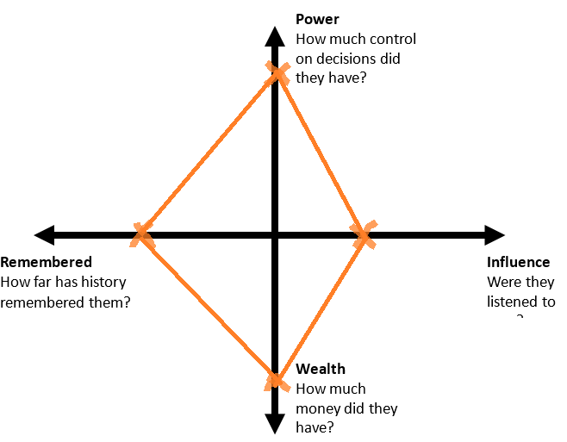

I