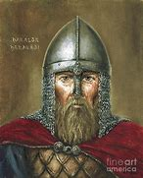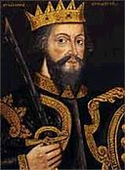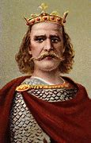

**The Three Contenders Top Trumps**

Read pages 20-21 in your Kerboodle books: Invasion Plague and Murder.

After you have read about each contender (person who wanted to be the King of England) you need to give them a Top Trumps score for each category.

**Categories are:**

Family History

Links to Edward (the previous King)

Tough Enough

Support from Clan.

Each score is out of 100. If you think the contender has a good claim to the throne give them a high score.

If you think they do not have a good claim, give them a low score.

Family History

Links to King Edward

Tough Enough

Support from his Clan

Family History

Links to King Edward

Tough Enough

Support from his Clan

Family History

Links to King Edward

Tough Enough

Support from his Clan