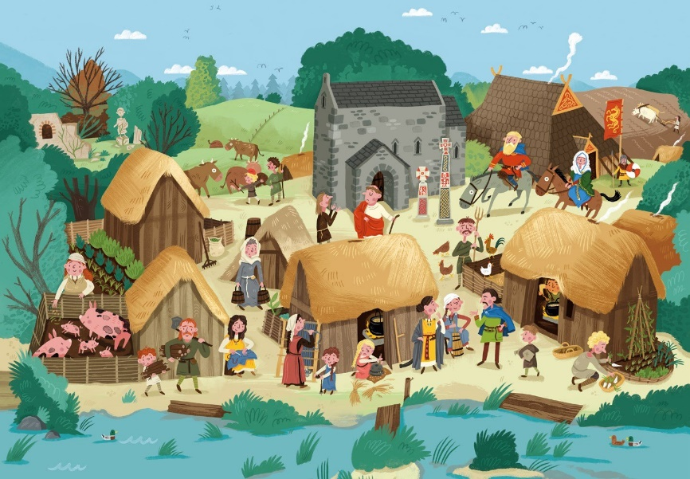

What can I see in this picture?

Q1 Can you see a Christian church?

1. Yes b) no

Q2 How do we know it is Christian?

1. I cannot tell
2. There are Christian crosses outside

Q3 What jobs are both the men and women doing?

1. Mostly farming jobs
2. Mostly jobs government jobs

Q5. Can you see some people that are more important or wealthier than others?

1. Yes b) no

Q6. Do the houses look as nice as the Roman houses that came before?

1. Yes b) no

Anglo Saxon Life

What can I infer/read between the lines?

The church is the only building made of stone and it is in the centre of the picture:

Q7. What can we infer (read between the lines) and learn?

A) Nothing,

B) That the church is the most important building and Christianity was important

C) That churches were where people went to pray

Q8. If men women and children are both doing farming jobs what can we infer?

1. Everyone loved farming
2. Life was hard so everyone had to work hard to survive
3. They were all bored

Q9. If there are some people that are wealthier than others what can we infer?

1. Some people were greedy
2. Some people worked harder
3. The Anglo-Saxon society was made up of different classes the with the Kings and Queens of the area had more wealth

Q10. Why might theses houses be less developed than the Romans

1. The Anglo-Saxons ran out of materials to build nice houses
2. When the Romans left they took all their knowledge and technology with them
3. The Anglo-Saxons preferred wooden houses.