**How did the Romans change Britain?**

**Roman roads**

Britain had no proper roads before the Romans - there were just muddy tracks. So the Romans built new roads all across the landscape – over 16,000km (10,000 miles) in fact!

The Romans knew that the shortest distance from one place to another is a straight line. So they made all their roads as **straight as possible** to get around quickly.

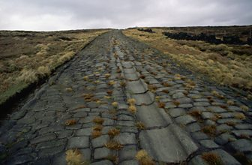They built their roads on foundations of clay, chalk and gravel. They laid bigger flat stones on top. Roman roads bulged in the middle and had ditches either side, to help the rainwater drain off.

Some Roman roads have been converted into motorways and main roads we use today. You can still find a few places where the original Roman road is still visible, too.

Bits of Roman road can still be seen. Soldiers and carts used this cobbled road to travel between Manchester and Yorkshire.

**How did the Romans change religion?**

Before the Romans came, the native Britons were **pagans**. They believed in lots of different gods and spirits.

The Romans were pagans too, but they didn't believe in the same gods as the Britons. They let the Britons worship their own gods, as long as they were respectful of the Roman ones too.

Christianity arrived in Britain during the second century. At first only a few people became Christian. When Christianity started to get popular, the Romans **banned it**. Christians refused to worship the Roman emperor and anyone who was caught following the new religion could be whipped or even executed.

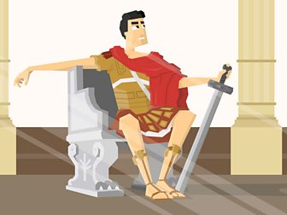By the beginning of the 4th century, more and more people were following Christianity. In AD313 the Emperor Constantine declared that Christians were free to worship in peace. By 391, Christianity was the official Roman religion, but pagan beliefs were still popular in Britain.

## Language, writing and numbers

Before the Romans came, very few people could read or write in Britain. Instead, information was usually passed from person to person by word of mouth.

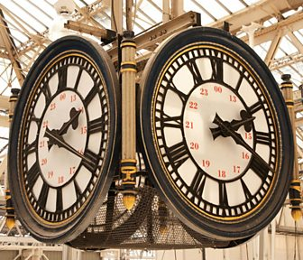The Romans wrote down their history, their literature and their laws. Their language was called **Latin**, and it wasn’t long before some people in Britain started to use it too. However, it only really caught on in the new Roman towns - most people living in the countryside stuck to their old Celtic language.

We've still got lots of words and phrases today that come from Latin. Words like ‘exit’, which means ‘he or she goes out’, and ‘pedestrian’, which means ‘going on foot’.

Some clocks today still use Roman numbers. Can you tell what the time is?

Our coins are based on a Roman design and some of the lettering is in Latin. Written around the edge of some £1 coins is the phrase 'decus et tutamen' which means 'glory and protection'.

## How did the Romans change towns?

The Romans introduced the idea of living in big towns and cities. Roman towns were laid out in a **grid**. Streets criss-crossed the town to form blocks called ‘insulae’. In the middle was the ‘**forum**’, a big market square where people came to trade.

Although they didn’t invent the arch, the Romans were the first people to build arches into big buildings and aqueducts. Romans used **aqueducts** to supply towns with water from springs, rivers or lakes. Aqueducts were like a bridge with a stone channel to carry water on top.

The Romans liked to keep clean. Towns and forts had underground drains to take away dirty water and sewage. The drain pipes were flushed with water from the baths, so they didn't get too smelly. Fresh water and sewers are important. Without them, people risk catching diseases.