Lesson 22: Starter Roman Equipment

A legionary typically carried around 27 kilograms of equipment. This kit consisted of his weapons and 15 days' food rations. There were also tools for digging and constructing a ‘castra’, the legions' fortified base camp.
Task 1: Look at your table of a Legionnaires equipment
Complete your table stating why each piece of information was so useful.

 | Name of Item | Why was this useful?
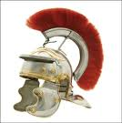 | Helmet  Extra info: Centurions and other officers wore a crest on their helmet so their soldiers could identify them.
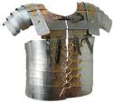 | Body Armor
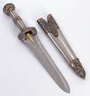 | Dagger  THINK: Why is it short rather than long like a medieval sword?
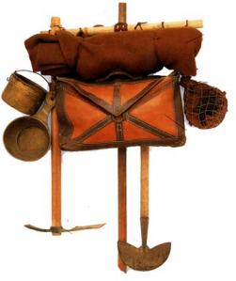 | Rucksack  Extra info: Contained necessary provisions – a cloak, some wine (mixed with water), a pot and some food. Each soldier carried his own.
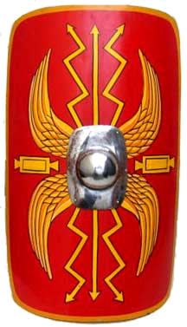 | Shield  Roman Legionnaires would create a tortoise formation was a type of shield wall formation ... For if [the legionaries] decided to lock shields for the purpose of avoiding the arrows by the closeness of their array

Task 2:
Using the online Atlas you need to fill in the blank map in below of you with the major battles that allowed Rome to grow its empire. You also need to write a brief description of the battle on your map too.
There are 6 battles that should be plotted onto your map.
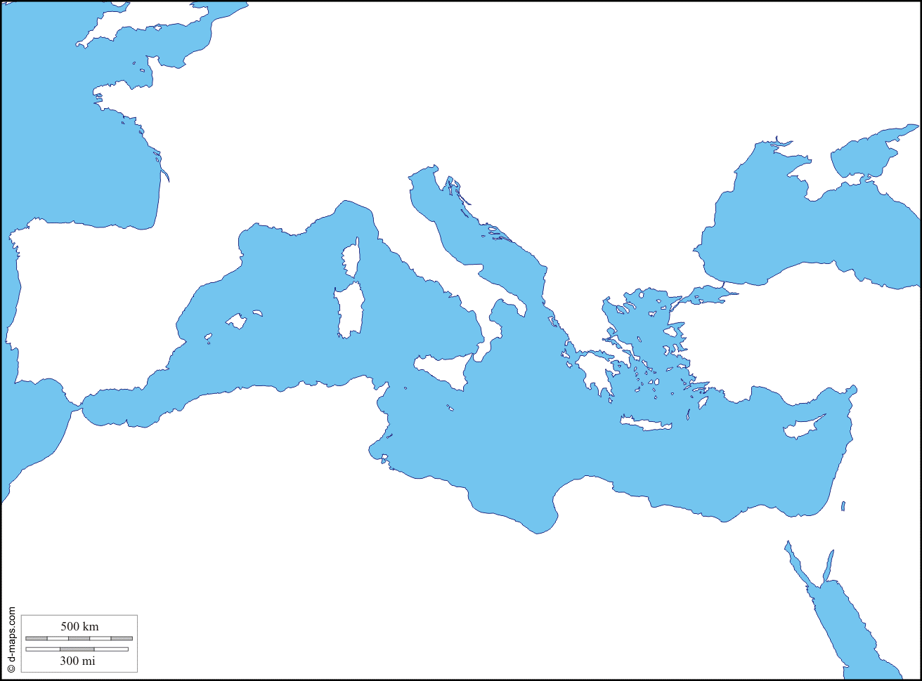
Task 3:
In full sentences using your atlas answer the following questions in full sentences.

- At its peak, which continents contained territories ruled by the Romans?
- What did the Romans call Britain, Scotland and Ireland?
- What did Julius Caesar achieve in 47BCE and what was his famous saying?
- At its height, what was the population of the Roman Empire?
- What happened to the Roman Empire by the 5th century CE?
- Who were the four groups from the north to overrun the western Roman Empire?
- When was Hadrian’s Wall built and why?
- What happened to the Roman army at Cannae?

