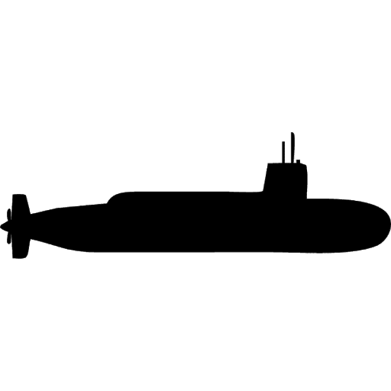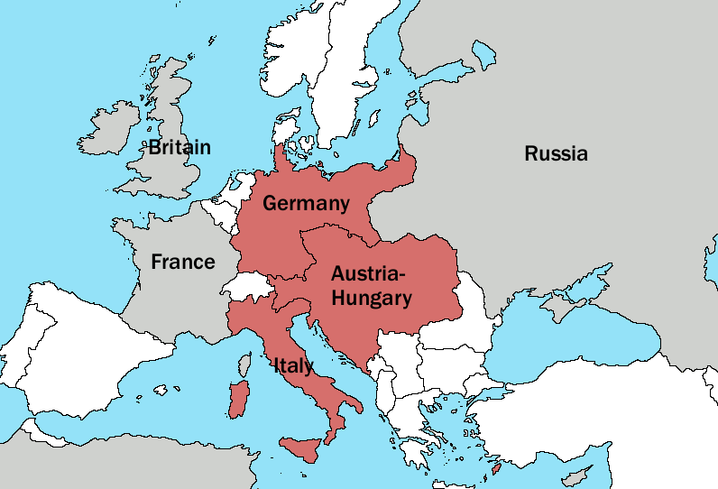

Overseas Empire: number of colonies



4 mil

28

280



1.2 mil

24

160



3.5 mil

34

200



700,000

80

380

Concerns: France attacking them over Empire in Africa. Wanted land from Austria-Hungary.

**Italy** Population: 35 mil Overseas Empire: 3

**France** Population: 40 mil Overseas Empire: 29

Concerns: Poorly trained army. Growing power of Germany. Wanted Balkans for coast.

**Russia** Population: 160 mil Overseas Empire: 0

Concerns: Growing power of Germany. Might be invaded again or lose more land to them.

**Britain**  Population: 43 mil Overseas Empire: 56

Concerns: Keeping supremacy in naval power, empire and industry. Threatened by Germany.



800,000

6

65

Concerns: Nationalism in Austria-Hungary breaking it apart. Needing strong allies.

**Germany** Population: 65 mil Overseas Empire: 10

Concerns: Jealous of Britain’s empire and navy. France wanting revenge.

**Austria-Hungary** Population: 50 mil Overseas Empire: 0



700,000

18

77

**Key:**

Triple Alliance

Triple Entente

Soldiers

Submarines

Warships (Dreadnoughts)