|  |  |
| --- | --- |
| NAME |  |
| TUTOR GROUP |  |
| LESSON DAY AND TIME |  |
| TEACHER |  |

**ISLAM**

Beliefs and Practices

**Your RS GCSE Topics…**

|  |  |  |
| --- | --- | --- |
| **The Study Of Two Religions** | | |
| **Islam** | | **Christianity** |
| * Articles of faith * The Nature Of Allah * Prophethood * Books * Angels * Judgement * Life after death * The Five Pillars * Worship | | * The Nature Of God * The Trinity * Creation * Evil And Suffering * Jesus * Salvation * Life After Death * Worship * The Role Of The Church |
| **Religion, Philosophy And Ethics In The Modern World From A Christian Perspective**  **Your RS GCSE Examinations…** | Relationships And Families | |
| The Existence Of God | |
| Religion, Peace And Conflict | |
| Religious And Non-Religious Beliefs And Attitudes | |

* 100% Examination
* Three papers

|  |  |  |  |  |
| --- | --- | --- | --- | --- |
|  | Title | Marks | Time | Weighting |
| 1 | The Study Of Islam | 63 | 1 Hour | 25% |
| 2 | The Study of Christianity | 63 | 1 hour | 25% |
| 3 | Religion, Philosophy And Ethics | 126 | 2 Hours | 50% |

Intro to islam

LEARNING TARGETS

|  |  |  |  |  |
| --- | --- | --- | --- | --- |
|  |  |  |  |  |
| 1 | I will know what Muslims believe. |  |  |  |
| 2 | I will understand the Five Pillars of Islam. |  |  |  |
| 3 | I will know the difference between Sunni and Shia. |  |  |  |
| 4 | I will understand why Muslims have different beliefs. |  |  |  |
| 5 | I will understand the concept of Jihad. |  |  |  |

At the start of the topic, draw a line on the confidenceometer to show how confident you are about the subject matter. At the end of the topic draw another line to show how confident you are after the lessons on the topic. Don’t forget to label your lines “1” and “2”.

VERY CONFIDENT

NO CONFIDENCE

YOUR QUESTIONS

Think of three questions about this topic that you would like answered by the end. Write them down.

|  |  |  |
| --- | --- | --- |
| 1 |  |  |
| 2 |  |  |
| 3 |  |  |

The nature of allah

LEARNING TARGETS

|  |  |  |  |  |
| --- | --- | --- | --- | --- |
|  |  |  |  |  |
| 1 | I will know what Muslims believe about Allah. |  |  |  |
| 2 | I will understand Tawhid and Shirk. |  |  |  |
| 3 | I will know what different groups of Muslims believe about Allah. |  |  |  |

At the start of the topic, draw a line on the confidenceometer to show how confident you are about the subject matter. At the end of the topic draw another line to show how confident you are after the lessons on the topic. Don’t forget to label your lines “1” and “2”.

VERY CONFIDENT

NO CONFIDENCE

YOUR QUESTIONS

Think of three questions about this topic that you would like answered by the end. Write them down.

|  |  |  |
| --- | --- | --- |
| 1 |  |  |
| 2 |  |  |
| 3 |  |  |

**Beliefs**

|  |  |
| --- | --- |
| TARGET GRADE |  |
|  | GRADE | How to improve |
| Key Words Quiz |  |  |
| Vaguely Impossible – Life of Muhammad |  |  |
| Sunni/Shia Big Quiz |  |  |
| Tawhid Question |  |  |
| Debate One |  |  |
| Sixty Second Challenge |  |  |
| Exam Question One |  |  |

**Practices**

|  |  |
| --- | --- |
| TARGET GRADE |  |
|  | GRADE | How to improve |
| Vaguely Impossible – The 5 Pillars |  |  |
| Festivals Big Quiz |  |  |
| Debate Two |  |  |
| Exam Question Two |  |  |

**FOUR THINGS THAT MANY RELIGIONS HAVE IN COMMON**

|  |  |
| --- | --- |
| 1 |  |
| 2 |  |
| 3 |  |
| 4 |  |

Thoughts and ideas for the sixty second challenge…

Notes, ideas, scribbles, thoughts and doodles

|  |
| --- |
|  |
|  |
|  |
|  |
|  |
|  |
|  |
|  |
|  |
|  |
|  |
|  |
|  |
|  |
|  |
|  |
|  |
|  |
|  |
|  |
|  |
|  |
|  |
|  |
|  |
|  |
|  |

Things That I Already Know About Islam

**Some key concepts…**

**ISLAM FACTS**

|  |  |
| --- | --- |
| 1 |  |
| 2 |  |
| 3 |  |
| 4 |  |

In Britain today there are nearly ______________ Muslims, making up __________ % of the population.

Up until the __________ twentieth century there were very ____________ Muslims in the __________. From the ___________ onwards significant numbers of __________ came from the former __________, taking up the offer of __________ in post Second _______________ Britain.

The 2011 ___________ shows that Britain is home to one of the most __________ Muslim communities in the ___________. The majority of British Muslims are __________ (95%) with remaining 5% coming from the __________ tradition.

**ISLAM IN BRITAIN**

|  |  |
| --- | --- |
|  | **Key Words** |
|  |  |
|  |  |
|  |  |
|  |  |
|  |  |
|  |  |
|  |  |
|  |  |
|  |  |
|  |  |
|  |  |

**STICK TEST SHEET HERE**

|  |  |
| --- | --- |
| My score |  |

|  |  |
| --- | --- |
| Corrections | |
|  |  |

|  |  |
| --- | --- |
| Re-test score |  |

**THE LIFE OF MUHAMMAD**

Key points from the video.

Notes, ideas, scribbles, thoughts and doodles

|  |
| --- |
|  |
|  |
|  |
|  |
|  |
|  |
|  |
|  |
|  |
|  |
|  |
|  |
|  |
|  |
|  |
|  |
|  |
|  |
|  |
|  |
|  |
|  |
|  |
|  |
|  |
|  |
|  |

Why is Muhammad important?

The ____________ brought by Muhammad is the same message as had been preached by all the ____________ back to __________ :- the need to ____________ the one true God - __________, who will be the _____________ of all.

But due to the teachings of these prophets becoming corrupt, a new prophet was needed.

Muslims believe that the greatest of revelations was given to Muhammad during “Laylat-ul-Qadr” – The Night of ____________ - in the Cave of Hira.

On this night, the Angel _________ appeared before Muhammad and ordered him to recite the words of the __________.

Muslims also believe Muhammad to be last and _________ prophet – the “Seal Of The Prophets”, highlighting his importance.

Muhammad is also a role ___________ because of the moral and prayerful way he lived. God chose Muhammad to be a prophet because he was a humble, honest man.

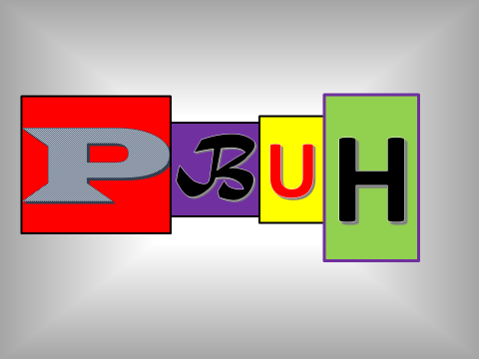

Challenge TWO

THE VAGUELY IMPOSSIBLE INFORMATION GRID

You must have at least five facts about the life of Muhammad in the grid. But beware – the number of facts required may well increase!

|  |  |  |  |  |  |  |  |  |  |
| --- | --- | --- | --- | --- | --- | --- | --- | --- | --- |
|  |  |  |  |  |  |  |  |  |  |
|  |  |  |  |  |  |  |  |  |  |
|  |  |  |  |  |  |  |  |  |  |
|  |  |  |  |  |  |  |  |  |  |
|  |  |  |  |  |  |  |  |  |  |
|  |  |  |  |  |  |  |  |  |  |
|  |  |  |  |  |  |  |  |  |  |
|  |  |  |  |  |  |  |  |  |  |
|  |  |  |  |  |  |  |  |  |  |
|  |  |  |  |  |  |  |  |  |  |

(Copy the end result into your grid).

YOUR FINAL PARAGRAPH

|  |
| --- |
|  |

Notes, ideas, scribbles, thoughts and doodles

|  |
| --- |
|  |
|  |
|  |
|  |
|  |
|  |
|  |
|  |
|  |
|  |
|  |
|  |
|  |
|  |
|  |
|  |
|  |
|  |
|  |
|  |
|  |
|  |
|  |
|  |
|  |
|  |
|  |

**Sources of Authority**

|  |  |
| --- | --- |
|  | The Qur’an |
|  | The Sunnah |
|  | The Hadith |
|  | Shari’ah Law |

“I have left among you that which if you hold fast to, then you would never go astray, clear things, the book of God and the Sunnah of his prophet.” - Muhammad

Notes, ideas, scribbles, thoughts and doodles

|  |
| --- |
|  |
|  |
|  |
|  |
|  |
|  |
|  |
|  |
|  |
|  |
|  |
|  |
|  |
|  |
|  |
|  |
|  |
|  |
|  |
|  |
|  |
|  |
|  |
|  |
|  |
|  |
|  |

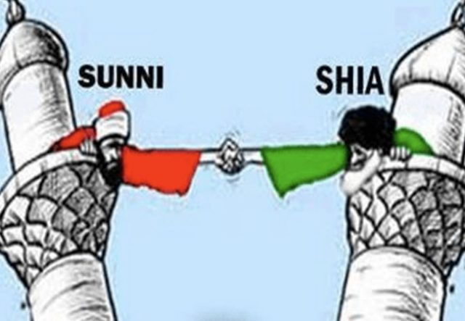

|  |
| --- |
| What does the video clip tell you? |
|  |

The sunni page

Write as many bits of information about Sunni Muslims as you can within the time limit.

The sHia page

Write as many bits of information about Shia Muslims as you can within the time limit.

The sunni/shia split (in the correct order)

Challenge Three

Rules

* Each team member must write down ten questions.
* They must also write down the answers to their questions.
* Five questions should be simple, basic, one word answer/true false questions.
* Three questions should be “describe” questions – asking for more information/longer answers.
* Two questions should be “explain” questions – asking deeper questions about beliefs, concepts and ideas. Why do people believe something, etc?
* MAKE SURE EVERYBODY HAS DIFFERENT QUESTIONS!

**BIG**

The Quiz

Preparation time = one lesson.

Each team must choose a questioner and a first answerer. The questioner remains seated in the group, the answerer comes up to sit with the other teams’ answerers. The object is to eliminate the other teams one member at a time. The questioners, one by one (going round the groups) will ask the answerers their questions. A questioner may not put a question to a member of their own team. Answerers who answer incorrectly or are unable to answer are eliminated and replaced by another team member.

Questioners who ask inadequate questions or questions that have previously been asked are also eliminated and replaced with another team member,

Notes, ideas, scribbles, thoughts and doodles

|  |
| --- |
|  |
|  |
|  |
|  |
|  |
|  |
|  |
|  |
|  |
|  |
|  |
|  |
|  |
|  |
|  |
|  |
|  |
|  |
|  |
|  |
|  |
|  |
|  |
|  |
|  |
|  |
|  |

Notes, ideas, scribbles, thoughts and doodles

|  |
| --- |
|  |
|  |
|  |
|  |
|  |
|  |
|  |
|  |
|  |
|  |
|  |
|  |
|  |
|  |
|  |
|  |
|  |
|  |
|  |
|  |
|  |
|  |
|  |
|  |
|  |
|  |
|  |

Notes, ideas, scribbles, thoughts and doodles

|  |
| --- |
|  |
|  |
|  |
|  |
|  |
|  |
|  |
|  |
|  |
|  |
|  |
|  |
|  |
|  |
|  |
|  |
|  |
|  |
|  |
|  |
|  |
|  |
|  |
|  |
|  |
|  |
|  |

Challenge Three

**BIG**

The Quiz

* The Aftermath -

|  |
| --- |
| How well did my team do? Why? |
|  |
| What new things did I learn during the quiz (including the preparation time)? |
|  |
| What was I already confident that I knew? |
|  |

|  |
| --- |
| SUNNI – THE SIX ARTICLES OF FAITH |

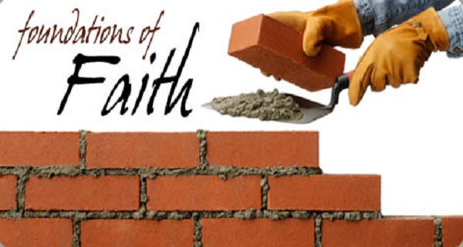

|  |
| --- |
| SHI’A – THE FIVE ROOTS OF RELIGION |



Notes, ideas, scribbles, thoughts and doodles

|  |
| --- |
|  |
|  |
|  |
|  |
|  |
|  |
|  |
|  |
|  |
|  |
|  |
|  |
|  |
|  |
|  |
|  |
|  |
|  |
|  |
|  |
|  |
|  |
|  |
|  |
|  |
|  |
|  |

**The Mystery Object**

How were the objects described?

Were the descriptions accurate? Would these descriptions alone help you to understand what the objects were, how they work, what they are for?

What does this tell us about trying to understand a concept like Allah?

**THE PICTIONARY PAGE**

|  |  |  |
| --- | --- | --- |
|  |  |  |
|  |  |  |
|  |  |  |
|  |  |  |

Notes, ideas, scribbles, thoughts and doodles

|  |
| --- |
|  |
|  |
|  |
|  |
|  |
|  |
|  |
|  |
|  |
|  |
|  |
|  |
|  |
|  |
|  |
|  |
|  |
|  |
|  |
|  |
|  |
|  |
|  |
|  |
|  |
|  |
|  |

“To anthropomorphise or not to anthropomorphise – that is the question.”

Word Search

|  |  |  |  |  |  |  |  |  |  |  |  |  |
| --- | --- | --- | --- | --- | --- | --- | --- | --- | --- | --- | --- | --- |
| A | L | L | M | E | R | C | I | F | U | L | O | C |
| L | B | A | E | R | L | I | G | H | T | W | N | R |
| L | T | S | F | U | W | I | F | I | R | S | T | E |
| C | R | U | O | P | A | G | P | T | S | A | L | A |
| O | U | O | H | L | G | R | E | A | T | E | S | T |
| M | T | I | I | O | U | N | R | M | O | G | O | O |
| P | H | R | D | K | A | T | F | M | H | N | O | R |
| A | E | O | D | N | R | R | E | H | A | I | R | D |
| S | M | T | E | I | D | D | C | R | S | V | E | R |
| S | E | C | N | T | I | S | T | E | U | O | R | S |
| I | R | I | Y | U | A | L | Y | N | W | L | I | H |
| O | P | V | G | E | N | E | T | S | I | B | E | B |
| N | U | G | O | O | D | U | G | D | S | A | B | R |
| A | S | E | F | I | L | F | O | R | E | V | I | G |
| T | N | E | M | E | L | C | T | P | E | A | C | E |
| E | F | O | R | G | I | V | E | R | M | E | O | D |

Muslims have attributed 99 names to Allah. Can you find any of them in the grid?

What do they tell you about Allah?

Notes, ideas, scribbles, thoughts and doodles

|  |
| --- |
|  |
|  |
|  |
|  |
|  |
|  |
|  |
|  |
|  |
|  |
|  |
|  |
|  |
|  |
|  |
|  |
|  |
|  |
|  |
|  |
|  |
|  |
|  |
|  |
|  |
|  |
|  |

quotes

|  |  |
| --- | --- |
| QUOTE | MEANING |
| In the name of Allah, the Entirely Merciful, The Especially Merciful,  (Surah 1) |  |
| God has not taken to Himself any son, nor is there any god with Him. For then each god would have taken of that which he created and some of them would have tried to overcome others.  (23:91) |  |
| Say: He is Allah, the One and Only; Allah, the Eternal, Absolute; He did not give birth nor was He born; and there is none like Him.  (Surah 112) |  |
| God is the Creator of everything. He is the guardian over everything. To him belong the keys of the heavens and the earth…  (39; 62,63) |  |
| “And indeed We have created man and We know what his soul whispers to him, and We are closer to him than [his] jugular vein.”  (Surah 50:16) |  |

TAWHID GROUP WORK

He is Allah

The One and Only

Allah the Eternal,

Absolute;

He begat none,

Nor was He begotten;

And there is none like Him.

Surah 112. 1-4

Challenge four – TAWHID questions

|  |
| --- |
| 1. What is Tawhid? 2. What ideas would a Muslim have in mind when they use the word? 3. Here are some good personality qualities that a Muslim might want to develop:   Bravery Determination Honesty Modesty Obedience Contentedness  Self-respect Respect for the environment.  Choose three that you think would be most likely to result from a belief in  Tawhid and explain your choices.   1. How might submission to Allah Affect the way people, races or countries relate to each other? |

|  |
| --- |
|  |
|  |
|  |
|  |
|  |
|  |
|  |
|  |
|  |
|  |
|  |
|  |
|  |
|  |

Notes, ideas, scribbles, thoughts and doodles

|  |
| --- |
|  |
|  |
|  |
|  |
|  |
|  |
|  |
|  |
|  |
|  |
|  |
|  |
|  |
|  |
|  |
|  |
|  |
|  |
|  |
|  |
|  |
|  |
|  |
|  |
|  |
|  |
|  |

Pair work

|  |
| --- |
| GOOD |
| A good demonstration of knowledge and understanding in response to the question:  • Good understanding of the question shown by appropriate selection of religious knowledge  • Good selection of appropriate material with detail and/or developed explanation  • Good knowledge and understanding of different viewpoints within Islam  • Good knowledge and understanding of the influence on individuals, communities and societies  • Good knowledge and understanding of the breadth and/or depth of the issues |
| ADEQUATE BUT UNDER-DEVELOPED |
| An **adequate but under-developed** demonstration of knowledge and understanding in response to the question:  • Adequate understanding of the question shown by some use of religious knowledge  • Selection of appropriate material with superficial explanation and/or description  • Adequate knowledge and understanding of different viewpoints within Islam  • Adequate knowledge and understanding of influence on individuals, communities and societies  • Adequate but underdeveloped knowledge and understanding of the breadth and/or depth of issues |
| LIMITED |
| A **limited** demonstration of knowledge and understanding in response to the question:  • Some understanding of the question shown through limited use of religious knowledge  • Some material selected is appropriate but description is limited  • Limited knowledge and understanding of different viewpoints within Islam  • Limited knowledge and understanding of influence on individuals, communities and societies  • Limited knowledge and understanding of the breadth and/or depth of issues |
| WEAK |
| A **weak** demonstration of knowledge and understanding in response to the question:  • Weak understanding of the question shown by factual errors or generalised responses with little connection to the question  • Weak and/or a small amount of relevant information selected  • Weak knowledge and understanding of different viewpoints within Islam  • Weak knowledge and understanding of the influence on individuals, communities and societies  • Points may be listed and/or lacking in relevant detail related to the issues |

**SHIRK**

Placing anything above _______ is idolatry. This is the sin of _________ and is considered the worst of all ________. Knowing that Allah is the _________ power can enable a ________ to be __________ with their _______. Muslims believe that even the time of their _______ is set by Allah, and so they have nothing to ________, as whatever happens is His ________.

Death. Allah. Content. Will. Fear. Life. Ultimate. Muslim. Sins. Shirk. Hamster.

In threes, create a short TV advert explaining why Shirk is bad and how to avoid it.

challenge FIVE



The motion is…

“This house believes that it is impossible to know Allah.”

INSTRUCTIONS

You will work in teams of three. Your team will either be proposition (for the statement) or opposition (against the statement). Each member of your team will stand up and speak for three minutes. You should prepare your speeches together so that you are not repeating or contradicting each other.

Each three minute speech is split as follows:-

* Minute one = protected (no interruptions).
* Minute two = Points Of Information (interruptions from the team playing against you) are allowed, but you don’t have to accept them.
* Minute three = protected.

You will be playing against another team of three people who will hold the opposite view to you. Speeches run in the following order:-

|  |  |  |  |
| --- | --- | --- | --- |
| PROPOSITION |  |  | OPPOSITION |
| P1 | first | second | O1 |
| P2 | third | fourth | O2 |
| P3 | fifth | last | O3 |

As you listen to the speeches of the team against you, you must also give them a score out of ten. At the end of the debate each member’s scores should be added up.

MY TEAM

Speaker One________________________________________________

Speaker Two________________________________________________

Speaker Three_______________________________________________

We are……………. .PROPOSITION/OPPOSITION

(Delete as appropriate)

SCORE SHEET (FOR THE TEAM AGAINST US)

|  |  |  |  |
| --- | --- | --- | --- |
| Speaker (name). | Evidence And Technical Terms  /5 | Debating Skills  /5 | Total  /10 |
|  |  |  |  |
|  |  |  |  |
|  |  |  |  |

MY SCORE (OUT OF 30):___________

DEBATE SCORING

|  |  |
| --- | --- |
| USE OF EVIDENCE/TECHNICAL TERMS | SCORE |
| One mark for each technical term or word used, up to a maximum of five marks. No marks for repetition of the same word or term. | 0 - 5 |

|  |  |  |
| --- | --- | --- |
| What To Look For | At this level the student… | SCORE |
| Nothing relevant/nothing said. | * *Shows no knowledge or understanding of the issue.* * *Has misunderstood the concept or has not prepared.* | 0 |
| A basic point made on the subject or a statement of opinion without any real explanation. | * *Shows a little, but not much understanding of the issue.* * *Has some awareness of what the statement means* * *Can see that people can have an opinion about it.* | 1 |
| A fully explained argument or opinion BACKED UP with reasoning and some explanation  OR…  More than one basic, outlined argument or statements of different opinions without any real explanation. | *Can either:*   * *demonstrate knowledge and understanding of one key aspect of the debate*   *or*   * *show an awareness that there are a number of different points of view/ideas.* | 2 |
| Fully explained argument(s) or opinion(s) BACKED UP with reasoning and some explanation, together with an attempt to ARGUE AGAINST opposite views. | * *Shows understanding of the issue* * *Shows understanding that there are two sides to the argument* * *is able to make some attempt to argue against the opposite view* | 3 |
| A number of different views/arguments are addressed. All points made are well argued and successful. The speech is persuasive. | * *Knows the arguments for and against and can explain/criticize them.* * *Can confidently explore and support or attack a number of the arguments for and against the statement.* | 4 |
| A number of different views/arguments are addressed. All points made are well argued and successful. The speech is persuasive AND REFERENCES ARE MADE TO CURRENT AFFAIRS/REAL LIFE ISSUES. | * *Knows the arguments for and against and can explain/criticize them.* * *Can confidently explore and support or attack a number of the arguments for and against the statement.* * *Understands the relevance of the issues to the real world.* | 5 |

Debate Speech

|  |
| --- |
|  |
|  |
|  |
|  |
|  |
|  |
|  |
|  |
|  |
|  |
|  |
|  |
|  |
|  |
|  |
|  |
|  |
|  |
|  |
|  |
|  |
|  |
|  |
|  |
|  |
|  |
|  |

Debate Speech

|  |
| --- |
|  |
|  |
|  |
|  |
|  |
|  |
|  |
|  |
|  |
|  |
|  |
|  |
|  |
|  |
|  |
|  |
|  |
|  |
|  |
|  |
|  |
|  |
|  |
|  |
|  |
|  |
|  |

Debate Speech

|  |
| --- |
|  |
|  |
|  |
|  |
|  |
|  |
|  |
|  |
|  |
|  |
|  |
|  |
|  |
|  |
|  |
|  |
|  |
|  |
|  |
|  |
|  |
|  |
|  |
|  |
|  |
|  |
|  |

Debate Speech

|  |
| --- |
|  |
|  |
|  |
|  |
|  |
|  |
|  |
|  |
|  |
|  |
|  |
|  |
|  |
|  |
|  |
|  |
|  |
|  |
|  |
|  |
|  |
|  |
|  |
|  |
|  |
|  |
|  |

Debate Speech

|  |
| --- |
|  |
|  |
|  |
|  |
|  |
|  |
|  |
|  |
|  |
|  |
|  |
|  |
|  |
|  |
|  |
|  |
|  |
|  |
|  |
|  |
|  |
|  |
|  |
|  |
|  |
|  |
|  |



**ANGELS**

|  |  |  |  |  |  |
| --- | --- | --- | --- | --- | --- |
| Jibril | |  | | | |
| Izra’il | |  | | | |
| Mika’il | |  | | | |
| Israfil | |  | | | |
|  |  | |  |  |  |
|  |  | |  |  |  |

Your Guide To The Afterlife…

|  |  |
| --- | --- |
|  |  |
|  |  |
|  |  |
|  |  |

God judges each person’s actions but ___________ (niyyah) are taken into _____________. The two terrifying judging angels __________ and ____________ will question each person, testing their faith.

In order to give the correct ___________ to their questions, it is not enough just to learn to recite the Shahadah. If the person has not truly lived a life of ___________ to God, following the ________ __________, they will be incapable of giving the right response on the day.

Muslims believe that, for those who _______ before that day, the angel of death, __________, will come to take their souls to await the day.

They will be kept in a state of barzakh (________) until the sound of the final _________.

**And now… CHALLENGE 6: the sixty second challenge!**

What was your score?__________

What did you remember?

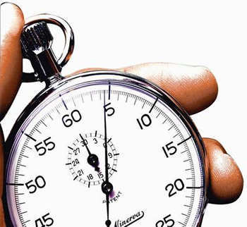

**The Examination Answer**

**Technique Song!**

*A and B and C*

*Just want simple facts, you see!*

*But when you get to D, there is more complexity*

*(HERE WE GO!)*

*D!*

*Multiple points made, develop them – try!*

*Don’t just describe stuff – try telling me why!*

*And add juicy evi-dence!*

*E!*

*Do just what it says on the tin…*

*Put more than one viewpoint in!*

*Argue like mad! But the examiner gets sad…*

*If you leave the religion out!*

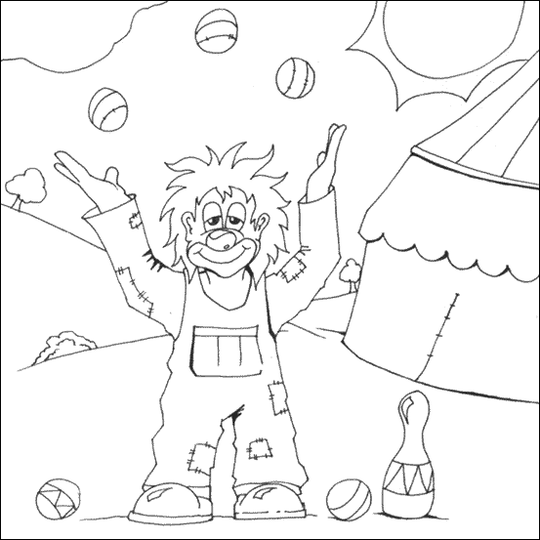

|  |  |
| --- | --- |
| **AO1** | **AO2** |
| A good demonstration of knowledge and understanding in response to the question:   * appropriate selection of religious knowledge * Selection of appropriate sources of wisdom and authority with detail and/or developed explanation      * Good knowledge and understanding of different viewpoints within Islam. * Good knowledge and understanding of the influence on individuals, communities and societies. | A good attempt to respond to the stimulus, demonstrating some or all of the following:   * A variety of viewpoints explored with good use of reasoned argument and discussion * Good analysis and evaluation of the significance and/or influence of the issue on different Muslim groups * Evidence of critical evaluation including comment on, and comparison of, arguments from different Muslim groups * Evidence of judgement on the issue in the stimulus and a balanced conclusion to the discussion |
|  | |

RS EXAM QUESTION SELF DIAGNOSTIC SHEET

Q1

|  |  |  |  |
| --- | --- | --- | --- |
|  | Did I… | Y | N |
| A, B, C | * Use clear, concise, factual information * Give one fact for each mark on offer * Answer as briefly as I could/use bullet points * Lead with things that I was sure of * Guess if I didn’t know   (UNDERLINE THE FACTS ON YOUR SHEET). |  |  |
| D | * Keep in mind the general topics when I answered the question * Include factual information. * Write in paragraphs * Use words like “because” * Show that I know how religious beliefs affect behaviour * Show that I know there are different groups within religions * Use technical terms and JUICY EVIDENCE   (UNDERLINE FACTS INCLUDED IN YOUR ANSWER) |  |  |

|  |
| --- |
| NOTES |
|  |

E

|  |  |  |
| --- | --- | --- |
| Did I… | Y | N |
| Follow the instructions fully. |  |  |
| Show that I understood what the statement was about. |  |  |
| Include factual information to show my knowledge. |  |  |
| Use technical terms and/or references (Juicy Evidence) |  |  |
| Include more than one “for” argument. |  |  |
| Include more than one “against” argument. |  |  |
| Fully explain ALL my arguments. |  |  |
| Include criticism of ALL the arguments. |  |  |
| Make a conclusion. |  |  |

EVALUATION QUESTION

|  |  |  |  |  |  |
| --- | --- | --- | --- | --- | --- |
| Statement | |  | | | |
| Three facts | | *  *  * | | | |
| WHAT? | DEVELOPMENT | | EVALUATION |
| Argument For | |  |  | |  |
| Argument Against | |  |  | |  |
| Argument For | |  |  | |  |
| Argument Against | |  |  | |  |
| Conclusion | |  | | | |
| 5 Things That Are Important To Me | | | | | | |
|  | Belief | | | Associated Action | | |
| 1 |  | | |  | | |
| 2 |  | | |  | | |
| 3 |  | | |  | | |
| 4 |  | | |  | | |
| 5 |  | | |  | | |

The five pillars of faith

|  |
| --- |
|  |



How to do…

WUDU

|  |  |
| --- | --- |
| 1 |  |
| 2 |  |
| 3 |  |
| 4 |  |
| 5 |  |
| 6 |  |
| 7 |  |

**Rak’ahs Dance!**

Notes, ideas, scribbles, thoughts and doodles

|  |  |  |
| --- | --- | --- |
|  | | |
|  | | |
|  | | |
|  | | |
|  | | |
|  | | |
|  | | |
|  | | |
|  | | |
|  | | |
|  | | |
|  | | |
|  | | |
|  | | |
|  | | |
|  | | |
|  | | |
|  | | |
|  | | |
|  | | |
|  | | |
|  | | |
|  | | |
|  | | |
|  | | |
|  | | |
|  | | |
| **Hajj** |  |
|  |  |
|  |  |
|  |  |
|  |
|  |

CHALLENGE EIGHT

THE FIVE PILLARS VAGUELY IMPOSSIBLE INFORMATION GRID

|  |  |  |  |  |  |  |  |  |  |
| --- | --- | --- | --- | --- | --- | --- | --- | --- | --- |
|  |  |  |  |  |  |  |  |  |  |
|  |  |  |  |  |  |  |  |  |  |
|  |  |  |  |  |  |  |  |  |  |
|  |  |  |  |  |  |  |  |  |  |
|  |  |  |  |  |  |  |  |  |  |
|  |  |  |  |  |  |  |  |  |  |
|  |  |  |  |  |  |  |  |  |  |
|  |  |  |  |  |  |  |  |  |  |
|  |  |  |  |  |  |  |  |  |  |
|  |  |  |  |  |  |  |  |  |  |

|  |
| --- |
|  |

**Minor Festivals**

|  |
| --- |
|  |
|  |
|  |

**Major Festivals**

|  |
| --- |
|  |
|  |
|  |

Challenge nine

Rules

* Each team member must write down ten questions.
* They must also write down the answers to their questions.
* Five questions should be simple, basic, one word answer/true false questions.
* Three questions should be “describe” questions – asking for more information/longer answers.
* Two questions should be “explain” questions – asking deeper questions about beliefs, concepts and ideas. Why do people believe something, etc?
* MAKE SURE EVERYBODY HAS DIFFERENT QUESTIONS!

**BIG**

The Quiz

Preparation time = one lesson.

Each team must choose a questioner and a first answerer. The questioner remains seated in the group, the answerer comes up to sit with the other teams’ answerers. The object is to eliminate the other teams one member at a time. The questioners, one by one (going round the groups) will ask the answerers their questions. A questioner may not put a question to a member of their own team. Answerers who answer incorrectly or are unable to answer are eliminated and replaced by another team member.

Questioners who ask inadequate questions or questions that have previously been asked are also eliminated and replaced with another team member,

Notes, ideas, scribbles, thoughts and doodles

|  |
| --- |
|  |
|  |
|  |
|  |
|  |
|  |
|  |
|  |
|  |
|  |
|  |
|  |
|  |
|  |
|  |
|  |
|  |
|  |
|  |
|  |
|  |
|  |
|  |
|  |
|  |
|  |
|  |

Notes, ideas, scribbles, thoughts and doodles

|  |
| --- |
|  |
|  |
|  |
|  |
|  |
|  |
|  |
|  |
|  |
|  |
|  |
|  |
|  |
|  |
|  |
|  |
|  |
|  |
|  |
|  |
|  |
|  |
|  |
|  |
|  |
|  |
|  |

Notes, ideas, scribbles, thoughts and doodles

|  |
| --- |
|  |
|  |
|  |
|  |
|  |
|  |
|  |
|  |
|  |
|  |
|  |
|  |
|  |
|  |
|  |
|  |
|  |
|  |
|  |
|  |
|  |
|  |
|  |
|  |
|  |
|  |
|  |

Challenge nine

**BIG**

The Quiz

* The Aftermath -

|  |
| --- |
| How well did my team do? Why? |
|  |
| What new things did I learn during the quiz (including the preparation time)? |
|  |
| What was I already confident that I knew? |
|  |

|  |
| --- |
| What are the things that you think are really worth fighting for? |

|  |  |
| --- | --- |
| What would you say are your own personal struggles in life? | |
| GREATER JIHAD | LESSER JIHAD |
|  |  |

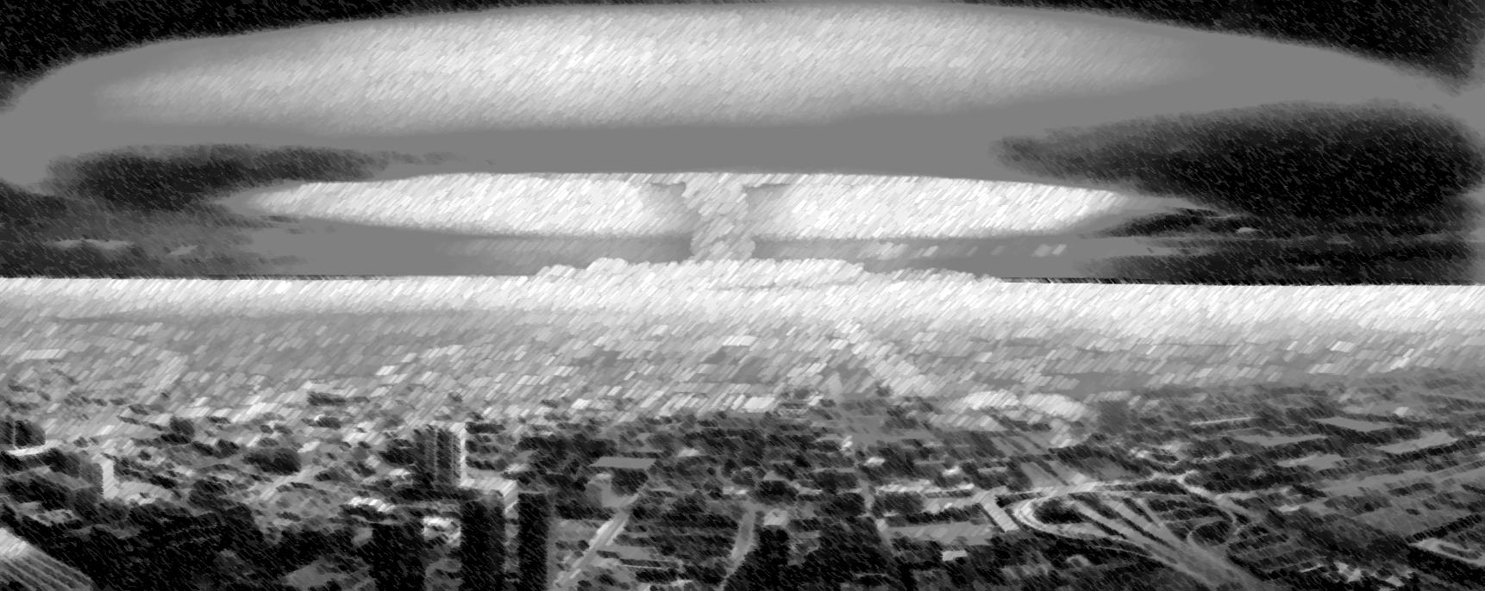

**YOUR RULES FOR GOING TO WAR**

|  |  |
| --- | --- |
| 1 |  |
| 2 |  |
| 3 |  |
| 4 |  |
| 5 |  |
| 6 |  |
| 7 |  |
| 8 |  |

**SNAP!**

**SNAP!**

Which of your rules matched the conditions for jihad?

Which of the conditions did you miss?

challenge ten



The motion is…

“This house believes that Muslims should be pacifists in all situations.”

INSTRUCTIONS

You will work in teams of three. Your team will either be proposition (for the statement) or opposition (against the statement). Each member of your team will stand up and speak for three minutes. You should prepare your speeches together so that you are not repeating or contradicting each other.

Each three minute speech is split as follows:-

* Minute one = protected (no interruptions).
* Minute two = Points Of Information (interruptions from the team playing against you) are allowed, but you don’t have to accept them.
* Minute three = protected.

You will be playing against another team of three people who will hold the opposite view to you. Speeches run in the following order:-

|  |  |  |  |
| --- | --- | --- | --- |
| PROPOSITION |  |  | OPPOSITION |
| P1 | first | second | O1 |
| P2 | third | fourth | O2 |
| P3 | fifth | last | O3 |

As you listen to the speeches of the team against you, you must also give them a score out of ten. At the end of the debate each member’s scores should be added up.

MY TEAM

Speaker One________________________________________________

Speaker Two________________________________________________

Speaker Three_______________________________________________

We are……………. .PROPOSITION/OPPOSITION

(Delete as appropriate)

SCORE SHEET (FOR THE TEAM AGAINST US)

|  |  |  |  |
| --- | --- | --- | --- |
| Speaker (name). | Evidence And Technical Terms  /5 | Debating Skills  /5 | Total  /10 |
|  |  |  |  |
|  |  |  |  |
|  |  |  |  |

MY SCORE (OUT OF 30):___________

DEBATE SCORING

|  |  |
| --- | --- |
| USE OF EVIDENCE/TECHNICAL TERMS | SCORE |
| One mark for each technical term or word used, up to a maximum of five marks. No marks for repetition of the same word or term. | 0 - 5 |

|  |  |  |
| --- | --- | --- |
| What To Look For | At this level the student… | SCORE |
| Nothing relevant/nothing said. | * *Shows no knowledge or understanding of the issue.* * *Has misunderstood the concept or has not prepared.* | 0 |
| A basic point made on the subject or a statement of opinion without any real explanation. | * *Shows a little, but not much understanding of the issue.* * *Has some awareness of what the statement means* * *Can see that people can have an opinion about it.* | 1 |
| A fully explained argument or opinion BACKED UP with reasoning and some explanation  OR…  More than one basic, outlined argument or statements of different opinions without any real explanation. | *Can either:*   * *demonstrate knowledge and understanding of one key aspect of the debate*   *or*   * *show an awareness that there are a number of different points of view/ideas.* | 2 |
| Fully explained argument(s) or opinion(s) BACKED UP with reasoning and some explanation, together with an attempt to ARGUE AGAINST opposite views. | * *Shows understanding of the issue* * *Shows understanding that there are two sides to the argument* * *is able to make some attempt to argue against the opposite view* | 3 |
| A number of different views/arguments are addressed. All points made are well argued and successful. The speech is persuasive. | * *Knows the arguments for and against and can explain/criticize them.* * *Can confidently explore and support or attack a number of the arguments for and against the statement.* | 4 |
| A number of different views/arguments are addressed. All points made are well argued and successful. The speech is persuasive AND REFERENCES ARE MADE TO CURRENT AFFAIRS/REAL LIFE ISSUES. | * *Knows the arguments for and against and can explain/criticize them.* * *Can confidently explore and support or attack a number of the arguments for and against the statement.* * *Understands the relevance of the issues to the real world.* | 5 |

Debate Speech

|  |
| --- |
|  |
|  |
|  |
|  |
|  |
|  |
|  |
|  |
|  |
|  |
|  |
|  |
|  |
|  |
|  |
|  |
|  |
|  |
|  |
|  |
|  |
|  |
|  |
|  |
|  |
|  |
|  |

Debate Speech

|  |
| --- |
|  |
|  |
|  |
|  |
|  |
|  |
|  |
|  |
|  |
|  |
|  |
|  |
|  |
|  |
|  |
|  |
|  |
|  |
|  |
|  |
|  |
|  |
|  |
|  |
|  |
|  |
|  |

Debate Speech

|  |
| --- |
|  |
|  |
|  |
|  |
|  |
|  |
|  |
|  |
|  |
|  |
|  |
|  |
|  |
|  |
|  |
|  |
|  |
|  |
|  |
|  |
|  |
|  |
|  |
|  |
|  |
|  |
|  |

RS EXAM QUESTION SELF DIAGNOSTIC SHEET

Q1

|  |  |  |  |
| --- | --- | --- | --- |
|  | Did I… | Y | N |
| A, B, C | * Use clear, concise, factual information * Give one fact for each mark on offer * Answer as briefly as I could/use bullet points * Lead with things that I was sure of * Guess if I didn’t know   (UNDERLINE THE FACTS ON YOUR SHEET). |  |  |
| D | * Keep in mind the general topics when I answered the question * Include factual information. * Write in paragraphs * Use words like “because” * Show that I know how religious beliefs affect behaviour * Show that I know there are different groups within religions * Use technical terms and JUICY EVIDENCE   (UNDERLINE FACTS INCLUDED IN YOUR ANSWER) |  |  |

|  |
| --- |
| NOTES |
|  |

E

|  |  |  |
| --- | --- | --- |
| Did I… | Y | N |
| Follow the instructions fully. |  |  |
| Show that I understood what the statement was about. |  |  |
| Include factual information to show my knowledge. |  |  |
| Use technical terms and/or references (Juicy Evidence) |  |  |
| Include more than one “for” argument. |  |  |
| Include more than one “against” argument. |  |  |
| Fully explain ALL my arguments. |  |  |
| Include criticism of ALL the arguments. |  |  |
| Make a conclusion. |  |  |

EVALUATION QUESTION

|  |  |  |  |
| --- | --- | --- | --- |
| Statement |  | | |
| Three facts | *  *  * | | |
| WHAT? | DEVELOPMENT | EVALUATION |
| Argument For |  |  |  |
| Argument Against |  |  |  |
| Argument For |  |  |  |
| Argument Against |  |  |  |
| Conclusion |  | | |

Debate Speech

|  |
| --- |
|  |
|  |
|  |
|  |
|  |
|  |
|  |
|  |
|  |
|  |
|  |
|  |
|  |
|  |
|  |
|  |
|  |
|  |
|  |
|  |
|  |
|  |
|  |
|  |
|  |
|  |
|  |

Debate Speech

|  |
| --- |
|  |
|  |
|  |
|  |
|  |
|  |
|  |
|  |
|  |
|  |
|  |
|  |
|  |
|  |
|  |
|  |
|  |
|  |
|  |
|  |
|  |
|  |
|  |
|  |
|  |