**Some Key Words**

|  |  |  |  |  |  |
| --- | --- | --- | --- | --- | --- |
| WORD | MEANING | WORD | MEANING | WORD | MEANING |
| Nuclear Family | The traditional family unit in Britain – two parents living together with their children. | Reconstituted Family | When parents separate and find new partners to live with together with their children. | Single Parent Family | When parents split up and one of them ends up living alone with the children. |
| Extended Family | When parents and children live together with other family members (grandparents etc) | Vows | The promises that a couple make to each other as part of the wedding ceremony. | Marriage | A legal partnership that binds a couple together in a loving relationship. |
| Cohabitation | When a couple choose to live together but without getting married. | **Divorce** | The official, legal ending of a marriage. | Annulment | When a marriage is declared never to have been official. |
| Consummation | The act of sexual intimacy that acts as the final seal of the marriage ceremony. | Registry  Office | The office that provides marriage certification without religious ceremony. | Wedding | The celebration of the start of married life – the ceremony and the party. |
| Contraception | The means to enjoy sexual intercourse with reduced risk of pregnancy. | Infidelity | When a partner cheats on their partner or is unfaithful. | Adultery | Infidelity when it occurs within a marriage. |

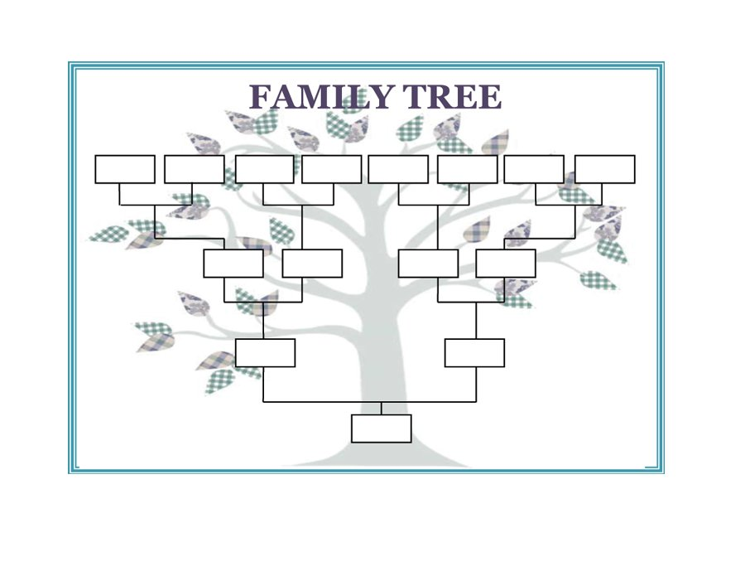

 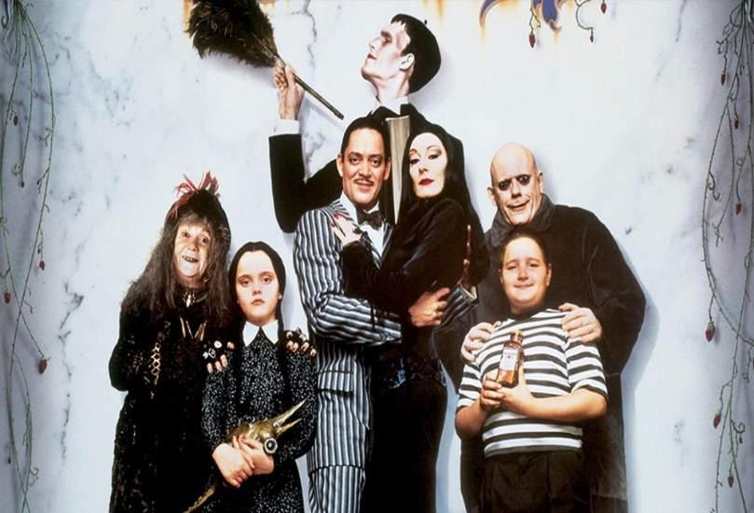

**What makes a family?**







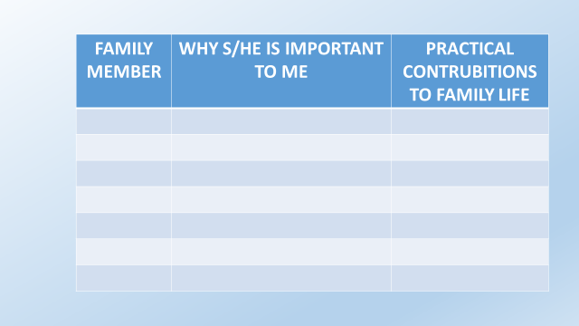

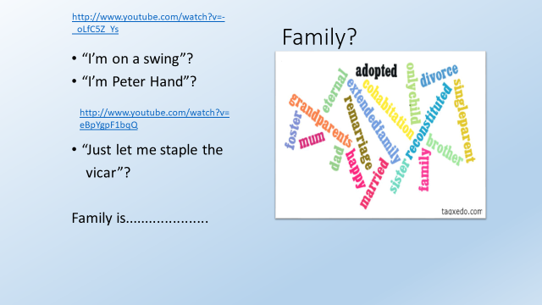

|  |  |  |
| --- | --- | --- |
| Men should be the head of the family | Men and women should be equal in a household. | Having two  parents of the same sex is as effective as two different sex parents. |
| To be a good family you don’t need to love each other | Divorce can ruin a family unit. | Any family  unit can be successful as long as the people love each other |
| Parents  need to be married to raise children properly. | You become  a better person if you are from a nuclear family. | A  successful family doesn’t need a male role model |

**Cohabitation**

**Pre-Marital Sex**

**Civil Partnership**

**Marriage**

**Promiscuity**

**Faithfulness**

**Adultery**

**Types of Family**

|  |
| --- |
| What are the different types of family that you are aware of in our society? |
|  |

* Why are families in our society so varied?
* Why do you think people feel families are so important in a society?
* Why might families be important to a religion like Christianity?

|  |  |
| --- | --- |
| TYPE OF FAMILY | DEFINITION |
|  | The traditional family unit in Britain – two parents living together with their children. |
|  | When parents separate and find new partners to live with together with their children. |
|  | When parents split up and one of them ends up living alone with the children |
|  | When parents and children live together with other family members (grandparents etc) |

Which type of family are you part of?

What are the benefits of living in this type of family?

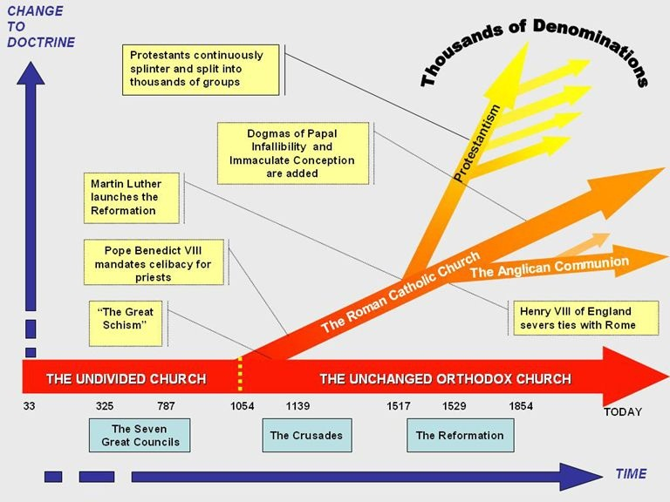

|  |
| --- |
|  |
|  |
|  |
|  |
|  |
|  |
|  |
|  |
|  |
|  |
|  |
|  |
|  |
|  |
|  |
|  |
|  |
|  |
|  |
|  |
|  |
|  |
|  |
|  |

|  |
| --- |
|  |
|  |
|  |
|  |
|  |
|  |
|  |
|  |
|  |
|  |
|  |
|  |
|  |
|  |
|  |
|  |
|  |
|  |
|  |
|  |
|  |
|  |
|  |
|  |
|  |
|  |
|  |
|  |
|  |
|  |
|  |
|  |
|  |
|  |
|  |
|  |
|  |
|  |
|  |
|  |
|  |
|  |
|  |
|  |
|  |
|  |
|  |
|  |
|  |
|  |
|  |
|  |
|  |
|  |
|  |
|  |
|  |
|  |
|  |
|  |
|  |
|  |
|  |
|  |
|  |
|  |
|  |
|  |
|  |
|  |
|  |
|  |
|  |
|  |
|  |
|  |
|  |
|  |
|  |
|  |
|  |
|  |
|  |
|  |
|  |
|  |
|  |
|  |

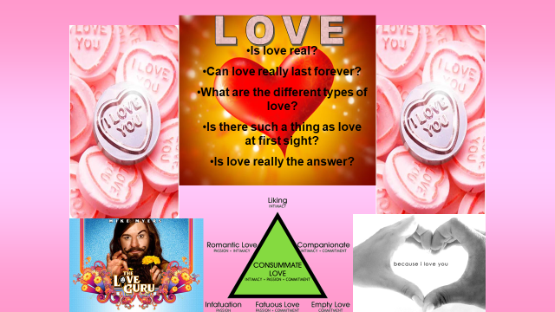

|  |
| --- |
|  |
|  |
|  |
|  |
|  |
|  |
|  |
|  |
|  |
|  |
|  |
|  |
|  |
|  |
|  |
|  |

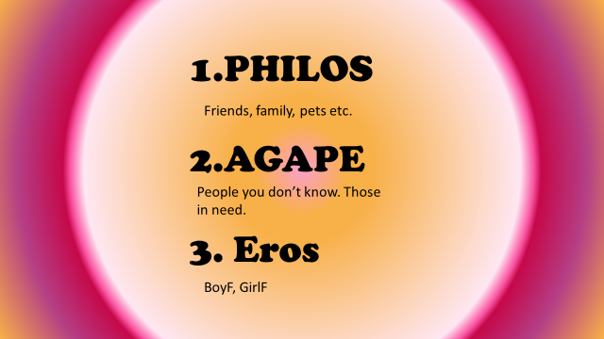

TYPES OF LOVE

There are several different types of love. Or, to be more precise, we love different people and things in several different ways. You don’t love football in the same way that you love your parents. And you shouldn’t love your dog in the same way that you love your wife, for all kinds of reasons. Complete the table below.

|  |  |  |
| --- | --- | --- |
| **TYPE OF LOVE** | **WHO OR WHAT WOULD YOU LOVE LIKE THIS?** | **HOW WOULD THIS LOVE**  **SHOW ITSELF?** |
| EROS | SEXUAL ATTRACTION. | PHYSICAL ACTS OF PASSION OR LOVE. HOLDING HANDS. SNOGGING ON THE BUS. LOOKING INTO EACH OTHERS EYES FOR DISGUSTINGLY LONG PERIODS OF TIME etc. |
| AGAPE | UNSELFISH CHRISTIAN LOVE FOR ALL.  “LOVE YOUR NEIGHBOUR” |  |
| PHILOS | LOVE FOR CLOSE FRIENDS |  |



**Your love song**

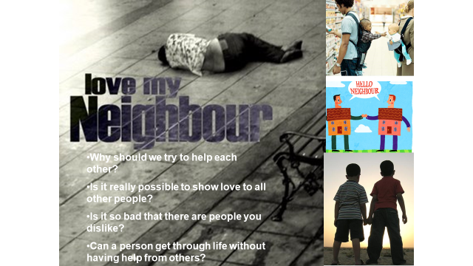

The Good Samaritan

|  |
| --- |
| IS LOVE REAL? |
|  |
|  |
|  |
|  |
|  |
|  |
|  |
|  |
|  |
|  |
|  |
|  |
|  |
|  |
|  |
|  |
|  |
|  |
|  |
|  |
|  |
|  |
|  |
|  |
|  |
|  |
|  |
|  |
|  |
|  |

**The Ingredients For A Marriage**



|  |
| --- |
| EXPLAIN YOUR CHOICES |
|  |

**A Christian view of marriage**

When a man and a woman get married they commit themselves to spending their lives in a new relationship. It is a partnership of love, made richer and deeper through sex. Like many people, Christians regard it as the best context for nurturing children. It is also seen as the best (many Christians would say the only) setting for sex.

In any marriage ceremony the bride and groom must confirm that they want to marry each other, and after the opportunity has been given publicly for anyone present to prevent the marriage if there is a legal reason, the couple join hands and make promises. They exchange rings, which are worn as a reminder of these promises for the duration of their married life.

If the marriage begins with a wedding service in a Christian church, the minister conducting the wedding reminds all present that marriage forms part of a pattern of life established by God. The first marriage that the Bible tells of is between Adam and his wife, Eve. God declared, ‘It is not good for the man to be alone. I will make a helper suitable for him.’

In a church service there are readings from the Bible which explain the nature and significance of marriage. The couple make promises to stay together ‘for better, for worse; for richer, for poorer; in sickness and in health; to love and to cherish until death us do part’. It is a commitment for life, and not just for the times which are easy. Prayers are said for the newlyweds, which recognise both the joys and difficulties ahead, and ask God’s blessing on the couple.

While marriage is honoured and affirmed among Christians, there is no suggestion that it is necessary for everyone. Singleness, with its freedom and flexibility, is described as ‘a gift’ in the Bible. And Jesus, the founder of the Christian faith, was himself unmarried.

Some Christians believe that marriage vows are unbreakable, so that even in the distressing circumstances in which a couple separates, they are still married from God’s point of view. This is so in the Roman Catholic church, although occasionally a marriage is declared to be null (in other words, it never really was a marriage). Other Christians have accepted divorce and remarriage in some circumstances - for example, to relieve one partner of intolerable hardship, unfaithfulness or desertion.

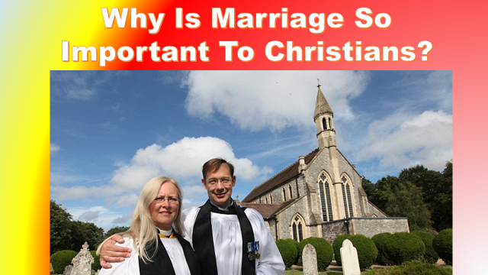

|  |  |
| --- | --- |
| CHRUCH OF ENGLAND | ROMAN CATHOLIC CHURCH |
|  |  |

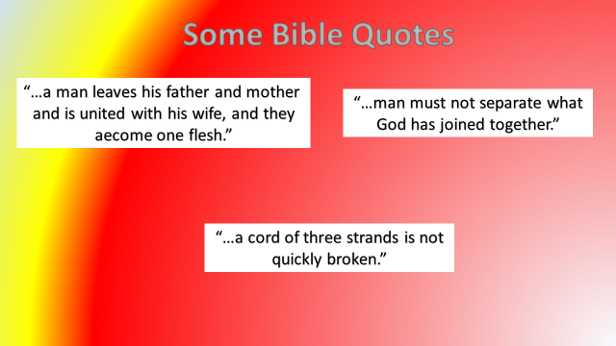

CHRISTIANITY AND LOVE/MARRIAGE

UNSCRAMBLE THE FOLLOWING PARAGRAPHS:

To you are married Churches sex teach should only happen with All Christian the person you.

|  |
| --- |
|  |

Have married get to not do Christians. Christians believe that God decide what people them to want do their life with.

|  |
| --- |
|  |

Marriage All Christians that believe life for be should, some but divorce allow do Churches.

|  |
| --- |
|  |

THE PURPOSE OF MARRIAGE

The following are the acknowledged purposes of marriage in the Christian religion.

They are in no particular order, but you must rank them in order of importance and explain why you put them in this particular order. But beware! Two of them are impostors and do note belong in the list. Remove them and throw them away forever, never to return.

|  |  |
| --- | --- |
| HAVE CHILDREN | leggo wedding |
| SHARE LOVE AND COMPANIONSHIP |
| KEEP GERBILS |
| ENJOY SEX IN GOD’S WAY |
| FORM A CHRISTIAN FAMILY |
| TEND TO THE SEVEN PRECEPTS OF MAHOGANY |
| SHOW THEIR LOVE FOR EACH OTHER AND GAIN GOD’S HELP IN THEIR MARRIAGE |

Now complete the following table, ranking the reasons in the order of importance and explaining your choices.

|  |  |
| --- | --- |
| 1. |  |
| 2. |  |
| 3. |  |
| 4. |  |
| 5. |  |

THE MAIN FEATURES OF A CHRISTIAN WEDDING SERVICE

True or false?

The main features of a Christian wedding service are…

|  |  |  |
| --- | --- | --- |
|  | TRUE | FALSE |
| Talk and Bible readings explaining the purpose of Christian marriage |  |  |
| Nudity. |  |  |
| Bride and groom exchanging vows that they will stay together for life and not have sex with anyone else. |  |  |
| The priest dancing on the altar. |  |  |
| Rings exchanged to show that marriage is like a ring, with no end. |  |  |
| Prayers asking for God’s help with the marriage. |  |  |

|  |
| --- |
| WHAT ELSE HAPPENS? |
|  |

**DIVORCE**

|  |
| --- |
| What would a Roman Catholic priest say to the Thackers? |
|  |

|  |
| --- |
| Would banning divorce make life better or worse? |
|  |

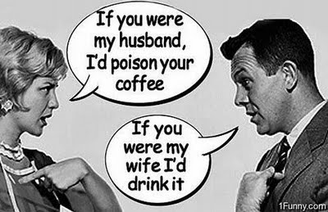

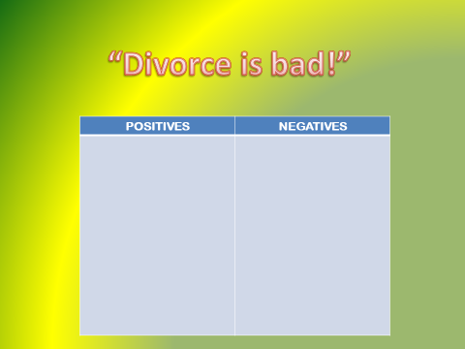

|  |  |  |
| --- | --- | --- |
| **BELIEF/TEACHING** | CofE | RC |
| * Marriage is a holy relationship, the vows are made in front of God and should never be broken. * Divorce is wrong. * Divorce is sometimes the kindest thing to do. * A separated couple may never re-marry. * In exceptional cases a marriage may be annulled. * Divorce is permitted because Jesus said the right course of action is the most loving thing to do. * To re-marry is to commit adultery. * Jesus allowed divorce for unfaithfulness. * Our interpretation of the Bible has to move with the times. |  |  |

All Christians know that sometimes ____________ don’t work. But there are _____________ views about what Christians should do if they don’t want to stay with the person they married.

The teaching in the ___________ is not always clear about divorce.

The **ROMAN CATHOLIC CHURCH** teaches that married ____________ may live apart if they want to, but they may not ____________. Catholics believe marriage is a _____________ - something holy that ____________ has done and it cannot be undone. Roman Catholics must not marry someone new if their husband/wife is still alive.

Other Christian churches, such as **THE CHURCH OF ENGLAND** have different ideas. They believe that divorce can be _____________ and both partners are then _____________ to marry other people. It is up to the ___________ to decide if they can get married in ____________ if they have been divorced before.

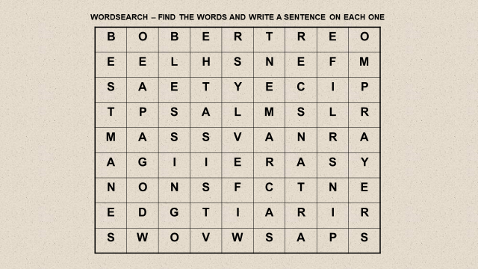

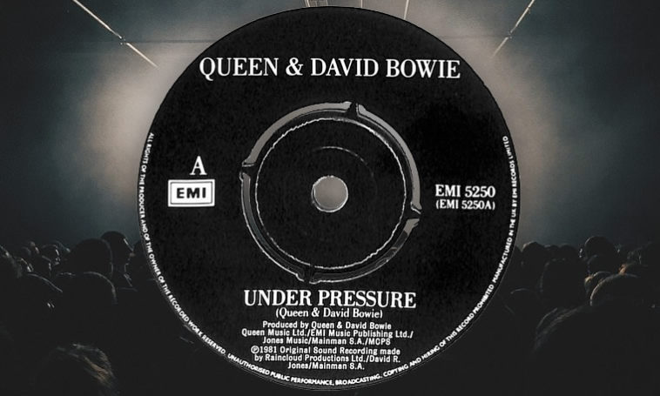

**What are**

**the pressures**

**that might happen**

**in a marriage?**

|  |
| --- |
| HOW CAN RELIGIOUS COMMUNITIES COME TO THE RESCUE? |
|  |

**ATTITUDES**

|  |  |
| --- | --- |
| ROMAN CATHOLIC | OTHER |
|  |  |

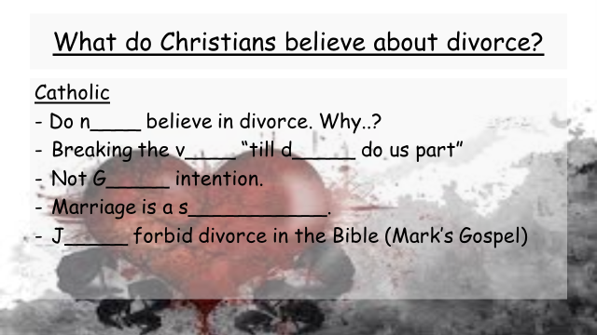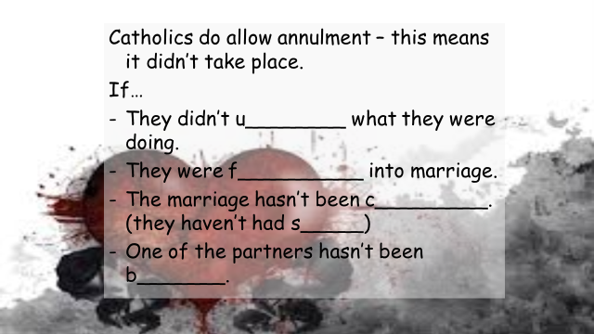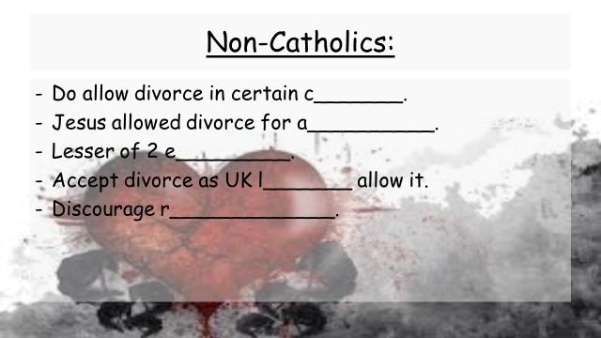

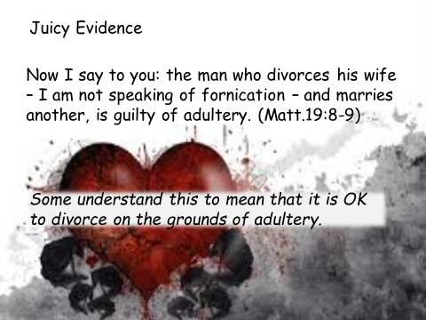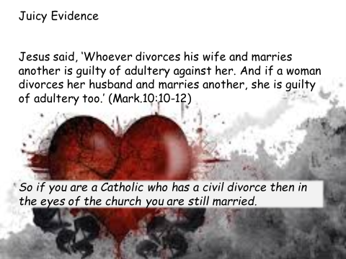

|  |
| --- |
|  |
|  |
|  |
|  |
|  |
|  |
|  |
|  |
|  |
|  |
|  |
|  |
|  |
|  |
|  |
|  |
|  |
|  |
|  |
|  |
|  |
|  |
|  |
|  |
|  |
|  |
|  |

**Family Roles**

[](http://www.google.co.uk/url?sa=i&rct=j&q=man's+work&source=images&cd=&cad=rja&docid=1t7Wbj_9D_UxuM&tbnid=nzo0FGrxDqbOeM:&ved=0CAUQjRw&url=http://barrylyga.com/2013/03/memory-monday-mans-work/&ei=n4SsUdiaNcW0hAf5sIHoAw&bvm=bv.47244034,d.ZG4&psig=AFQjCNEfIjus38lteTE96SOqCi0wVuSdlw&ust=1370347018993761)

|  |  |
| --- | --- |
| MAN’S JOB | WOMAN’S JOB |
|  |  |
| MAN’S ROLE | WOMAN’S ROLE |
|  |  |

FAMILY ROLES IN CHRISTIANITY

Some Christians believe that different members of the family have different roles to play in the family. Others believe that men and women should be treated equally.

|  |  |  |  |  |
| --- | --- | --- | --- | --- |
| (1)  “The Lord God said: ‘It is not good for the man to be alone. I will make a helper suitable for him.” GENESIS 2:18 | (2)  “Wives…be submissive to your husbands. Husbands, in the same way be considerate as you live with your, and treat them with respect as the weaker partner.” | (3)  “There is neither male nor female, for you are all one in Christ Jesus.”  GALATIANS 3:28 | (4)  The Christian wedding vows say a wife must obey her husband. | (5)  Jesus took no women for his disciples – he chose men to do his work for him. |
| (6)  According to the bible, Adam was created first, before Eve. | (7)  Roman Catholic Christians believe that only men can become priests. | (8)  In the Church of England women can become priests too. | (9)  Both men **and** women were made in the image of God in Genesis. | (10)  Eve was the first person to sin. She then led Adam astray. |
| Now write in the numbers of the teaching that support each argument. | | | | |
| Men and women should have different roles within the family. | | 1, | | |
| Men and women should be treated as equals within the family. | | 9, | | |

CHRISTIANITY AND THE FAMILY

COPY THE TEXT INTO THE BOX BELOW, FILLING IN THE BLANKS:

In a ____________ family, parents should provide their children with ________, clothes etc. Parents should give __________ to their children and to each other. Parents should teach their children about ___________ and how to have a Christian life. Parents should set their children a good ________ of the Christian life. Parents should encourage their children to go to _________ or Sunday __________ and be ___________. Young children should ________ and respect their parents. Children should look after their parents if they can no longer look after themselves.

|  |
| --- |
|  |

Some words to help:

|  |
| --- |
| Christian Christianity confirmed love school food example hedgehog  Church obey |

Christians believe that family life is important because

* it was created by god to keep society together
* it is the only way god wants children to be brought up
* it is the place where children learn about Christianity.

EXPLAIN THE DIFFERENT WAYS CHURCHES HELP FAMILY LIFE

|  |  |
| --- | --- |
| Baptism |  |
| Sunday Schools/Confirmation Classes |  |
| Family Services |  |
| Youth Clubs |  |
| Priests acting as counsellors |  |
| The running of Church Schools |  |

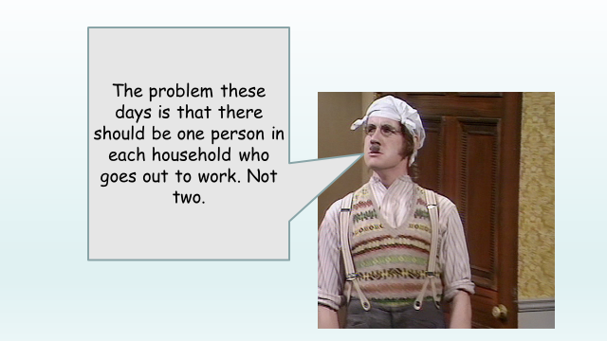

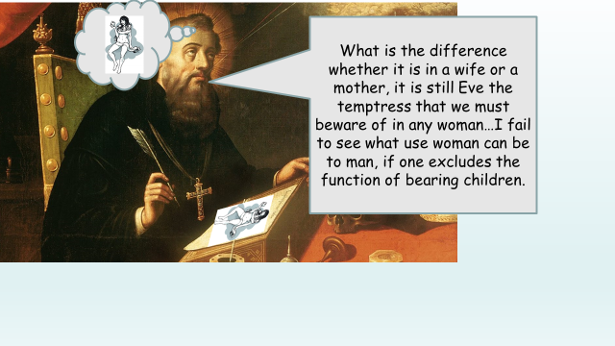

|  |
| --- |
| WHAT ARE YOUR RESPONSES TO THESE STATEMENTS? WOULD ALL CHRSTIANS AGREE? |
|  |

**Which is better, marriage or cohabitation? Why?**

|  |  |
| --- | --- |
| MARRIAGE | |
| FOR | AGAINST |
|  |  |
| COHABITATION | |
| FOR | AGAINST |
|  |  |
| CONCLUSION | |
|  | |

**SEXUALITY & SAME SEX**

**RELATIONSHIPS**

|  |
| --- |
| YOUR THOUGHTS |
|  |

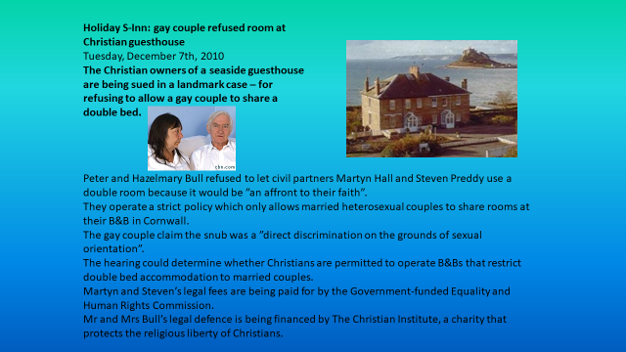

|  |
| --- |
| Do you think people are born “gay” or is it something that happens later? Why do you think this? |
|  |
| Would you say same-sex relationships and marriages are acceptable? Why/Why not? What would different groups of Christians think? |
|  |

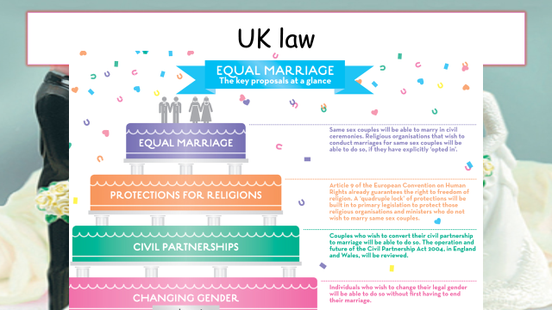

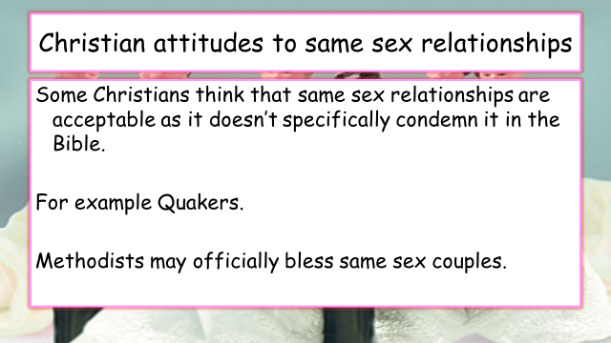

|  |  |
| --- | --- |
| HOMOSEXUALITY IN THE BIBLE | |
| SODOM AND GOMORRAH |  |
| HAM AND NOAH |  |
| LEVITICUS |  |

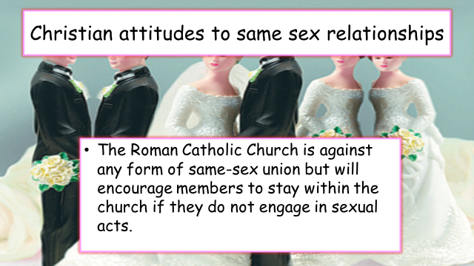

“Marriage should always be between a man and woman”

**SEX & CONTRACEPTION**

|  |
| --- |
| **What were Augustine’s views on sex?** |
|  |

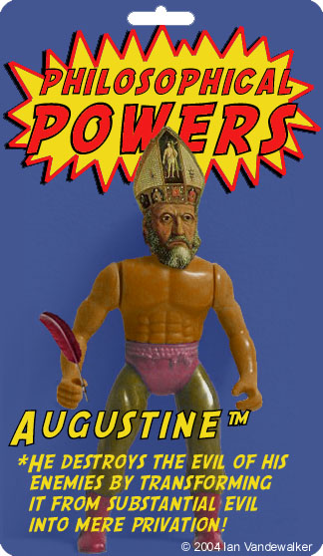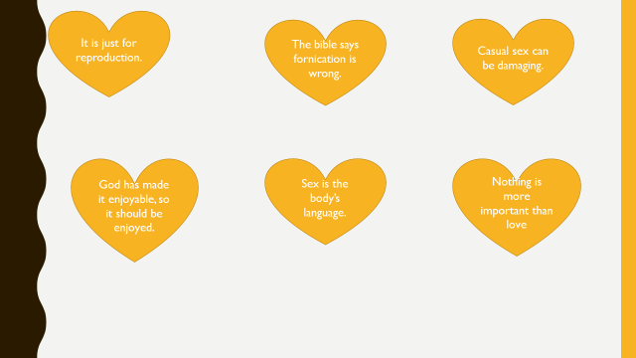

Are these views acceptable in modern society? Would they make society better?

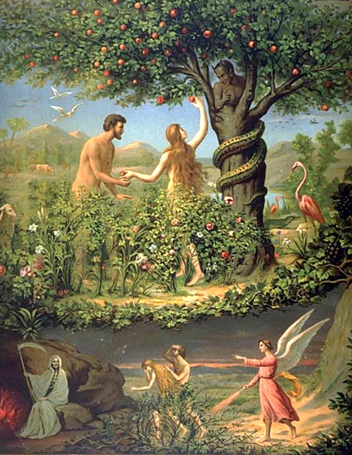

|  |
| --- |
| Explain how St Augustine used the story of the Fall to support his views on sex. |
|  |

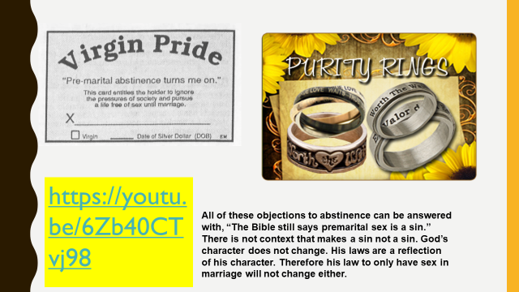Why is abstinence important to some Christians?

CONTRACEPTION AND BIRTH CONTROL



Match up and copy out the separate halves of the different sentences.

|  |  |  |
| --- | --- | --- |
|  |  |  |
| 1 | Some Christians would say that God designed sex… | …God made it for, then this behaviour spoils something that was meant to be very special. |
| 2 | They would say that if sex was used just for pleasure and not for the reasons… | …the main message of Christianity is love, and that sex is morally acceptable in any loving relationship, whether or not the couple are married. |
| 3 | Other Christians think that these views are old-fashioned and that… | …would be acceptable because there is nothing wrong with people having sex just to strengthen their love rather than to have children. |
| 4 | For this reason some Christians might accept sexual relationships…. | …between a committed homosexual couple or a couple who are not married but are together on a permanent basis. |
| 5 | They would also say that using contraception… | …for a purpose and that is to have children. |
| 1 |  | |
| 2 |  | |
| 3 |  | |
| 4 |  | |
| 5 |  | |